Health & Well-Being Webinar Tip Sheet
Note: The following information is from a March 2021 ACL webinar series, Nutrition, Socialization, and Health & Well-Being. To view the webinars, visit acl.gov/SeniorNutrition.
Purpose: Understand why health and well-being are important, the value and impact of partnerships on nutrition programs, and barriers to nutrition programs.

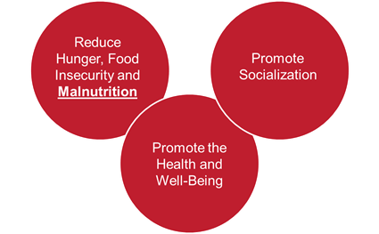
National Senior Nutrition Program
The National Senior Nutrition Program (SNP) is funded by the Older Americans Act. The program provides older adults with meals and nutrition services and promotes socialization and health and well-being. Learn more about the SNP.

Promoting Health and Well-Being
Aging network organizations should consider setting specific goals for promoting health and well-being. For example, the goal of Ohio’s 2020-2022 Strategic Action Plan on Aging is for older adults to live longer, healthier lives with dignity and autonomy and eliminate disparities and inequities.
Setting outcomes is also important. The SNP outcomes include impact on the nutritional status of older adults, including avoiding malnutrition and improving physical activity. Ohio’s plan includes measuring social connectedness (social inclusion and volunteerism), maintaining population health (cognitive health, cardiovascular health, and mental health), and preserving independence (chronic pain management and falls prevention).
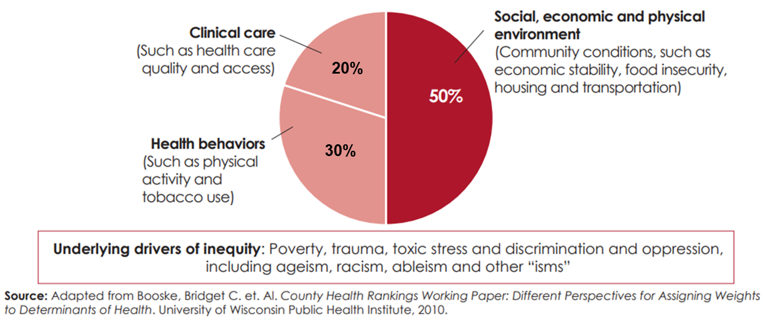
The figure below shows that health and wellness are heavily influenced by factors in the environment and people’s health behaviors (also called “social determinants of health”). Only 20% of health and wellness is directly related to the availability of and access to quality health care.

Some Common Barriers and Strategies that Contribute to the Success of a SNP
Common Barriers | Improvement Strategy
Unnecessarily Strict Nutrition Guidelines | ● Eliminate unnecessary requirements  ● Follow the DGA and DRI requirements
Lack of Menu Diversity/Choices | ● Foster restaurant partnerships  ● Add multiple meal options  ● Customize menus to each population  ● Emphasize the importance of taste and appeal
Unappealing Site Environment | ● Choose more attractive location sites and supplies (use real plates instead of plastic or Styrofoam)  ● Switch to a café/restaurant style meal service
Inadequate Funding | ● Partner with local businesses, organizations, and government
Ineffective Marketing | ● Increase word-of-mouth marketing  ● Leverage partnerships
Ineffective Participant Intake Forms | ● Create an online form  ● Include privacy statements  ● Use person-friendly layout  ● Use plain language

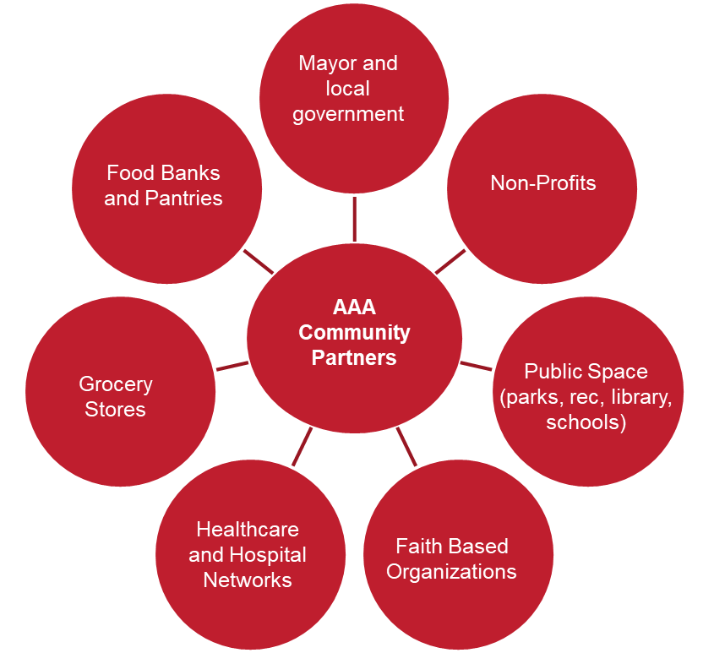
Partnerships
Partnerships are vital to making nutrition programs successful and promoting health and wellness. Partnerships help with funding, marketing, and donations. Partnership opportunities for nutrition programs could include:
- Local government
- Non-profits
- Public spaces such as parks, libraries, and schools
- Faith based organizations
- Healthcare and hospital networks
- Grocery stores
- Food banks and pantries

Examples of Partnerships

Ohio Farmers’ Markets
During the COVID-19 pandemic, local Ohio farmers’ markets catered to the needs of older adults in the community to help ensure that no one went hungry. They began to sell items in bulk, opened a drive-thru pickup, and offered home-delivered produce.

Iowa Café
Iowa found that participation in their congregate meal program had decreased, so they decided to make some improvements. The program was given a more appealing name, The Iowa Café, which included a café-like dining experience and an expanded menu. During the two-year pilot, congregate meal sites saw a significant increase in attendance; attracted more “younger” (60-69 years) older adults; generated over $150,000 in in-kind support from government, local businesses, and volunteers; and increased average donations from $2.25 to $3.95 per meal.

Resources and Tools
- Summary Assessment of Older Ohioans
- Ohio’s Strategic Plan on Aging
- Iowa Department on Aging Iowa Café
- Condition of Iowa’s Congregate Meal Program

This material was developed by ACL Intern Mackenzie Brown, Tufts University, 2021.

This list not intended to be all-inclusive. SNPs should evaluate their program, survey seniors, etc. to determine additional barriers and develop strategies to address those barriers.

