Salad Bar Guide

This guide was developed to help programs and agencies successfully provide a salad bar as part of their nutrition services. It includes frequently asked questions and answers on salad bars and related resources. In addition, the appendices provide examples from successful salad bar programs for reference.

Quick Links
Introduction 1
Frequently Asked Questions 1
References 5
Appendix A: Salad Bar Recommendations 6
Appendix B: Heritage AAA Iowa Salad Bar Guide 9
Appendix C: Iowa Encore Café Salad Bar Guide 12

Introduction
The 2020-2025 Dietary Guidelines for Americans (DGAs) recommend 6 cups of fruits and vegetables per day for adults 60 and older. However, the DGAs indicate that on average, these individuals only consume 4.5 cups towards this goal. Intake of red and orange vegetables – which are especially high in vitamins A, C, K, and potassium – is as much as 3 cups less than the recommended intake over a week.
The Senior Nutrition Program (SNP) can help address this issue and ensure that older adults are meeting the DGAs by offering a salad bar as part of their nutrition services. Salad bars increase food choice, provide plentiful fruit and vegetable options, and can result in increased fruit and vegetable intake by SNP participants.

Frequently Asked Questions

What is a salad bar?
A salad bar is a standing food service station where participants can select two or more food items or ingredients generally used in salad making, such as fruits, vegetables, protein, grains, and fats (e.g., salad dressings). Salad bars have been offered in restaurants, aging network meal sites, and public schools for many years. They may be served by staff or self-serve. Salad bars can be planned to provide one component of a meal, such as a side salad or a fruit and vegetable plate, or they may provide a full meal, depending on the number and types of food items provided and based on your state’s menu policies.

How do participants choose food items to meet a state’s required menu pattern?
The Older Americans Act requires that each meal served by an SNP meet 33.3% of the Dietary Reference Intakes (DRIs) and follow the most current DGAs. State Units on Aging (SUAs) are required to establish policies and procedures to implement these nutrition requirements, which may include mandating that SNP providers use nutritional analysis and/or menu patterns.
State policies that allow for menu patterns are most amenable to implementing a salad bar, although salad bars may be permitted by state policies requiring nutrient analysis. Please see the Nutrition & Aging Resource Center for examples of menu policies that require nutrient analysis and menu patterns.
The SNP is an “offer versus serve” program, which means that participants can choose the food items they want to eat and refuse items they do not want. If a salad bar contains items from each required menu pattern area, the participant can choose what they want to eat. It is recommended that SNPs offer a few choices from each food group. This will ensure participants are happy with their meal choice and increase their intake of important nutrients. It also ensures state menu requirements are met.

What meal components need to be offered at the salad bar?
This depends on participant preferences, your menu items, and how you plan to use the salad bar. Following are examples of two ways in which you may want to use your salad bar:
- Fruit and vegetable bar: Participants choose their own options for a side salad or a fruit plate. These items are selected as an addition to the rest of their meal.
- Full salad bar: Includes protein (e.g., chicken, fish, egg), vegetables, fruit, and grains. These items create the full meal excluding beverages.
An example of a salad bar layout where participants can access both sides. This example has five options, offering a full meal. Usually at least four types of vegetables are offered.
Lettuce | Veggie Option | Veggie Option | Protein Option | Fruit on menu or fruit options | Salad Dressing | Crackers or breadsticks
Lettuce | Veggie Option | Veggie Option | Protein Option | Fruit on menu or fruit options | Salad Dressing | Crackers or breadsticks

For an example of a successful salad bar project, see the Iowa Encore Café in Appendix C and the Nutrition & Aging Resource Center’s Dietary Guidelines for Americans Toolkit.

How do we plan the amount of food to serve at the salad bar?
Your first few times may be trial and error. Forecasting the amount will be easier if you have an idea of the number of people who will be using the salad bar. Production records can also be helpful in keeping track of the amounts needed on certain days. See A Field Guide to Salad Bars in Schools for an in-depth guide to planning for a salad bar.
To plan what food items to include in the salad bar, start by surveying participants and asking questions like:
- Do you plan on choosing items from our new salad bar?
- Please select from the items below to indicate foods you enjoy. (For this question, make a list of items you plan to serve and ask them to circle their answers. It may be helpful to list food items by their meal component category. Leave a blank for participants to add any items not listed.)
- Do you have any allergies or foods that you avoid?

What kind of equipment is needed?
In order to have a salad bar service, you must have a food preparation sink for washing fruits and vegetables. You cannot use a hand washing sink for food preparation.
Your salad bar unit should have four to six “wells” for pans to hold food items. Half-size, two-inch-deep pans are recommended so that utensils will not fall into the food. Depending on your equipment, you may be able to use six-inch-deep pans for items that do not require utensils, like whole fruit. Numerous quarter, half, and full pans may be needed, as well as utensils such as tongs, spoons, and ladles. Lids for the pans may also be helpful to keep food covered prior to the meal.
Any self-service unit should be National Sanitation Foundation (NSF) approved equipment. When purchasing a self-service unit, you must know what type of bar you want to have, as well as your budget. Ask yourself the following questions:
- What type of salad bar do we want? Will we be serving hot food, cold food, or both?
- Where will the salad bar be placed? Is there electricity available in that area?
- How much would we like it to hold (i.e., how many wells)?
- What other features do we want? For example:
  - Breathe guards/sneeze guards that flip up or stay in place.
  - A drain.
  - Access to both sides or just one.
- How easy is the salad bar unit to clean?
Contact your local health inspector for a full list of requirements.

How will a salad bar affect our health inspection?
Any time a new process is added to your program, it is important to consult your SUA, as well as your local health inspector, to ensure you are following the regulations and rules for your state.

Is a self-service salad bar safe for participants during a disease outbreak such as the flu or COVID-19?
Providing hand sanitizer at the beginning of the service line can help decrease instances of cross contamination and infection caused by participants using shared utensils. Any time illnesses are increasing in your area (such as during flu season or increased rates of COVID-19), a self-service salad bar may need to be limited or avoided all together. Consider using alternative serving methods such as having participants line up in a socially distanced manner on one side of the salad bar while staff/volunteers serve them from the other side. Serving prepackaged food is another way to allow participants to pick up their food items at the bar without the risk of multiple people using the same utensils.
See the CDC’s response to the question “Is it safe to open self-serve food and drink options?” on their Frequently Asked Questions about Coronavirus (COVID-19) for Institutional Food Service Operators page for more considerations.
Where can I find additional food safety guidance?
Food safety should be the primary focus of any meal service program. Always follow your local food safety requirements and health codes. Learn more about food safety from the Nutrition & Aging Resource Center under Program Basics.
You can also find information using the FDA’s State Retail and Food Service Codes and Regulations by State.

How can we include nutrition education as part of the salad bar service?
Providing nutrition education at or near the salad bar can help participants make healthier choices or select the food items that are most appropriate for chronic conditions (e.g., diabetes, high blood pressure). For example, you can add MyPlate Graphics to label food items by their food group and instruct participants to choose an item(s) from each food group. The “Minimum Salad Bar Food Choice Recommendation” in Appendix A would also be helpful to post at or near the salad bar.
Smart Tips to Build a Healthy Salad from the Academy of Nutrition and Dietetics may also be helpful near the salad bar.
The Nutrition & Aging Resource Center has additional ideas for nutrition education in the Dietary Guidelines for Americans and Older Adults: Toolkit for Senior Nutrition Programs.
Education regarding how to avoid the spread of illnesses while using a salad bar or other self-service meals may help keep participants safe. Washington State University’s Food Safety and Buffet Etiquette is a good resource on this topic.

References
Dietary Guidelines for Americans, 2020-2025
Dietary Guidelines for Americans Toolkit (Nutrition & Aging Resource Center)
Field Guide to Salad Bars in Schools (Minnesota Department of Health)
Food Safety and Buffet Etiquette (Washington State University)
Frequently Asked Questions about Coronavirus (COVID-19) for Institutional Food Service Operators (CDC)
Lunch Salad Bars in New Orleans’ Middle/High Schools: Student Intake of Fruit & Vegetables
MyPlate Graphics (USDA)
Program Basics: Food Safety (Nutrition & Aging Resource Center)
Offer vs Serve High School Lunch Poster (USDA)
Older Americans Act
Salad Bars to Schools (CDC)
School Lunch Salad Bars (Special Nutrition Programs, USDA and FNS)
Smart Tips to Build a Healthy Salad (Academy of Nutrition and Dietetics)
State Retail and Food Service Codes and Regulations by State (FDA)

Appendix A: Salad Bar Recommendations

Minimum Salad Bar Food Choice Recommendation
The following is a recommendation for lunch based on the Dietary Guidelines for Americans 51 and older. Other meals throughout the day help to meet the remaining daily nutrient requirements.

Food group | Servings per meal | Example of 1 serving
Fruits | 1 Serving | ½ cup (4 oz)  Fruit the size of a baseball
Vegetables | 1 Serving | ½ cup (4 oz)  Vegetable the size of a baseball
Grains | 1-2 Servings | ½ cup (4 oz), 6 crackers, 1 roll  Grain the size of the palm of hand
Meat or Meat Alternative | 3 Servings | 1 egg or 1 oz of meat, which is the size of 2 dice; 3 oz meat is the size of smart phone or deck of cards
Dairy | 1 Serving | 1 milk carton or 8 oz
Oil/Fats | Use sparingly | 1 tbsp or the size of a thumb

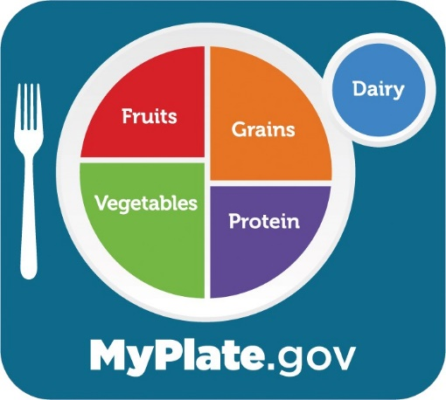

Salad Bar Serving Sizes

Full Meal Example

Lettuce (romaine, iceberg, or spinach): 1 tong
Cherry tomatoes: 2 each
Cucumbers, sliced: 3 slices
Bell peppers: 3 slices
Broccoli, cauliflower, carrots: 2 each
Egg, hard boiled: ½ egg
Cheese, shredded: 1 small spoonful
Grilled chicken, diced: 1 (2 oz) spoonful
Bacon bits: 1 small spoonful
Low-fat dressing: 1 small ladle
Crackers: 6 - 12 crackers

Reminders:
- Always use a clean plate for each trip to the salad bar.
- Always use the utensils provided.

Staff Guide for Serving Utensils
Large Tongs: Lettuce, spinach, romaine.
2 oz Spoodle: Grilled diced chicken, cheese, diced boiled egg, tuna salad, red/black beans, cottage cheese.
4 oz Spoodle: Fruit (applesauce, Mandarin oranges, fresh melon, grapes), fruited yogurt.
Small Tongs: Broccoli, cauliflower florets, cucumber slices, cherry tomatoes, sliced bell peppers.
2 oz Spoodle: Sliced mushrooms, diced tomatoes, peas, diced celery, olives, shredded carrots, artichokes.
2 oz Spoodle: Dried fruit, croutons, sunflower seeds.
1 oz Ladle: Dressings, oil, vinaigrettes.

Spoodles are a cross between a spoon and a ladle. They are perfect for measuring out correct portions. Spoodles come in 2-, 4-, 6-, and 8-ounce measurements.

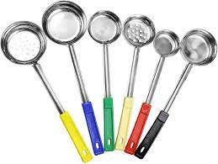

Appendix B: Heritage AAA Iowa Salad Bar Guide

Daily Offerings

- At least two choices of greens
- At least three vegetable choices
- One salad
- At least one meat/protein
- At least one fruit choice
- At least one legume choice
- At least three salad dressing choices
- At least three toppings

Potential Items (Not Limited To)

Lettuce/Greens

- Iceberg (salad mix)
- Romaine
- Spring greens
- Spinach

Vegetables

- Carrots (sliced)
- Tomatoes
- Broccoli
- Peppers (red, green, yellow)
- Cauliflower
- Sliced mushrooms
- Sliced olives
- Sliced onions
- Celery
- Peas
- Baby corn
- Beets
- Cucumbers

Fruit

- Applesauce
- Fruit cocktail
- Fresh fruit (bananas, apple/orange wedges)
- Fresh melon/grapes
- Mandarin oranges
- Fruited gelatin
- Peaches/pears/pineapple tidbits (packed with juice/water preferred)

Meats/Protein

- Ham
- Turkey
- Tuna
- Egg/Egg salad
- Chicken strips (grilled)

Legumes

- Red/Black beans
- Butter beans
- Garbanzo beans

Miscellaneous Toppings

- Dried cranberries
- Croutons
- Shredded cheese
- Sunflower seeds
- Sesame sticks

Dressings

- Oil/Vinegar
- French
- Ranch
- Raspberry vinaigrette
- Other

Salads

- Cottage cheese
- Pasta salad (oil-based preferred)
- Pea salad
- Three bean salad
- Fruit salad
- Plain/Fruited yogurt
- Cucumbers and onions

Participant Guidelines
- Participants that choose to have a full meal may use a clean salad-sized plate for one trip through the salad bar.
- Participants may choose to make salad their meal and may request a full-sized plate for the salad bar.
- Plates brought to the salad bar must be clean, not one that has already had food served on it.
- Participants must use the utensils provided with each item and not mix between different items on the salad bar.

Salad Bar Layout (Initial)
- Greens/Lettuce
- Vegetables
- Legumes/Beans
- Protein
- Toppings (cheese, etc.)
- Salad dressings
- Fruit
- Miscellaneous salads
- Dry toppings

Additional Notes
- Establish a sample plate/recipe.
- Dedicated utensils will be used for the salad bar for each item offered.
- Size/Suggested portion size will be determined for optimum health benefit.
- Salad bar layout and portion/utensil size will be determined in conjunction with the regional nutrition coordinator.
- Suggested portion size to use the salad bar as a meal will be posted at the salad bar.

Appendix C: Iowa Encore Café Salad Bar Guide

Salad Bar Procedures
- Subcontractor may offer a salad bar as part of the congregate meal program.
- Nutrition Policy and Procedures shall be followed.
- A participant may choose to have the salad bar (large plate) as their meal or have a side salad (small plate) in addition to their meal.
- Quality donated produce and/or food items may be used from reputable suppliers or organizations.
- All food offered must be served and maintained at safe food handling temperatures.
- Clean and appropriate serving utensils will be used with the salad bar.
- The suggested analyzed recipe for an entrée salad (large plate) shall be posted at the salad bar for participant view.
- Participants must use a clean plate if making a return trip to the salad bar.
- Offerings:
  - At least one choice of greens
  - At least three vegetable choices
  - One mixed salad
  - At least one protein choice
  - At least one fruit choice
  - At least three toppings
  - At least three salad dressing choices
- Salad Bar order from first to last offerings:
  - Lettuce/Greens
  - Vegetables
  - Protein
  - Cold toppings
  - Salad dressings
  - Fruit
  - Mixed salads
  - Dry toppings
- Equipment examples

Potential Offerings (not limited to):

Lettuce/Greens

- Iceberg
- Romaine
- Spring mix
- Spinach

Vegetables

- Carrots (shredded)
- Broccoli
- Cauliflower
- Olives
- Celery
- Baby corn
- Peas
- Onions (chopped or sliced)
- Mushrooms (sliced)
- Tomatoes (cherry, sliced, etc.)
- Bell peppers (sliced or chopped)
- Beets
- Cucumbers

Fruit

- Strawberries (fresh, frozen)
- Applesauce
- Fruit cocktail
- Fresh fruit (bananas, apple, oranges)
- Fresh melon
- Grapes
- Mandarin oranges
- Peaches/Pears/Pineapple tidbits (packed with water or 100% juice preferred)

Protein

- Ham
- Turkey
- Tuna
- Hard boiled eggs
- Chicken strips (preferably grilled)
- Red/Black beans
- Butter beans
- Garbanzo beans
- Cottage cheese
- Plain or fruited yogurt

Toppings

- Dried fruit
- Croutons
- Shredded cheese
- Sunflower seeds
- Sesame sticks

Mixed Salads

- Pasta salad (oil-based preferred)
- Pea salad
- Three bean salad
- Fruit salad
- Cucumbers and onions
- Marinated beets
- Fruited gelatin
- Egg salad

Dressings

- Oil/Vinegar
- French
- Ranch
- Blue cheese
- Italian
- Raspberry vinaigrette

Salad Bar Temp Log

Week of _________________
Time In and Out Every Day 11am to 1pm

Food Type | Monday | Tuesday | Wednesday | Thursday | Friday
Lettuce
Shredded cheese
Hard boiled eggs
Cottage cheese
Ham
Chicken
Olives
Cucumbers
Tomatoes
Tuna salad
Chicken salad
Pickled cucumbers
Pickled beets
Fruit
Jello
Pudding
Beans

Salad Bar Serving Sizes
The following is a description of the suggested ingredients and amounts to make one side salad. The provided information meets nutritional guidelines for one side salad (small plate).

1 Tong: Romaine lettuce
1 Spoon: Tomatoes
1 Spoon: Fresh peppers (3 slices)
1 Small spoon: Edamame
1 Spoon: Hard boiled eggs
1 Spoon: Shredded cheddar cheese
1 Spoon: Featured Salad of the Day
1 Ladle: Low-fat dressing
1 Spoon: Croutons

Please remember:
- Use a clean plate for each trip to the salad bar.
- Use utensils that are provided.
- If you would like to have a large plate to have salad as your meal, just ask.

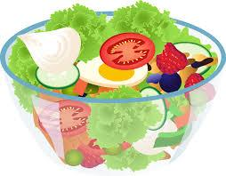

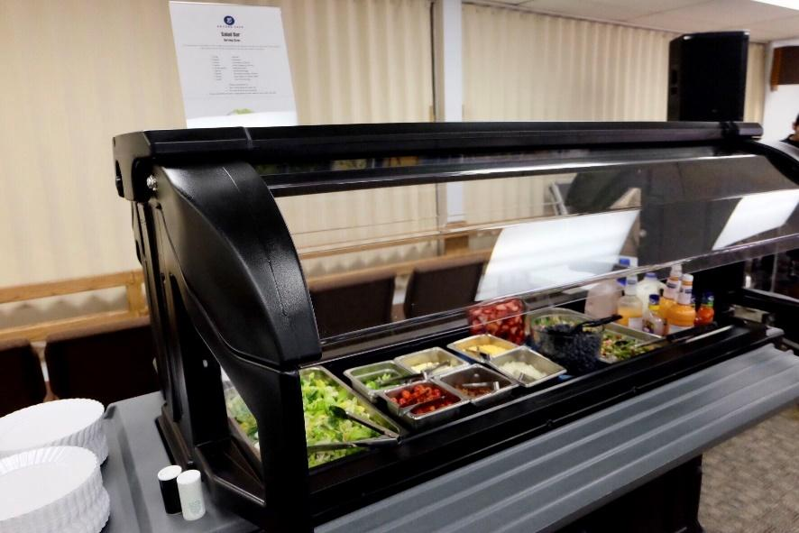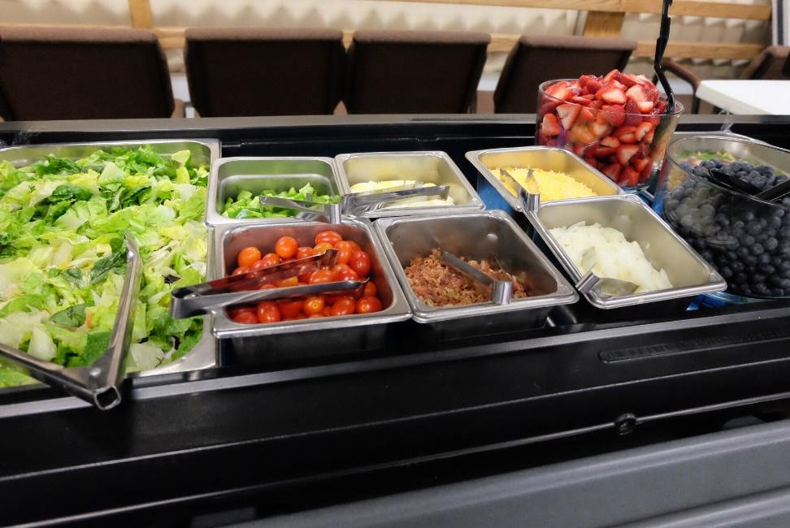

Salad Bar Survey
To continually provide the best possible offerings to Encore Cafe participants, our team is currently looking for suggestions and comments about the selection and offerings of the salad bars offered at the Encore Cafes. Please complete the below questions and if offering comments or suggestions, please be as specific as possible.
- What items currently offered do you enjoy the most?
- What items currently offered do you enjoy the least?
- What types of salad dressings do you prefer (mark all that apply)?
  - French
  - Ranch
  - Blue cheese
  - Vinaigrette
  - Raspberry vinaigrette
  - Dorothy Lynch
  - Other:
- What types of salads do you prefer (mark all that apply)?
  - Beet salad
  - Pasta salad
  - Cole slaw
  - Potato salad
  - Other:
- What are items not currently offered that you would like to see offered?
- Other comments?

