Menu Creation Tool Kit
This document provides a generalized menu pattern with portion size equivalents. This was created based off multiple states’ meal pattern standards. The menu pattern’s goal is to provide a basic guide to create a nutritionally adequate meal. It is recommended that any menu or meal would go through an additional nutritional analysis to ensure the Dietary Guidelines and Dietary Reference Intakes are met.
This document contains menu highlights from program sites with links provided to their full monthly menus.
An average meal will include a
minimum of:
- Protein: 3 oz
- Grain: ½ cup or 1 oz
- Fruit: ½ cup
- Vegetable: ½ cup
- Dairy: 1 cup
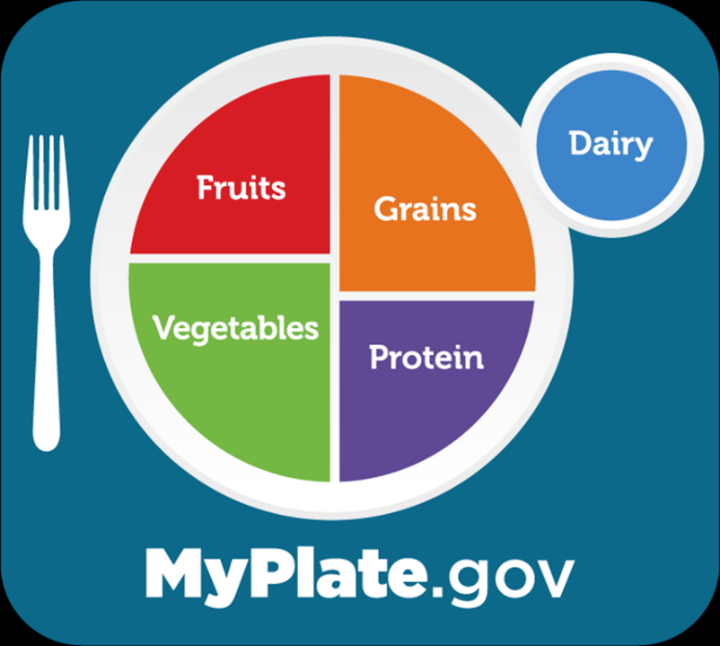

Menu Pattern & Portion Size Equivalents
- | Protein | Grain | Milk/Milk Alternatives | Fruits and/or vegetables | Oils/Fats
Serving Size | 1 oz | ½ cup or 1 oz | 1 cup | ½ cup | 1 tablespoon
Servings Per Meal | Minimum 3 | 1-2 | Minimum 1 | Minimum 2 | Varies
Portion Size Equivalents | - 1 egg  - ½ cup (4 oz) legumes (beans and lentils)  - 1 oz cooked meat, fish, poultry  - 1 oz cheese  - 2 tablespoons peanut butter  - 1/3 cup nuts  - ¼ cup cottage cheese  - 1 oz tofu | - 1 slice (1 oz) bread  - 4 oz starchy vegetable  - ½ cup cooked pasta, rice, noodles  - 1 oz ready‐to‐eat cereal  - 2” cube cornbread  - 1 slice French toast  - ½ English muffin  - 4‐6 crackers (1 oz)  - 1 tortilla, biscuit, waffle, pancake, muffin  - ½ bagel, 3‐4” diameter  - 1 small sandwich bun  - ½ cup cooked cereal  - ½ large hotdog/hamburger bun, 1 oz  - ½ cup bread dressing/stuffing | - 8 oz milk  - 8 oz milk alternative, such as lactose-free, soy, almond, or oat milk  - 1 ½ oz of cheese  - ½ cup calcium processed tofu  - Calcium fortified, ready-to-eat cereal  - Powdered calcium‐fortified beverage mix; must have serving of water to accompany  - 4‐6 oz of calcium fortified juice  - 1 cup yogurt  - ¼ cup nonfat powdered dry milk per 1 cup water | - ½ cup cooked, frozen or canned, drained fruit (e.g., apple, pear, banana, etc.)  - ½ cup 100% fruit juice  - 1/3 cup cranberry juice  - ¼ cup dried fruit  - 15 grapes  - ½ cup cooked, drained fresh, frozen, canned, or raw vegetable (e.g., green beans, peas, etc.)  - 1 cup raw leafy greens, with a variety of vegetable greens  - ½ cup tomato juice  - ½ cup 100% vegetable juice | - 1 tablespoon oil (vegetable, canola, corn, olive, soybean)  - 1 tablespoon margarine or butter  - 1 tablespoon mayonnaise

Protein | Grains | Milk/Milk Alternatives | Fruits and/or Vegetables
- Omelet with broccoli and cheese  - Pinto bean tacos  - Egg salad sandwich  - Grilled chicken with peach salsa  - Spiced salmon  - Lemon pepper fish  - Tuna a la King  - Beef and cabbage casserole  - Ham with pineapple sauce  - Meatloaf with low-sodium gravy  - Vegetarian chili  - Pork loin with mushroom gravy  - Shrimp scampi  - Beer battered cod with tartar sauce  - Stuffed bell pepper  - Chicken and cheese enchilada  - Seasoned tofu  - Beef stew  - Baked ziti  - Beef noodle stroganoff  - Chicken Caesar salad  - Peanut butter and jelly sandwich | - Whole-wheat bread  - Whole-wheat dinner roll  - Brown rice  - Wild rice  - Parsley mashed potatoes  - Spanish rice  - Sweet potato, sweet potato mash  - Whole-grain cornbread  - Red skin potatoes  - Baked potato  - Whole-grain breadstick  - Whole-grain pasta  - Whole-grain hamburger or hotdog bun | - Cow’s Milk (white or flavored)  - 1%, 2%  - Skim  - Whole  - Soy, rice, almond, oat, and lactose-free milk  - Fortified orange juice  - Fortified grapefruit juice  - Calcium-fortified juice; Powdered calcium‐fortified beverage mix; must have serving of water to accompany | - California vegetables  - Green pepper coleslaw  - Three bean salad  - Brussels sprouts  - Seasoned green beans, broccoli, or kale  - Zucchini and summer squash  - Split pea, lentil, or vegetable barley soup  - Corn chowder  - Savory cabbage or red cabbage slaw  - Cinnamon honey yams  - Stir fry vegetables  - Cauliflower florets  - Roasted sweet potato and root vegetables  - Tomato sauce  - Mushroom sauce  - Peas and carrots  - Spiced apricots  - Pineapple  - Banana orange salad  - Mixed berries  - Fresh fruit salad  - Mandarin oranges  - Yogurt with fresh fruit  - Melon medley  - Nectarine  - Fresh strawberries  - Grapes  - Fresh apple  - Banana  - Apple crisp  - Cinnamon applesauce or hot cinnamon apples

Meal Creation

Optional: Dessert
*High sugar & saturated fat content*
- Strawberry shortcake
- Lemon bar
- Pineapple nut delight
- Pudding (low sugar)
- Rice pudding
- Sugar-free cookie
- Angel food cake
- Blueberry muffin
- Fortune cookie
- Peach cobbler
- Oatmeal cookie
- Date bar

Program Menu Highlights
Listed below are menu highlights from program sites along with the link to their full month menu
State Senior Nutrition Programs | Menu Example 1 | Menu Example 2 | Menu Example 3 | Menu Example 4
Bristol Elder Services,  Massachusetts | Grilled chicken, peach salsa, parsley mashed potatoes, brussels sprouts, whole-wheat bread, mixed berries | Shrimp with pesto cream, mashed potatoes, riviera vegetable, whole-wheat bread, mixed fruit | Chicken stew with vegetables, white/brown rice, biscuit, mandarin oranges | Turkey stir-fry, lo mein noodles, whole-wheat roll, pineapple
Dexter Senior Center,  Michigan | Stuffed pepper, garlic mashed redskin potatoes, garden salad, strawberries with topping, whole-wheat dinner roll | Chef salad, chicken noodle soup, crackers, apple, pita bread | Potato crunch pollock with wild and whole-grain pilaf; green beans; cucumber, tomato, and onion salad; diced watermelon, dinner roll | BBQ pulled chicken, bun, corn O’Brien, collard greens with lemon and vinegar, cinnamon applesauce
El Dorado County, California | Sesame chicken, fried wild rice, stir-fry vegetables, mandarin oranges, fortune cookie, milk | Southwestern stuffed bell pepper, garden salad, potato roll, apple crisp, milk | Beef stew with roasted sweet potatoes and root vegetables, cornbread, pineapple, milk | Pork tamale verde, refried beans and cheese, Spanish rice, orange, milk
Habersham County,  Georgia | Macaroni and cheese, black-eyed peas, collard greens, cornbread, fresh fruit, milk | Fajita chicken, fiesta rice, pinto beans, lettuce/ tomato, flour tortilla, fresh fruit, milk | Sausage patty, cheese grits, hot spiced apples, grape juice, biscuit | Beef and bow tie casserole, country corn, green beans, wheat bread, vanilla wafers, milk
Johnson County,  Kansas | Smoked polish sausage, Delmonico potatoes, glazed carrots, multigrain bread, strawberry swirl pudding or diet vanilla pudding | Tuna salad, lemon orzo pasta salad, beet salad, club crackers, fresh fruit | Loaded potato casserole, whole kernel corn, stewed tomatoes, wheat bread, pineapple tidbits | Eggplant parmesan, rotini pasta, Italian green beans, breadstick, raisins
St. Mary’s County,  Maryland | Tilapia Veracruz, rice pilaf, seasoned spinach, whole-wheat dinner roll, pears | Low-sodium V8 juice, pork loin, low-sodium gravy, baby lima beans, seasoned broccoli florets, whole-wheat dinner roll, hot spiced apples | Orange juice, 5-spice chicken, rice pilaf, seasoned zucchini, whole-wheat dinner roll, pineapple | Fruit juice blend, chicken sandwich on a bun, 3-bean salad, chickpea salad, mandarin oranges
Wasilla Area Seniors,  Alaska | Beef lo mein, steamed rice, vegetables, soup or salad, dessert | Chicken and dumplings, dinner roll, vegetables, soup or salad, dessert | Swiss steak, roasted potatoes, vegetables, soup or salad, dessert | Cheese manicotti, garlic bread, vegetables, soup or salad, dessert

Resources
- Dietary Guidelines for Americans, 2020-2025
- Food Shopping and Meal Planning Resources (USDA)
- MyPlate.gov (USDA) – Learn what MyPlate is, how it differs between life stages, and access nutrition education resources.

Full Program Menus
- Bristol Elder Services, Massachusetts
- Dexter Senior Center, Michigan
- El Dorado County, California
- Habersham County, Georgia
- Jasper County, Iowa
- Johnson County, Kansas
- St. Mary’s County, Maryland
- Wasilla Area Seniors, Alaska

