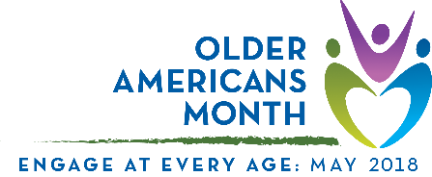

Sample article
This drop-in article can help you raise awareness of and encourage participation in Older Americans Month. Use it as a fill-in-the-blank template or as inspiration for an original piece.

Older Americans Month 2018: Engage at Every Age
Across the country, older Americans – a rapidly growing population – are taking part in activities that promote wellness and social connection. They are sharing their wisdom and experience with future generations, and they are giving back to make enrich their communities. They’re working and volunteering, mentoring and learning, leading and engaging.

For 55 years, Older Americans Month (OAM) has been observed to recognize older Americans and their contributions to our communities. Led by the Administration for Community Living’s Administration on Aging, every May offers opportunity to hear from, support, and celebrate our nation’s elders. This year’s OAM theme, “Engage at Every Age,” emphasizes the importance of being active and involved, no matter where or when you are in life. You are never too old (or too young) to participate in activities that can enrich your physical, mental, and emotion well-being.

It is becoming more apparent that remaining socially engaged can improve the quality of life for older adults. [Organization name] will use OAM 2018 to focus on how older adults in our area are engaging with friends and family, and through various community activities. Throughout the month, [organization name] will conduct activities and share information designed to highlight [local programs, resources, stories, etc.]. We encourage you to get involved by [dependent on goals/activities (e.g., events calendar)].

And, join ACL and AoA in celebrating by participating the Selfie Challenge! They want to see how you’re engaging. Simply take a selfie (or have someone take your photo) and tweet it with the hashtag #OAM18.

[optional signoff or final call to action]

***
Visit the Official OAM Website
Follow ACL on Twitter and Facebook
Follow AoA on Twitter and Facebook

Connect with us: [name(s), phone number/email, and social media sites as applicable]
Contact your Area Agency on Aging: Visit http://www.eldercare.gov/ or call 1-800- 677-1116

