The Department of Health and Human Services

Elder Justice Coordinating Council

2016-2018 Report to Congress

Table of Contents
Executive Summary ii
REPORT OF THE SECRETARY 1
Overview of the Problem 1
The Elder Justice Act 3
Summary Of Activities Undertaken By The EJCC October 2016 – September 2018 4
HIGHLIGHTS OF PARTICIPANT AGENCY ACCOMPLISHMENTS 6
United States Department Of Health And Human Services 7
United States Department Of Justice 18
Consumer Financial Protection Bureau 26
Corporation For National And Community Service 29
Federal Trade Commission 32
Social Security Administration 34
United States Department Of Agriculture 39
United States Department Of The Treasury 49
United States Department Of Veterans Affairs 50
United States Postal Inspection Service 54
United States Securities And Exchange Commission 55
Appendix A: EJCC Recommendations A-1
Appendix B: Fall 2016 Public Meeting Materials B-1
Fall 2016 Meeting Agenda B-2
Robert Blancato B-4
William F. Benson B-6
Paul Greenwood B-18
Erica Wood B-22
Daniel reingold, jd, msw B-30
Appendix C: spring 2017 public meeting materials C-1
Spring 2017 Meeting Agenda C-2
laura mosqueda, md C-3
andrew volmert C-11
Appendix D: fall 2017 executive session materials D-1
Fall 2017 Meeting Agenda D-2
Appendix E: SPring 2018 public meeting materials E-1
Spring 2018 Meeting Agenda E-2
laura mosqueda, md E-3
Robert Blancato E-6
William F. Benson E-10

Executive Summary

Title XX of the Social Security Act, Subtitle B, the Elder Justice Act of 2009, which was signed into law in March 2010, establishes the Elder Justice Coordinating Council (EJCC) within the Office of the Secretary of the Department of Health and Human Services (DHHS). The purpose of the EJCC is to make recommendations to the DHHS Secretary on the coordination of elder justice activities within DHHS, the Department of Justice, and other federal, state, and local entities. The EJCC was initially convened on October 11, 2012, and currently is comprised of 14 federal agencies.

The EJCC is required to submit a report to Congress every two (2) years describing the accomplishments and activities of the EJCC and making recommendations for Congressional action as the EJCC deems appropriate. As the statutorily named Chair of the EJCC, the DHHS Secretary has prepared this report to satisfy the requirement. This report contains the following:

- Introduction
- Summary of activities undertaken by the EJCC for the period October, 2016 to September, 2018;
- Highlights of the elder justice activities and accomplishments of the EJCC’s member agencies from 2016-2018; and
- Written statements from experts consulted by the EJCC.

In 2014, the EJCC adopted a set of eight recommendations for federal action to address elder abuse, neglect, and financial exploitation. The EJCC believes the recommendations represent a focused, but well-balanced, approach for establishing greater federal leadership in the area of elder justice and for improving the federal response to elder abuse, neglect, and exploitation. These recommendations for federal action fall into two categories and address a broad range of elder justice issues important to stakeholders and constituents:

Improve the Response to Elder Abuse, Neglect, and Exploitation
Recommendation 1: Support the Investigation and Prosecution of Elder Abuse Cases
Recommendation 2: Enhance Services to Elder Abuse Victims
Recommendation 3: Develop a National Adult Protective Services System
Recommendation 4: Develop a Federal Elder Justice Research Agenda

Improve Awareness and Prevention of Elder Abuse, Neglect and Exploitation
Recommendation 5: Develop a Broad-Based Public Awareness Campaign
Recommendation 6: Promote Cross-disciplinary Training on Elder Abuse
Recommendation 7: Combat Elder Financial Exploitation, including Abuse by Fiduciaries
Recommendation 8: Improve Screening for Dementia and Cognitive Capacity, Financial Capacity, and Financial Exploitation

REPORT OF THE SECRETARY

DETAILING THE ACTIVITIES OF
THE ELDER JUSTICE COORDINATING COUNCIL
2016-2018
The Elder Justice Coordinating Council (EJCC) is required to submit, every two (2) years, a report to Congress describing its activities and accomplishments, and may make recommendations for legislation, model laws, or other action as determined to be appropriate. This report fulfills the statutory requirement for the period October 2016 – September 2018, as required by Title XX of the Social Security Act, Subtitle B, the Elder Justice Act of 2009.

Overview of the Problem
Elder abuse is a substantial public health and human rights problem. Available prevalence data suggest that at least 10 percent (or 5 million) of older Americans experience abuse each year, and many of them experience it in multiple forms. In addition, data from Adult Protective Services (APS) agencies show an increasing trend in reports of elder abuse, despite estimates that as few as 1 in 14 cases of elder abuse, and 1 in 44 cases of financial exploitation, come to the attention of authorities.

The term “elder abuse” is used generally as an umbrella term to include physical abuse, neglect, financial exploitation, sexual abuse, and emotional/psychological abuse. Some states and federal statutes also include the concepts of abandonment of an elder by a person who has assumed a duty to care, isolation, and self-neglect. Legal definitions of these terms vary from state to state, and there is no consistently used definition by researchers or at the federal level. The Elder Justice Act defines the following terms:

- Abuse: “the knowing infliction of physical or psychological harm or the knowing deprivation of goods or services that are necessary to meet essential needs or to avoid physical or psychological harm.”

- Exploitation: “the fraudulent or otherwise illegal, unauthorized, or improper act or process of an individual, including a caregiver or fiduciary, that uses the resources of an elder for monetary or personal benefit, profit, or gain, or that results in depriving an elder of rightful access to, or use of, benefits, resources, belongings, or assets.”

- Neglect: “(A) the failure of a caregiver or fiduciary to provide the goods or services that are necessary to maintain the health or safety of an elder; or ‘‘(B) self-neglect.”

- Self-neglect: “an adult’s inability, due to physical or mental impairment or diminished capacity, to perform essential self-care tasks including— (A) obtaining essential food, clothing, shelter, and medical care; (B) obtaining goods and services necessary to maintain physical health, mental health, or general safety; or (C) managing one’s own financial affairs.”

Elder abuse results in a wide range of negative health impacts, including the increased likelihood of injury and chronic health conditions, both of which significantly impact health care expenditures. On average, older people have more chronic diseases and health conditions, and access the health care system at higher rates than other age groups. Older adults who are victims of violence have additional health care problems and higher premature mortality rates than non-victims. Older victims of even modest forms of abuse have dramatically (300 percent) higher morbidity and mortality rates than non-abused older people. Research has also demonstrated that older adults who are victims of violence have more health care problems than other older adults, including increased bone or joint problems, digestive problems, depression or anxiety, chronic pain, high blood pressure, and heart problems.

Victims of elder abuse also have significantly higher levels of psychological distress and lower perceived self-efficacy than older adults who have not been victimized. For older victims of sexual violence, the negative health impacts of abuse are even more pronounced. One study found that 12.7 percent of older women in the study group reported a history of sexual assault, all of whom experienced significant associated increased risk of breast cancer and arthritis. Also, those who experienced repeated violence were up to four times more likely to develop these chronic conditions than women who were never abused.

There is a significant lack of evidence and data about effective methods and practices to prevent elder abuse, despite growing knowledge about the scope of the problem and the growing body of evidence on the negative impacts of abuse. Not only is there a dearth of tested prevention models, but interventions that incorporate multiple service components, as well as multidisciplinary teams, are also generally lacking across states and communities. This has been widely noted in a range of studies, including by the National Research Council, the Institute of Medicine, the U.S. Government Accountability Office, and the Centers for Disease Control and Prevention.

The Elder Justice Act
Title XX of the Social Security Act, Subtitle B, the Elder Justice Act of 2009 (EJA), was signed into law on March 23, 2010, to address weaknesses in federal and state responses to elder abuse, as well as gaps in the literature, outlined above. The EJA contains a number of provisions, including provisions to:

- Improve and enhance adult protective services programs,
- Enhance the long-term care ombudsman program, and
- Receive reports of crimes in long-term care facilities.

In addition, the EJA establishes the EJCC. The purpose of the EJCC is to make recommendations to the Secretary for the coordination of activities of the Department of Health and Human Services (DHHS), the Department of Justice (DOJ), and other relevant federal, state, local, and private agencies and entities, relating to elder abuse, neglect, and exploitation and other crimes against elders.

The DHHS Secretary is identified as the Chair of the EJCC, and the Attorney General, or a designee, is identified as a permanent member. Other members of the EJCC are to be federal department or agency heads identified by the Chair as having responsibilities, or administering programs, relating to elder abuse, neglect, or exploitation.

Summary Of Activities Undertaken By The EJCC October 2016 – September 2018
The EJA requires each member of the EJCC be an officer or employee of the federal government. Prior to 2016, the EJCC had twelve members. During this reporting period, two new departments joined the EJCC, the U.S. Department of Agriculture and the U.S. Department of the Interior.

Current agency membership includes:

- U.S. Department of Health and Human Services, Chair
- U.S. Department of Housing and Urban Development
- U.S. Department of Justice
- U.S. Department of the Interior (new)
- Consumer Financial Protection Bureau
- U.S. Department of Labor
- Corporation for National and Community Service
- U.S Department of the Treasury
- Federal Trade Commission
- U.S. Department of Veterans Affairs
- Social Security Administration
- U.S. Postal Inspection Service
- U.S. Department of Agriculture (new)
- U.S. Securities and Exchange Commission

The EJCC is required to meet at least twice per year. The EJCC met four (4) times in this report period, thrice in public session and once in Executive Session. The meetings are summarized below, and agendas and meeting materials for those meetings are included in the Appendices.

The fall 2016 meeting provided EJCC members with the opportunity to celebrate the accomplishments it has achieved since the passage of the EJA in 2010 and the convening of the EJCC in 2012. Held on October 5, 2016, the EJCC also heard from community representatives how they believe the increased federal attention has helped stimulate innovation in their communities. Finally, the EJCC reflected on next steps for continuing the momentum it has generated. An agenda for this public meeting, as well as written remarks of the panel of experts consulted by the EJCC at this meeting, are included in Appendix B to this report.

The spring 2017 meeting was held on June 12, 2017 and was open to the public. The EJCC discussed a new toolkit of framing research, recommendations, and sample communications developed by the Frameworks Institute. This toolkit is designed to help experts and advocates who work in the Elder Justice field to increase public understanding of why elder abuse is a matter of public concern, the causes of elder abuse, and what solutions exist to effectively prevent elder abuse. During the meeting, representatives from the Frameworks Institute and the National Center on Elder Abuse (NCEA) shared the toolkit with the EJCC and the attendees. This toolkit is based on the findings of a two-year, multi-method study of elder abuse and aging that queried more than 10,400 Americans’ thinking on these issues. The research included expert interviews, on-the-street interviews, large-scale surveys, and persistence and usability trials. The goal of the toolkit is to help shape a society that makes informed choices on policies and practices that address elder abuse and to help ensure nationwide implementation and impact of the new communication strategy on elder abuse. An agenda for this meeting can be found in the Appendix C.

The fall 2017 meeting was a closed, Executive Session that occurred on October 30, 2017. The meeting centered on reviewing the collaborative efforts of the EJCC to date, as well as determining a strategic focus for the EJCC over the next year. The EJCC dialogued about the ongoing and future elder justice coordination among federal partners consistent with the Eight Recommendations. An agenda for this Executive Session can be found in the Appendix D.

The spring 2018 meeting of the EJCC took place on June 5, 2018. The meeting included an in-depth discussion on the opioid crisis and elder abuse and featured remarks from federal leaders including DHHS Secretary Alex Azar, Attorney General Jeff Sessions, and Securities and Exchange Commission Chair Jay Clayton. The Elder Justice Interagency Working Group (EJWG), a group of federal employees who support the work of the EJCC, also presented on their proposed activities for research and grant making, data collection and sharing, and information dissemination. An agenda for this meeting, as well as the written testimony of experts who were consulted, can be found in the Appendix E.

HIGHLIGHTS OF PARTICIPANT AGENCY ACCOMPLISHMENTS

Agencies represented on the EJCC also have staff participate in the EJWG. The EJWG is an informal group that brings together federal staff responsible for carrying out elder justice activities including elder abuse prevention, research, grant and program funding, and prosecution. This group meets to support the EJCC, as well as to discuss emerging issues, promising practices, and mechanisms for coordinating efforts throughout the federal government.

Listed below are highlights of programs, initiatives, and/or activities relevant to elder justice within each of the participating agencies in this reporting period, October 2016 to September 2018. When relevant, the authors have referenced the appropriate EJCC Recommendation related to the progress described by each EJCC member. Please note that because of the broad scope of elder justice work across and within agencies, and the diverse individual missions of each EJCC member agency, this report is only able to highlight selected examples. Cataloguing the full breadth of the federal government’s work on elder justice is beyond the scope of this report.

UNITED STATES DEPARTMENT OF HEALTH AND HUMAN SERVICES
The mission of the U.S. Department of Health and Human Services (DHHS) is “to enhance the health and well-being of all Americans, by providing for effective health and human services and by fostering sound, sustained advances in the sciences underlying medicine, public health, and social services.” Many Divisions within DHHS focus on elder justice as a component of that mission. The following section includes highlights of that work, and is not intended to be an inclusive list of all work on elder justice within DHHS.

ADMINISTRATION FOR COMMUNITY LIVING
The Administration on Aging (AoA), within the Administration for Community Living (ACL), manages a portfolio of programs for the protection of vulnerable adults. This portfolio consists of several distinct, but complementary programs designed to prevent, detect, and respond to elder abuse, neglect, and exploitation. Specific accomplishments under ACL/AoA core programs are highlighted below.

Older Americans Act Formula Grants
The Prevention of Elder Abuse and Neglect program provides formula grants to states for training and education and promoting public awareness of elder abuse. The program also supports state and local elder abuse prevention coalitions and multi-disciplinary teams. These activities are important elements of ACL/AoA’s enhanced focus on elder justice. The program coordinates activities with state and local adult protective services programs (many of which are directly administered by State Units on Aging) and other professionals who work to address issues of elder abuse and elder justice. ACL/AoA supports these grants by providing technical assistance to states on specific issues and challenges that arise in the operation of the grants, as well as by providing guidance in the development and review of their state plans on aging (EJCC Recommendations 2 and 6).

National Center on Elder Abuse
ACL/AoA funds the NCEA. The NCEA serves as a national resource center dedicated to engaging and empowering older people so that they may be an advocate for themselves and their communities. The NCEA disseminates elder abuse information to professionals and the public, and provides technical assistance and training to states and to community-based organizations. NCEA also facilitates the exchange of strategies for uncovering and prosecuting fraud and scams targeted at seniors.

In 2016, ACL awarded a new grant for the NCEA to continue its work over the next three years to strengthen connections and foster collaboration across organizations dedicated to the well-being of older people and eradicate elder abuse. With this funding, the NCEA increased identification and reporting of elder abuse, replicated model materials for professionals to support outreach efforts, adopted and disseminated a strategy for professional and public communication on elder abuse, neglect and exploitation, and increased engagement with disadvantaged populations and organizations.

Adult Protective Services Technical Assistance Resource Center
In 2015, ACL launched the National Adult Protective Services Resource Center. Now known as the Adult Protective Services Technical Assistance Resource Center (APS TARC), APS TARC represents the largest dedication of technical assistance directly supporting the improvements in the quality, consistency, and effectiveness of Adult Protective Services (APS) programs across the country. A new website for the APS TARC was created and launched in early 2018. The APS TARC works to enable state APS programs to enhance their critical role in responding to elders and adults with disabilities who are facing abuse, neglect, and exploitation. (EJCC Recommendation 3)

National Adult Mistreatment Reporting System
The National Adult Maltreatment Reporting System (NAMRS) is the first comprehensive, national reporting system for adult protective services programs. It collects quantitative and qualitative data on APS practices and policies, and the outcomes of investigations into the maltreatment of older adults and adults with disabilities. NAMRS is an annual, voluntary system to collect both summary and de-identified case-level data on APS investigations. ACL has collected and released the first 2 years of data for FFY 2016 and FFY 2017. (EJCC Recommendation 3)

State Grants to Enhance Adult Protective Services
In 2015, ACL established the State Grants to Enhance Adult Protective Services Program to help address the gaps and challenges in state APS systems. With this funding, ACL was able to provide funding to states to enhance APS systems statewide, to include innovations and improvements in practice, services, and data collection and reporting. The goal of the program is to improve the experiences, health, well-being, and outcomes of the individuals served by APS, and accurately document the improvements in outcomes in a manner that is consistent with national data collection efforts, including NAMRS. In 2018, ACL provided a third set of grants to 14 states to enhance APS systems statewide, to include innovations and improvements in practice, services, and data collection and reporting. (EJCC Recommendation 3)

Voluntary Consensus Guidelines for State APS Systems
In July 2015, ACL began facilitating the development of field-driven, consensus-informed, national guidelines for state APS systems in order to provide a core set of principles and common expectations for APS programs, and to encourage consistency in the policies and practices of APS across the country. Those guidelines were published in September 2016, and have been well received by the states, facilitating ACL’s goal of ensuring that adults are afforded similar protections and service delivery, regardless of the state or jurisdiction in which they reside. In fall 2018, ACL began the process of updating the guidelines for the next biennium. (EJCC Recommendation 3)

IOM Forum on Global Violence Prevention
ACL/AoA supports the National Academies Forum on Global Violence Prevention (the “Forum”). ACL participated in a forum on The Neuro-Cognitive and Psycho-Social Impacts of Violence, held from July 31, 2017 – August 1, 2017. In FY 2018, ACL provided $20,000 in funding for Forum Activities. Each year, the Forum conducts two (2) workshops. Due to ACL/AoA involvement, the Forum has consistently considered violence against older adults and elder abuse in the focus of their work and activities.

Late Life Domestic Violence
For many years, ACL/AoA has been a member of the DHHS Violence Against Women (VAW) Steering Committee. The VAW Steering Committee has the responsibility for coordinating the DHHS response to issues related to violence against women and their children, and coordinates DHHS violence-related activities with those of other federal agencies. ACL/AoA’s participation ensures that the interests of older women victims are represented in the Committee’s work. Complementing the public health approach of the DHHS VAW Steering Committee to violence and abuse affecting women across the life span, ACL/AoA continues to participate as a member of the federal agency-wide Interagency Working Group on VAW. This whole-of-government coordinating mechanism convenes stakeholder agencies across 12 departments to exchange program and policy updates, and share information on federal work concerning domestic violence, dating violence, sexual assault, stalking, human trafficking, and elder abuse. In addition to participating on the DHHS VAW Steering Committee and Interagency Working Group on VAW, ACL/AoA has partnered with a number of federal and non-governmental organizations to promote the inclusion of older women in responses to domestic violence.

Raising Global Awareness of Elder Abuse
As a member of the global community, ACL and DHHS strive to raise awareness of elder abuse on the global stage. In January 2018, ACL participated in AARP International's United Nations Global Ageing Briefing Series on the margins of the 56th United Nations Commission for Social Development. Providing the keynote address for the event, ACL Administrator/Assistant Secretary for Aging Lance Robertson spoke on the importance of focusing anti-poverty efforts on older adults, emphasizing the heightened vulnerability to elder abuse among older persons who are economically insecure. (EJCC Recommendation 5)

World Elder Abuse Awareness Day
Every year, ACL joins with leaders from other federal departments and others throughout the United States and the world to recognize World Elder Abuse Awareness Day (commemorated on June 15th). (EJCC Recommendation 5) These activities include the “Finish this Sentence” campaign on social media, which allowed individuals to share what World Elder Abuse Day meant to them, as well as coloring the Map Purple, an online campaign designed for states to share how they commemorate World Elder Abuse Day. When states list their activities, the states are turned purple on the map. There is also a push to encourage individuals to share photos from their commemoration activities on Twitter and Instagram with the hashtag #WEAAD.

At the spring 2017 meeting on the EJCC, ACL held a Voice of Elder Abuse experience where survivors and family members of survivors of elder abuse shared their stories with the EJCC. The NCEA and FrameWorks also presented new messaging strategies on ways to raise public awareness on abuse, neglect, and exploitation.

The spring 2018 meeting of the EJCC took place on June 5, 2018, and recognized World Elder Abuse Awareness Day through an in-depth discussion on the opioid crisis and elder abuse. The meeting also featured remarks from a federal leaders including DHHS Secretary Alex Azar, Attorney General Jeff Sessions, and Securities and Exchange Commission Chair Jay Clayton.

Legal Assistance and Elder Abuse
Legal assistance and elder rights programs under Tile III-B of the OAA are instrumental in addressing the harmful consequences of elder abuse, including financial damage caused by exploitation and fraud. With the rapid increase in the aging population creating unique demands on existing service delivery systems, the need to have aging services, legal services, and elder abuse prevention and response networks working cohesively to protect the rights of older persons will become even more critical. There are approximately 870 OAA-funded legal services providers nationwide, which provide approximately 950,000 hours of legal assistance per year. Legal services under Title III-B can protect older persons against the direct challenges to independence presented by elder abuse. These cases involve complex legal issues, which may include cases of financial exploitation, fiduciary abuses, and consumer fraud; cases of physical abuse; and cases of neglect/self-neglect.

National Center on Law and Elder Rights
The National Center on Law and Elder Rights (NCLER) empowers professionals in aging/disability and legal networks with tools and resources to provide older clients and consumers with high quality legal assistance. As a streamlined and accessible point of entry, the NCLER supports the leadership, knowledge, and systems capacity of legal and aging provider organizations in order to enhance the quality, cost effectiveness, and accessibility of legal assistance and elder rights protections available to older persons with social or economic needs. The NCLER is currently providing resource support to aging/disability, legal, and elder rights networks through a strategic combination of case consultation, legal training, and technical assistance on a broad range of priority legal issues and systems development issues. Types of pervasive legal issues addressed by the NCLER include preventing the loss of an older adult’s home through foreclosure, protecting against consumer scams and debt collection harassment, addressing elder abuse in the community and in long-term care facilities, and difficulties in accessing benefits essential to financial security, independence, and health. The NCLER also provides technical assistance on the efficient, cost effective, and targeted provision of state-wide legal and elder rights advocacy services.

Model Approach to Statewide Legal Assistance Systems
Through Model Approaches to Statewide Legal Assistance Systems (Model Approaches), ACL continues and expands its support for state leadership efforts in implementing well-integrated and cost effective legal service delivery systems that maximize the impact of limited legal resources targeted to older adults in greatest need. The ultimate goal of these grants is to promote and support the continued evolution of legal service delivery systems towards higher levels of capacity, performance, and service delivery impact. Model Approaches grants are moving statewide legal service delivery systems towards greater accessibility for older adults presenting a wide range of complex legal issues, including improved responsiveness to legal issues that emerge from elder abuse, neglect, and financial exploitation. Model Approaches grants are also expanding knowledge and expertise of aging and legal service providers, implementing legal service delivery guidelines, and promoting data collection and reporting systems that measure legal program results and demonstrate tangible impact on the independence, health, and financial security of older adults.

Long-Term Care Ombudsman Program
Long-Term Care (LTC) Ombudsman programs provide person-centered support for residents of long-term care facilities (nursing homes and residential care communities), including residents who are survivors of alleged abuse, neglect, and financial exploitation. ACL administers this program through OAA grants to states, which operate the programs. LTC Ombudsman programs are not the primary finder of fact in order to substantiate allegations of abuse. However, they coordinate with adult protective services, regulatory agencies, law enforcement agencies, LTC facilities, and others to prevent abuse, to resolve resident complaints, and to strengthen responses to abuse. In FY 2016, states’ LTC Ombudsman programs worked to resolve more than 18,700 complaints related to abuse, gross neglect, or financial exploitation of long-term care facility residents.

From 2016-2018, ACL has conducted a number of activities to enhance the quality and effectiveness of LTC Ombudsman services to residents, including:

- Implementation of LTC Ombudsman Program Regulations – ACL published its first-ever Final Rule on States’ LTC Ombudsman Programs in 2015, effective July 2016 (45 CFR Part 1324). Among other things, the Rule provides specific guidance related to LTC Ombudsman resolution of abuse-related complaints and abuse reporting. Additionally, the Rule emphasizes the role of State Units on Aging in providing elder justice coordination and leadership. In FY 2017, ACL worked with every state to ensure compliance with the Rule. (EJCC Recommendation 2) In FY 2018, states reported completion of, or revisions to, program policies and procedures, changes in regulations and in some states changes in legislation.

- LTC Ombudsman Program Evaluation – In FY 2017 and 2018 ACL began evaluating LTC Ombudsman program operations. ACL plans to use the findings of this “process evaluation” to prepare for an “outcomes evaluation” to understand the effectiveness and efficiency of the program. Outcomes evaluation activities are in process for FY 2019. (EJCC Recommendations 2 and 4)

- Reporting LTC Ombudsman Program Activities – In April 2018, the Office of Management and Budget (OMB) approved proposed changes to update the National Ombudsman Reporting System in order to streamline reporting by states, increase reliability and accuracy of the data, implement regulatory requirements, and increase ACL’s ability to analyze data related to abuse, neglect and exploitation. Reporting software is in the final stage of development after a successful pilot test. States will implement new data collection in FY 2020. (EJCC Recommendations 2 and 4)

- Training and technical assistance are provided to LTC Ombudsman programs by the ACL-funded National LTC Ombudsman Resource Center (NORC), operated by the National Consumer Voice for Quality Long-Term Care. Relevant training topics include training on Complaint Investigations and Abuse Reporting (March 2017) and responding to nursing home discharge notices (April 2017). Resources include a reference guide on responding to allegations of abuse and the role and responsibilities of the LTC Ombudsman program, published in 2018. (EJCC Recommendation 2) Recent events of note include a webinar hosted by the NORC and the NCEA, entitled Sexual Abuse in Nursing Homes: What You Need to Know. This webinar included promising practices of DOJ Office of Violence Against Women grantees who are developing a multi-disciplinary coalition specifically to address sexual assault in long-term care settings (September 2018). Over 1500 individuals registered for the webinar and a link to the recording is available online.

- ACL’s Office of LTC Ombudsman Programs presented at the DOJ Elder Justice Coordinator’s conference comprised of Elder Justice Task Forces (August 2018) and continues to coordinate with DOJ, particularly on issues related to abuse and neglect in long-term care facilities. ACL convened meetings with LTC Ombudsman programs and the DOJ to inform State Ombudsmen on the role of the DOJ (May 2017.) The Office of LTC Ombudsman Programs and DOJ’s Elder Justice Initiative worked together to share specific contact information between Offices’ of State LTC Ombudsmen and Elder Justice Coordinators. (Recommendation 1)

- In FY 2017, ACL’s Office of LTC Ombudsman Programs participated in a stakeholder work group initiated by the Centers for Medicare and Medicaid Services Survey and Certification Group to address inappropriate, facility initiated discharges from nursing homes. These discharges, sometimes due to lack of payment caused by financial exploitation, are the most common nursing home complaint addressed by LTC Ombudsman programs. Ombudsman programs report that inappropriate discharges can cause emotional harm when the resident is uprooted from their home, or remains in a hospital for an extended period. Results of this workgroup include two guidance letters (May and December 2017) that instruct providers on their requirements to notify the Ombudsman program of facility initiated discharges; address Ombudsman program concerns about inappropriate discharges; and offer opportunity to apply for Civil Monetary Penalty funds to fund projects to address this problem. (Recommendations 2 and 7)

CENTERS FOR MEDICARE & MEDICAID SERVICES
The Centers for Medicare & Medicaid Services (CMS) has implemented several initiatives to ensure that nursing home residents are protected from abuse:

On October 4, 2016, CMS issued a final rule entitled, “Medicare and Medicaid Programs; Reform of Requirements for Long-Term Care Facilities” (81 FR 68688). The October 2016 final rule significantly revised the requirements that Long-Term Care facilities must meet to participate in the Medicare and Medicaid programs. This includes requirements for facilities to investigate and report all allegation of abusive conduct. The requirements for LTC facilities had not been comprehensively reviewed and updated since 1991.

Beginning on November 28, 2017, CMS implemented a new computer-based, standardized nursing home survey process that is resident-centered and which emphasizes evidence of potential quality of care issues and concerns identified through resident observation and interviews. As part of the new survey process, surveyors screen a sample of residents to determine whether any may have been victims of abuse; if so, an in-depth investigation of the allegation is conducted. Surveyors also now have detailed instructions on how to investigate an allegation of abuse, to assure that sufficient information is gathered so that the surveyor can determine whether the facility meets Federal requirements related to abuse.

Concurrent with the implementation of the new survey process, CMS issued new interpretive guidance for nursing home surveyors. In its guidance, CMS emphasized that nursing home residents have the right be free from abuse, whether the abuse is perpetrated by staff, other residents, or visitors. CMS’s guidance also provides information on how to identify abuse, risk factors for abuse, and possible physical and psychosocial outcomes of abuse. In addition, CMS improved its guidance on sexual abuse, including how to determine whether sexual activity was nonconsensual, which may be a challenging issue during investigations of sexual abuse for a cognitively impaired resident. Lastly, CMS’s guidance details that the facility’s response to an allegation of abuse to be centered upon the protection of the residents, which includes prompt reporting, including to law enforcement and other State authorities as appropriate; thorough investigation of the allegation; and immediate corrective action. Guidance on the survey process is available in Chapter 7 and Appendix PP of the State Operations Manual.

HEALTH RESOURCES AND SERVICES ADMINISTRATION
The goal of the Health Resources and Services Administration (HRSA) funded Geriatrics Workforce Enhancement Program is to develop a health care workforce that maximizes patient and family engagement and improves health outcomes for older adults by integrating geriatrics with primary care. Special emphasis is on providing the primary care workforce with the knowledge and skills to care for older adults and on collaborating with community partners to address gaps in health care for older adults through individual, system, community, and population level changes. Funding may be used by the recipients to support training of patients, families, caregivers, direct care workers, health professions practitioners, students, residents, and fellows who provide health care to older adults and the faculty who train these individuals. Elder justice is a topic being addressed by 30 of the 44 grant recipients. (EJCC Recommendation 6)

HRSA funds nearly 1,400 health centers operating approximately 12,000 service delivery sites in every U.S. state, U.S. territory, and the District of Columbia, which provide affordable, accessible, quality, and cost-effective primary health care services to vulnerable populations. HRSA-supported health centers served more than 28 million patients in 2018, including more than 2.6 million older adults.

INDIAN HEALTH SERVICE
The webinar series addressing Tribal Long-term Services and Supports, a collaborative effort of the CMS, IHS, and ACL/AoA, delivered a webinar addressing elder abuse, neglect, and exploitation in Tribal communities on March 28, 2018.

The CMS Tribal Long-Term Services and Supports technical assistance website, co-sponsored by CMS, IHS, and ACL/AoA, includes a page with multiple resources for Tribes addressing elder abuse, neglect, and exploitation. (EJCC Recommendations 2, 5, and 6)

CENTERS FOR DISEASE CONTROL
The Centers for Disease Control and Prevention (CDC) and a diverse group of elder abuse (EA) experts collaboratively produced version 1.0 of uniform definitions and recommended core data elements for possible use in standardizing the collection of EA data locally and nationally. Proposed uniform definitions were developed for the following phenomena (and for associated terms or elements that could be sources of confusion or disagreement): Elder Abuse; Involved Parties; Physical Abuse; Sexual Abuse; Emotional/Psychological Abuse; Neglect; Financial Abuse/Exploitation; Other Related Phenomena; and Elder Abuse Circumstances or Consequences (associated concepts). CDC also launched the Connecting the Dots. Connecting the Dots is a new online training that helps users implement prevention strategies that address shared risk and protective factors across multiple forms of violence including bullying, sexual violence, suicidal behavior, youth violence, teen dating violence, child abuse and neglect, elder abuse and neglect, and intimate partner violence. (EJCC Recommendations 1 and 6)

NATIONAL INSTITUTES OF HEALTH

National Institute on Aging (NIA)
Between October 1, 2016 and September 30, 2018, the National Institute on Aging funded 15 grant awards for research studies on elder mistreatment (EM). The majority of these funded projects were proposed in applications submitted in response to NIA funding opportunity announcements (FOA) which specifically solicited research applications focused on EM. (EJCC Recommendations 2, 4, 6, 8)

In May of 2017, NIA issued RFA-AG-18-010: Uncovering the Causes, Contexts, and Consequences of Elder Mistreatment (R01) to encourage development tools and methods for the screening and detection of elder mistreatment and identification of modifiable risk and protective factors, with potential to prevent maltreatment and/or enable individuals who have been mistreated to overcome adversity and thrive. In December of 2017, NIA re-issued two FOAs on Basic and Translational Research on Decision Making in Aging and Alzheimer's Disease (PAR-18-544 and PAR-18-538), which encouraged research on decision-making factors that render older adults (with or without cognitive impairment) vulnerable to financial exploitation and other forms of mistreatment and abuse. Grants awarded during the reporting period are listed below. They include both basic and translational research on EM, as well as several career development awards.

Grant #, PI, and State | Grant Title
1K23AG055626-01  PI: NOWRANGI, MILAP A.  (MD) | Neural Network Connectivity of Financial Capacity in Mild Cognitive Impairment
1K76AG054866-01  PI: ROSEN ANTHONY  (NY) | Identifying Injury Patterns and Forensic Biomarkers Diagnostic of Physical Elder Abuse
1R01AG055511-01  PI: BEACH, SCOTT RICHARD  (PA) | Understanding Factors Influencing Financial Exploitation Among Diverse Samples of Older Adults
1R01AG057389-01  PI: TERESI, JEANNE A.  (NY) | Resident-to-Resident Elder Mistreatment Intervention for Dementia Care in Assisted Living
1R01AG059823-01  PI: HERRENKOHL, TODD I  (MI) | Lifecourse Patterns of Abuse and Elder Mistreatment
1R01AG059993-01  PI: CANNELL, MICHAEL BRADLEY | Detection of Elder abuse Through Emergency Care Technicians (DETECT)
1R01AG060080-01  PI: BURNES, DAVID  (CANADA) | Understanding the Causes, Consequences, and Severity of Elder Mistreatment: A Longitudinal, Population-Based Study
1R01AG060083-01  PI: PICKERING, CAROLYN E ZIMINSKI  (TX) | Daily Dynamics and Long-Term Trajectories of Elder Abuse and Neglect in the Family Caregiving
1R01AG060084-01  PI: ABUJARAD, FUAD  (CT) | Feasibility of Virtual cOaching in making Informed Choices on Elder Mistreatment Self-Disclosure (VOICES)
1R01AG060086-01  PI: ROSEN, ANTHONY  (NY) | Identifying Patterns of Health Care Utilization among Physical Elder Abuse Victims Using Medicare Data and Legally Adjudicated Cases
1R01AG060096-01  PI: MOSQUEDA, LAURA A  (CA) | Uncovering the Causes, Contexts, and Consequences of Elder Mistreatment in People with Dementia
1R56AG053272-01A1  PI: GRESENZ, CAROLE R  (VA) | Accessing the Early Vulnerability of Individuals with Alzheimer’s Disease to Adverse Financial Outcomes
1RF1AG058065-01  PI: KABLE, JOSEPH W  (PA) | Learning and decision-making in healthy aging and preclinical Alzheimer’s Disease
1R01AG057764-01A1  PI: EBNER, NATALIE C  (FL) | Uncovering and Surveilling Financial Deception Risk in Aging
3R01AG060083-01S1 (Supp)  PI: PICKERING, CAROLYN E ZIMINSKI  (TX) | Daily Dynamics and Long-Term Trajectories of Elder Abuse and Neglect in the Family Caregiving

NIA grantees have published many articles on elder abuse during the past two years. (EJCC Recommendations 2, 7, 8). For example, Burnes et al.’s paper in The American Journal of Public Health reports findings from a systematic review and meta-analysis, which suggest that approximately 1 of every 18 cognitively intact older adults living in the community experiences financial fraud or scam every year in the United States. Evans et al.’s article in the Journal of the American Geriatrics Society presents results indicating that, while the estimated prevalence of elder abuse for adults living in communities in the United States is 5–10%, less than 0.02% of patients aged 60 years and older receive a formal diagnosis of elder abuse in Emergency Departments (ED), which may indicate that greater support is needed for EM victims in ED settings. Results documented in Breckman et al.’s paper in The Gerontologist documents that individuals who assume a helping role in the life of EM victims experience significantly higher levels of distress than those who do not help, and that helpers who are women, of increasing age, and lower household income experience even higher levels of distress. The National Institutes of Health completed a summary report for the 2015 “NIH Workshop: Multiple Approaches to Understanding and Preventing Elder Abuse and Mistreatment,” which convened experts in EM, child abuse, intimate partner violence, emergency medicine, and in the field of elder justice, to identify barriers to progress and promising research opportunities. A copy of the summary report is available on the NIA website. Finally, in November of 2016, the Journal of Elder Abuse & Neglect published Proceedings papers for this meeting,” which includes several articles authored by NIA grantees. (EJCC Recommendation 4)

In October 2017, NIA hosted the first Research Summit on Dementia Care and Services, which was sponsored by DHHS and private sector organizations, and facilitated by The Assistant Secretary for Planning and Evaluation. The goal of this summit was to identify research needs for accelerating the development, evaluation, translation, implementation, and scaling up of comprehensive care, services, and supports for persons with dementia, families, and other caregivers. Among the main Summit recommendations made was research to “develop and evaluate physical and social environments and processes of care to protect persons with dementia from physical injury, abuse, neglect, and financial exploitation, while maintaining support for autonomy, independence, and choice.” (EJCC Recommendation 4) This recommendation informed the development of a new success criterion in the research implementation area of “Research on Care and Caregiver Support” in the FY2020 Alzheimer's Disease Bypass Budget Milestones —“Launch a research program to identify interventions with demonstrated reduction in harm to people with dementia due to elder mistreatment.” (EJCC Recommendation 4)

NIA published information on elder abuse and where to get help in: LONG-DISTANCE CAREGIVING: “Spotting Elder Abuse: Tips for Long-Distance Caregivers” on its public facing website. (EJCC Recommendations 5, 8)

The following elder justice activities were undertaken in collaboration/partnership with other federal departments/offices.

In September of 2018, the Office for Victims of Crime (OVC) at the U.S. Department of Justice provided co-funding support to the NIA though an interagency agreement for Dr. Anthony Rosen’s grant (1R01AG060086-01), “Identifying Patterns of Health Care Utilization Among Physical Elder Abuse Victims Using Medicare Data and Legally Adjudicated Cases,” an important area of mutual interest to both agencies. (EJCC Recommendations 1, 4)

As described above, NIA hosted the 2017 Research Summit on Dementia Care and Services which was coordinated by ASPE. (EJCC Recommendation 4)

OFFICE OF THE INSPECTOR GENERAL
The DHHS Office of the Inspector General (OIG) exercises oversight of the Medicaid Fraud Control Units (MFCUs) by conducting an annual recertification, assessing MFCU performance and compliance with federal requirements, and administering federal grant awards to fund a portion of each MFCUs operational costs. MFCUs are partners in the effort to protect the elderly and address fraud, waste, and abuse. The work and role of MFCUs supports EJCC Recommendation 1.

DHHS OIG produced a report on elder abuse in nursing homes, “Early Alert: The CMS Has Inadequate Procedures to Ensure that Incidents of Potential Abuse or Neglect at Skilled Nursing Facilities Are Identified and Reported In Accordance with Applicable Requirements” in August 2017. In subsequent work, OIG found that potential abuse and neglect at nursing facilities was not always reported and investigated, and that CMS could better use Medicare data to identify instances of potential abuse and neglect. An estimated one in five high-risk emergency room visits by Medicare beneficiaries in 2016 resulted from potential abuse or neglect at skilled nursing facilities (SNFs). OIG determined that SNFs did not report many of these incidents to State Survey Agencies, and that some Survey Agencies failed to report substantiated abuse to local law enforcement. In addition, OIG found that a data extract containing diagnosis codes indicative of abuse or neglect could help ensure that incidents of potential abuse or neglect are detected and investigated. OIG recommended that CMS work with Survey Agencies and SNFs to improve staff training and clarify guidance on identifying and reporting abuse and neglect. OIG also recommended that CMS use diagnosis codes in Medicare claims data to better monitor potential abuse and neglect incidents. (See reports A-01-16-00509 and A-01-17-00513.) (EJCC Recommendation 4)

UNITED STATES DEPARTMENT OF JUSTICE
The following section highlights the United States Department of Justice’s (DOJ) work on elder justice from October 1, 2016 – September 30, 2017, and July 1, 2018 – September 30, 2018, the time-period not covered is available in the Attorney General’s Annual Report to Congress on Department of Justice Activities to Combat Elder Abuse and Financial Exploitation submitted in October 2018.

the Antitrust Division
The Antitrust Division (ATR) (along with eight states and the District of Columbia) filed a civil complaint in D.C. on July 21, 2016 to enjoin Aetna Inc.’s acquisition of Humana Inc., a merger that predominately affected elders. The complaint alleged that the $37 billion merger would substantially lessen competition, in violation of Section 7 of the Clayton Act, 15 U.S.C. § 18, and result in higher health insurance prices, reduced benefits, and worse service for seniors who have Medicare Advantage plans in 364 counties across 21 states where Medicare Advantage serves approximately 1.6 million seniors. The complaint also alleged harm to more than 700,000 individuals buying health insurance on the Affordable Care Act exchanges. After a 13-day trial in December 2016, on January 23, 2017, Judge Bates issued an order enjoining the merger. (EJCC Recommendation 7)

The Antitrust Division and five states filed a civil complaint in D.C. on October 10, 2018 to enjoin the $69 billion acquisition by CVS Health Corporation of Aetna Inc., a merger that predominately affected elders. The complaint alleged that the proposed acquisition would substantially lessen competition, in violation of Section 7 of the Clayton Act, 15 U.S.C. § 18, and result in higher prices and less service quality and innovation for individual Medicare Part D Prescription Drug Plans (“PDPs”) in 16 regions where over 9.3 million people are enrolled in individual PDPs. On the same day the complaint was filed, Plaintiffs also filed a proposed settlement designed to eliminate the likely anticompetitive effects of the acquisition. The proposed Final Judgment requires CVS and Aetna to divest Aetna’s Medicare Part D prescription drug plan business to Wellcare, another health insurance company. (EJCC Recommendation 7)

the Civil Rights Division
The Civil Rights Division sets forth its contributions to the advancement of elder justice through the Americans with Disabilities Act of 1990 (ADA) in Section IV(G) of the DOJ report of October 2018 (Elder Abuse Cases, Programs that Benefit the Elderly) at pages 24-25. The sole update to these paragraphs for the forthcoming EJCC’s report due in 2019 is as follows:

During the reporting period, the Department entered into 139 ADA settlement agreements and an additional 65 informal ADA resolutions.

the Civil Division
The Civil Division (CIV) initiated several litigation actions dealing with elder fraud during the designated reporting period.

Commercial Litigation Branch, Frauds Section

The Civil Division’s Commercial Litigation Branch (Fraud Section) investigates complex health care fraud allegations and files suit under the False Claims Act (FCA) to recover money on behalf of defrauded federal health care programs including Medicare, Medicaid, TRICARE, the Department of Veterans Affairs (VA), and the Federal Employee Health Benefits Program (FEHBP). The Fraud Section works closely with the United States Attorneys’ Offices, state Medicaid Fraud Control Units and other federal and state law enforcement agencies to pursue allegations of health care fraud. As a result of these efforts, the Fraud Section has obtained settlements and judgments in health care cases of over $2 billion every year since FY 2010.

Many of the health care fraud schemes pursued by the Civil Fraud Section impact older Americans, particularly those insured by Medicare or Medicaid. The Fraud Section has investigated and sued providers for providing medically unnecessary services to hospice and skilled nursing facility beneficiaries. It has also aggressively pursued “failure of care” cases against nursing homes that bill Medicare and Medicaid for grossly substandard nursing services that oftentimes result in preventable injuries to beneficiaries. For example, in February 2019, the Civil Fraud Section and the United States Attorney’s Office for the Middle District of Tennessee announced their settlement with Vanguard Healthcare, its majority owner, and its former director of operations, for over $18 million to resolve False Claims Act allegations that the nursing home chain had billed the Medicare and Medicaid programs for grossly substandard nursing home services.

In addition to its FCA work, the Fraud Section hosts the Department’s Elder Justice Initiative (EJI), which helps to coordinate and support the Department’s programmatic efforts to combat elder abuse, neglect and financial exploitation. All training, resources, and information developed by the Elder Justice Initiative can be found at the Elder Justice Website (www.elderjustice.gov).

Intra-Department Partnerships/Collaborations

- EJI partnered with DOJ’s COPS Office to produce a series of elder abuse articles and podcasts targeting law enforcement. (EJCC Recommendation 1,6)

- EJI is working with the Office on Violence Against Women (OVW) to create advanced law enforcement training that will be converted to an online training program (forthcoming). (EJCC Recommendation 1,6) EJI also partnered with DOJ’s OVW to host the Elder Justice Judicial Roundtable, which brought together judges from around the country to discuss their observations and challenging presiding over cases involving elder abuse, neglect, and financial exploitation.

DOJ Partnerships/Collaborations with Other Federal Agencies

- On November 14-15, 2018, the EJI hosted the first Rural and Tribal Elder Justice Summit in Des Moines, Iowa. The Summit brought together various federal agencies (including the US Department of Agriculture, the Federal Trade Commission (FTC, DHHS/ACL), as well as a wide array of state and local elder justice professionals to highlight innovative practices, available resources, and ongoing initiatives to enhance the ability of elder justice professionals to more robustly respond to elder abuse and support victims in rural and tribal communities. Information on the Rural Summit can be found on the Elder Justice Website. (EJCC Recommendation 2, 4, 5, 6, 7)

- Webinar for Law Enforcement: Memorandum on Financial Institution and
Law Enforcement Efforts to Combat Elder Financial Exploitation (October 19, 2017)
In collaboration with the Consumer Financial Protection Bureau (CFPB), EJI co-hosted a webinar for law enforcement on Suspicious Activity Reports (SARs) in conjunction with the release of a Memo on Financial Institution and Law Enforcement Efforts to Combat Elder Financial Exploitation (released August 17, 2017). (EJCC Recommendation 1, 6, 7)

State and Federal Partnerships

- Elder Justice Task Forces
To enhance and improve coordination among federal, state and local authorities and stakeholders to respond to nursing homes that provide grossly substandard care, as well as other forms of elder financial exploitation, the Department of Justice launched 10 regional Elder Justice Task Forces that bring together professionals that provide services to the elderly, including representatives from the U.S. Attorneys’ Offices, state Medicaid Fraud Control Units, state and local prosecutors’ offices, state and local law enforcement, DHHS, state APS agencies, and LTC Ombudsman programs. (EJCC Recommendation 2, 6)

Consumer Protection Branch

The Consumer Protection Branch (CPB) is a Department leader in conducting affirmative civil litigation and criminal prosecutions to stop and punish fraud schemes that disproportionately affect older Americans. As part of its Elder Fraud Initiative, CPB brings scores of such cases each year and coordinates multi-district and transnational actions. More information about CPB’s Elder Fraud Initiative is available online.

Within the reporting period, CPB coordinated a Department-wide, historic sweep of elder fraud cases. The cases involved more than two hundred and fifty defendants from around the globe who victimized more than a million Americans, most of whom were elderly. The cases included criminal, civil, and forfeiture actions across more than 50 federal districts. Of the defendants, 200 were charged criminally. In each case, offenders engaged in financial schemes that targeted or largely affected seniors. In total, the charged elder fraud schemes caused losses of more than half a billion dollars. CPB coordinated its announcement with the FTC and state Attorneys General, who independently filed numerous cases targeting elder frauds within the sweep period. It also worked with Senior Corps, a national service program administered by the federal agency the Corporation for National and Community Service (CNCS), to educate seniors and prevent further victimization. The Senior Corps program engages more than 245,000 older adults in intensive service each year, who in turn, serve more than 840,000 additional seniors, including 332,000 veterans.

In addition to its coordinating role, CPB prosecutors and attorneys have filed actions against numerous individuals and entities engaged in transnational elder fraud schemes. For example, in June 2018, CPB filed charges against Maria Thanos and Philip Lett, two Canadians who managed the daily operations of a massive mass mailing fraud scheme. The scheme lasted for two decades and caused losses to over one million victims through bogus psychic mailings. Thanos and Lett pled guilty in the Eastern District of New York to charges of conspiracy to commit mail fraud for their roles in the scheme.

In a second sample case, CPB brought charges against another trending type of transnational elder fraud scheme – tech-support fraud. In September 2018, prosecutors charged Parmjit Brar, a resident of the San Francisco Bay Area, for knowingly helping a large-scale tech-support fraud call center to funnel large sums of money from American victims, most of whom were elderly. Perpetrators in India offered bogus computer technical-support, falsely claiming to be Microsoft technicians. Brar opened and maintained U.S. post office boxes, shell companies, and bank accounts used in the scheme to receive and forward proceeds to the call center operators. Brar pled guilty to the fraud charge brought against him.

Criminal Division
The Department of Justice’s Criminal Division is intensely committed to protecting older Americans and vindicating the rights of such victims by aggressively investigating and prosecuting cases that impact these important members of our society. The Criminal Division’s successful execution on this commitment is evidenced by a number of publicly reported cases that impacted older victims and that were set forth in the Attorney General’s October 18, 2018 Annual Report to Congress. While many of these cases do not meet the specific reporting criteria based on the available evidence and victim data – i.e., that the perpetrators specifically targeted elderly victims, defined as age 60 and older, and/or that the crime predominately affected elders, meaning that elders constituted 50% or more of the victims – some of these cases nonetheless involved significant numbers of older victims, some of whom suffered devastating consequences as a result of the criminal schemes. Notably, a number of these cases involved investment and telemarketing schemes, such as Internal Revenue Service (IRS) impersonator and lottery schemes, which often have a significant impact on older victims.

the Executive Office for United States Attorneys
Throughout the period, United States Attorneys’ Offices prosecuted numerous elder justice cases. Many of those are detailed in the Department’s recent Elder Justice Report, which covers activities after October 1, 2017. In the previous year, examples of cases the United States Attorneys’ Offices handled include:

In January 2017, a former insurance agent was sentenced to 18 months in prison for stealing over $100,000 from his elderly client. Evidence set forth during the defendant’s guilty plea and sentencing hearing established that he was a licensed insurance broker who owned and operated a Franklin, Tenn.-based insurance agency. In 2010, he sold two annuity policies worth over $175,000 to one of his existing clients, an elderly widow and former employee of the United States Postal Service. The evidence also established that the defendant took numerous steps to engender the victim’s trust, including visiting her home, attending family events, referring to her as “mother” and sending her Mother’s Day cards. Between 2011 and 2015, the defendant made numerous withdrawals from the victim’s accounts without her knowledge or authorization. In order to take the victim’s money, the defendant sent fraudulent disbursement requests to the company that issued the annuity policies, forged the victim’s signature on the resulting checks and deposited the money into his personal and business accounts. He used the embezzled funds to pay various personal expenses.

In May 2017, two people, a married couple, pled guilty in the Northern District of Iowa for participating in a scheme to defraud elderly victims across the United States. The defendants admitted that the fraud was primarily targeted towards the elderly. They admitted that while they never made calls to victims, other individuals involved in the scheme called victims on the phone and told these victims that a relative was in jail. The caller would then ask the victims to wire money via Western Union or Money Gram to get the relative released. They further admitted that the money was being wired to various participants in the fraud who would pick up the wire transfers. Both defendants admitted that they were participants in and around Dubuque who received wire transfers from the victims and also sent the proceeds of the fraud via wire transfer to other participants of the scheme often located in the Dominican Republic. The two were sentenced in December 2017 to 120 months and 12 months in prison, respectively, and ordered to pay restitution. Two additional defendants were sentenced to 79 months and 87 months and ordered to pay restitution in connection with this fraudulent scheme.

In June 2017, the Northern District of California announced a $53 million settlement with Genesis Healthcare, Inc. to resolve six federal lawsuits and investigations regarding the submission of false claims for medically unnecessary therapy and hospice services, and grossly substandard nursing home care. Among other allegations, the settlement resolves allegations that Skilled Healthcare LLC (which was subsequently acquired by Genesis Healthcare, Inc.) submitted false claims to the Medicare and Medi-Cal programs at certain of its nursing homes for services that were grossly substandard and/or worthless and therefore ineligible for payment. More specifically, the settlement resolves allegations that Skilled Healthcare LLC violated certain essential requirements that nursing homes are required to meet to participate in and receive reimbursements from government healthcare programs and failed to provide sufficient nurse staffing to meet residents’ needs.

the Office for Victims of Crime
Through the Office for Victims of Crime (OVC) Victims of Crime Act (VOCA) Victim Assistance State Formula funding, OVC distributes Crime Victims Funding (non-tax dollars) to states to support state and local programs providing supporting services to victims of crime. More than 4,600 VOCA funded organizations provided services to an average of 65,978 victims age 60 an older during each quarter in FY 2017. (EJCC Recommendation 2)

the Office on Violence Against Women
To support the investigation and prosecution of elder abuse cases, OVW supported the National Institute on Prosecuting Elder Abuse (NIPEA). OVW also awarded Abuse in Later Life grants to 12 communities in FY 2016 and FY 2017. These communities provide training to local law enforcement on identifying, investigating, and addressing elder abuse, neglect, and exploitation, including domestic violence, sexual assault, dating violence, and stalking. (EJCC Recommendation 1)

To enhance services to elder abuse victims, OVW awarded Abuse in Later Life grants to 12 communities in FY 2016 and FY 2017. These communities provide new or enhanced services to victims of elder abuse, neglect, and exploitation, including domestic violence, sexual assault, dating violence, and stalking. (EJCC Recommendation 2)

To promote cross-disciplinary training on elder abuse, OVW awarded Abuse in Later Life grants to 12 communities in FY 2016 and FY 2017. These communities provide training to law enforcement agencies, prosecutors, agencies of states or units of local government, attorneys, health care providers, population specific organizations, faith-based advocates, victim service providers, and courts to better serve victims of abuse in later life, including domestic violence, dating violence, sexual assault, stalking, exploitation, and neglect. (EJCC Recommendation 6)

OVW supported the Enhancing Judicial Skills in Elder Abuse Cases Workshop in FY 2017 for new and experienced state, tribal and territorial judges and judicial officers to enhance their skills in handling cases of elder abuse, neglect, and exploitation, including domestic violence, sexual assault, dating violence, and stalking.

The National Institute of Justice
Beginning in January 2018, the National Institute of Justice (NIJ) funded the Joan and Sanford I. Weill Medical College of Cornell University to developing a taxonomy to understand and measure outcomes of success in community-based elder mistreatment interventions. This study will develop and verify a victim-centric taxonomy of case outcomes that indicate elder mistreatment response program (EMRP) success drawing on multiple sources, including elder mistreatment (EM) victims, EMRP practitioners, and members of EM multidisciplinary teams. (EJCC Recommendation 4)

Beginning in January 2018, the National Institute of Justice funded The University of Texas Health Science Center for a study to explore elder abuse poly-victimization, including common poly-victimization occurrences, their profiles across the socioecological context, and their associations with mental and physical health symptoms and mortality. Conducting secondary analyses on data from the Texas Department of Family and Protective services, Division of Adult Protective Services and the Texas Department of Health and Human Services, Division of Vital Statistics, this study will provide a framework for operationally defining elder abuse poly-victimization, understanding related factors across the socioecological context and developing intervention and prevention responses. (EJCC Recommendation 4)

During the reporting period, NIJ archived five elder abuse-related research reports and publications on the National Criminal Justice Reference Service website for public access (EJCC Recommendation 4):

- Exploring Elder Financial Exploitation Victimization: Identifying Unique Risk Profiles and Factors To Enhance Detection, Prevention and Intervention, NIJ-Sponsored, March 2017, NCJ 250756.
- Identification of Risk and Protective Factors for Elder Financial Exploitation, NIJ-Sponsored, 2017, NCJ 251034.
- Integrating Improved Assessments of Financial Judgment: Conceptual and Measurement, NIJ-Sponsored, August 2018, NCJ 252134.
- National Elder Mistreatment Survey: 5 Year Follow-up of Victims and Matched Non-Victims, NIJ-Sponsored, 2018, NCJ 252029.
- Safe Seniors Camera Program Seeks to Protect the Elderly, NIJ, Tech Beat, April 2018, NCJ 251692
- Social Support Can Diminish Negative Effects of Elder Abuse, NIJ-Sponsored, December 2017, NCJ 251468

The following elder justice activities were undertaken in collaboration/partnership with other federal departments/offices.

the Antitrust Division
The Antitrust Division partnered with Delaware, Florida, Georgia, Illinois, Iowa, Ohio, Pennsylvania, Virginia, and the District of Columbia, as noted above, in filing suit in July 2016 to enjoin Aetna Inc.’s acquisition of Humana Inc. The proposed merger predominately affected elders and would have resulted in higher health insurance prices, reduced benefits, and worse service for seniors who have Medicare Advantage plans in hundreds of counties across 21 states where Medicare Advantage serves approximately 1.6 million seniors. The United States also worked with DHHS on this case. The United States collected millions of DHHS documents, screened documents for privilege, and produced more than one million DHHS documents and vast quantities of data in response to Defendants’ subpoena. Also, Dr. Richard Frank, former Assistant Secretary for Planning and Evaluation at DHHS, testified at trial as an expert for the United States about competition in the Medicare Advantage and public exchange markets. After the December 2016 trial, in January 2017, the district court in the District of Columbia issued an order enjoining the merger. (EJCC Recommendation 7).

the Executive Office for United States Attorneys
As detailed in the Department’s Elder Justice Report, the United States Attorneys’ Offices work with numerous other federal agencies, including but not limited to DHHS and the Postal Inspectors. Working with these agencies, the United States Attorneys Offices investigate and prosecute appropriate cases in which the elderly are victimized, including but not limited to financial scams targeting or disproportionately affecting the elderly, as well as healthcare fraud cases in which elderly individuals do not receive appropriate levels of medical care.

the Office for Victims of Crime
From 2016 - 2018, the Office for Victims of Crime (OVC) provided funding for the continuation of the Victim Assistance Professional Development Fellowship – Elder Abuse and Financial Exploitation. The Fellow is co-located and works directly with DOJ’s Elder Justice Initiative to assist that office (and other federal agencies) in coordinating, planning, and training efforts identified by the Elder Justice Initiative. (EJCC Recommendation 2)

To better protect older Americans by improving identification of elder abuse and strengthening the response to victims through innovative technology, closer interagency collaboration and enhanced legal services, among other approaches, the Office for Victims of Crime - in close collaboration with DOJ's Elder Justice Initiative and the CFPB - funded 14 organizations around the country under OVC's 2017 and 2018 Field Generated Innovations in Addressing Elder Abuse and Financial Exploitation Program, for a combined total of over $6 million dollars. (EJCC Recommendation 2)

As part of a coordinated strategy between the Office for Victims of Crime and DOJ's Elder Justice Initiative to ensure that other allied professionals who work directly with victims of elder abuse know about and can effectively engage VOCA funding for direct victim services at the state and local levels, OVC presented workshops at both the 2017 and 2018 National Adult Protective Services Association (NAPSA) conferences on "Accessing Victim of Crime Act Funds for Elder Justice" and "Talking Elder Abuse: Building Community and National Solutions". As a result, OVC has been asked by NAPSA to collaborate on a track of training at their 2019 national conference to showcase VOCA-funded elder abuse programs to benefit APS workers who may wish to replicate these needed victim assistance programs. (EJCC Recommendation 2)

OVC, along with DOJ’s Elder Justice Initiative (EJI), funded ($1.5 million) the Elder Justice AmeriCorps program, which placed attorneys specializing in elder abuse in different organizations throughout the U.S. The program provides legal assistance and direct support services to victims of elder abuse, neglect, and exploitation, while building the capacity of pro bono elder abuse programs at organizations across the country. The OVC and EJI Elder Justice AmeriCorps program has served more than 8,000 older adults, and provided critical services to older Americans in need. (EJCC Recommendation 2)

Through OVC’s Training and Technical Assistance Center (TTAC) and the Online Civil Legal Aid Training, which offers a series of online training modules for legal aid attorneys to detect and address elder abuse, neglect, and exploitation, over 10,000 total completions of the four modules were reported for FY 2017 and 2018. (EJCC Recommendation 2)

the Office on Violence Against Women
DOJ’s Office on Violence Against Women and Elder Justice Initiative worked together to support the National Institute on Prosecuting Elder Abuse (NIPEA) in FY 2017. In doing so, they increased the number of prosecutors able to receive training on practical skills to enhance their ability to successfully prosecute elder abuse cases. (EJCC Recommendation 1)

The National Institute of Justice
Over the past few years, the National Institute of Justice (NIJ) and the Civil Division have collaborated on developing and co-funding research projects designed to answer important questions about the elder mistreatment, fraud, and abuse. Specifically, beginning in January 2017, NIJ worked with the Civil Division to launch two research awards to conduct planning for rigorous, multi-year demonstration projects to prevent abuse, neglect, and/or financial exploitation among community-residing, at-risk elderly individuals. These studies included a project by the Urban Institute to design and implement an elder abuse prevention pilot program with at-risk adults 60 years and older in Maricopa County, Arizona; and a planning effort by the University of Southern California to develop a home-based, elder mistreatment intervention for patients aged 65 and older who are discharged from a medical facility and their caregivers. In 2018, NIJ and the Civil Division supplemented funding for both projects to begin pilot testing to investigate how well these interventions are being implemented and how effective they are at producing the intended intermediate outcomes. Based on the results of the pilot phase, NIJ may opt to implement one or more full randomized control trial evaluations. (EJCC Recommendation 4)

CONSUMER FINANCIAL PROTECTION BUREAU
The Consumer Financial Protection Bureau (“CFPB” or “Bureau”) was established under Title X of the Dodd-Frank Wall Street Reform and Consumer Protection Act (Dodd-Frank Act). To create a single point of accountability in the federal government for consumer financial protection, the Dodd-Frank Act consolidated many of the consumer financial protection authorities previously shared by seven federal agencies into the CFPB and provided the Bureau with additional authorities to:
- Conduct rulemaking, supervision and enforcement with respect to the federal consumer financial laws;
- Handle consumer complaints and inquiries;
- Promote financial education;
- Research consumer behavior; and,
- Monitor financial markets for risks to consumers.

DIVISION OF CONSUMER EDUCATION & ENGAGEMENT

Office Of Financial Protection For Older Americans
The Office of Financial Protection for Older Americans (Office for Older Americans) develops initiatives, tools, and resources to:
- Help protect older consumers from financial harm, and
- Help older consumers make sound financial decisions as they age.

Elder Fraud Protection and Response Networks Initiative:
Elder fraud protection networks of state and local governments, elder justice advocates, law enforcement agencies, financial service providers, and other key stakeholders have been working to increase prevention of, and improve community response to, elder financial exploitation. In August 2016, the CFPB released a report and resource guide to support stakeholders in creating or expanding local networks. In 2017, the Bureau began a program to assist communities with developing elder justice stakeholder networks. In fiscal years 2017 and 2018, the Bureau facilitated five convenings to help launch new networks in Florida, Oklahoma, Tennessee, Montana and Oregon. (EJCC Recommendations 6 and 7)

Managing Someone Else’s Money Initiative:
To assist financial caregivers who manage money or property for a family member or friend who is unable to pay bills or make financial decisions, in 2013 the Bureau issued four easy-to-understand guides for non-professional fiduciaries. The guides are for agents under a power of attorney, court-appointed guardians of property, trustees under revocable living trusts, and government benefit fiduciaries. The guides advise financial caregivers on how to watch out for scams and financial exploitation and what to do if their loved one is a victim. During FY 2017 and 2018, the CFPB released state-specific guides for Illinois, Georgia and Arizona. Using the CFPB’s tips and templates for adaptation of the guides by experts in other states, external entities released Managing Someone Else’s Money guides for three additional states (Texas, Michigan and Alabama). By the end of FY 2018, CFPB had distributed approximately 1.25 million guides. The materials are available on the CFPB website. (EJCC Recommendation 7)

Money Smart for Older Adults Initiative:
The CFPB continues to distribute its Money Smart for Older Adults (MSOA) program since releasing it in June 2013 in collaboration with the FDIC. MSOA is an instructor-led training module within the FDIC’s Money Smart program. It provides older consumers and their caregivers with information on preventing and responding to elder financial exploitation. The materials include a resource guide and instructor materials. In February 2017 and again in September 2018, CFPB and FDIC released updated versions of MSOA with expanded content. The most recent materials are now available in Spanish. The CFPB’s Office for Older Americans offers in-person and webinar training sessions. MSOA is delivered to consumers through a broad range of intermediaries, including state and local governments and nonprofit and financial service organizations. By the end of Fiscal Year 2018, the initiative had reached all 50 states as well as the Virgin Islands and Puerto Rico, and over 3,000 trainers had been trained to deliver presentations. The materials are available for download and bulk ordering in English and Spanish. (EJCC Recommendations 5 and 7)

Placemat Initiative:
In 2016, the CFPB launched an initiative to develop, print, and distribute placemats printed with consumer education messages for use in meal delivery services, at meal sites and in other settings. The placemats feature simple graphics and plain-language tips to help older consumers avoid financial exploitation. By the end of FY 2018, the CFPB had printed 16 different placemats about avoiding fraud and scams—10 in English and 6 in Spanish. In September 2017, the CFPB published a coordinator’s guide and lesson plan to enable organizations to deliver talks about the placemat content at meal sites, and in December 2017 published a coordinator’s guide focusing on the charity scams placemat. By the end of FY 2019, over 1.4 million placemats were distributed to meal providers and other organizations. The Bureau collaborated with DHHS, the Department of Justice, and the USPIS to develop placemat content and promote distribution. (EJCC Recommendation 7)

Financial Institution Prevention of and Response to Elder Financial Exploitation:
Because banks and credit unions are uniquely positioned to detect elder financial exploitation and take action, the CFPB developed a set of voluntary best practices to assist these financial institutions with their efforts to prevent elder financial abuse and intervene effectively when it occurs. In March 2016, the Bureau published a concise Advisory, and a more in-depth Report. During fiscal years 2017 and 2018, the Bureau disseminated these recommendations widely through meetings with bank and credit union trade associations (national and state-based), webinars for industry and other relevant entities, panel presentations at national conferences, and meetings with individual financial institutions. (EJCC Recommendation 7)

The following elder justice activities were undertaken in collaboration/partnership with other federal departments/offices.

On August 30, 2017, the CFPB, U.S. Treasury, and the Financial Crimes Enforcement Network (FinCEN) issued a joint Memorandum on Financial Institution and Law Enforcement Efforts to Combat Elder Financial Exploitation. The Joint Memorandum encourages coordination among financial institutions, law enforcement, and adult protective service agencies (APS) to help protect older adults from elder financial exploitation. It aims to raise awareness of the existence of Suspicious Activity Reports (SARs) and the role that they may play in aiding law enforcement’s investigation of financial exploitation cases. The Joint Memorandum is on the Bureau’s website. The Bureau collaborated with other members of the EJCC to deliver three webinars focusing on the Joint Memorandum and its key messages: a November 2017 webinar hosted by the Department of Justice aimed primarily at law enforcement and prosecution; a January 2018 webinar hosted by DHHS/ACL geared for adult protective services staff; and a webinar hosted by CFPB focusing on financial institution efforts. These webinars reached a total of over 5,000 participants and also remain available online for viewing. (EJCC Recommendations 1 and 7)

In FY 2017, the CFPB collaborated with the Department of Justice and numerous other agencies to create the Elder Abuse Resource Roadmap – Financial. This interactive consumer tool, housed on the Department of Justice’s Elder Justice Initiative website, enables consumers who have experienced financial harm to determine which federal (and, in some cases, state) agency offers a complaint process and other resources to address harm by a particular type of financial service providers. The tool includes a web page on the CFPB and its resources. (EJCC Recommendation 7)

To improve awareness and prevention of elder financial exploitation, CFPB routinely collaborates with the FTC in its outreach efforts. From 2016 to 2018, CFPB and FTC co-hosted numerous resource tables at national conferences. The agencies co-authored and published two blogs in September 2018 about new federal statutory provisions regarding credit freezes. The purpose of the blog posts is to make older adults and their caregivers aware of tools that can protect older adults from identity theft and financial exploitation. In addition, the agencies each promoted the other agency’s resources in presentations at national conferences. (EJCC Recommendations 5, 6 and 7)

CORPORATION FOR NATIONAL AND COMMUNITY SERVICE
In 2016, the Corporation for National and Community Service (CNCS) AmeriCorps Program and the Department of Justice/Elder Justice Initiative, Office for Victims of Crime, entered into an Inter-agency Agreement and announced Elder Justice AmeriCorps, a $2 million dollar partnership to expand legal resources for older crime victims. The program supports 300 AmeriCorps members to serve through Elder Justice Works, to represent elderly victims of abuse, neglect, and exploitation in Alaska, California, Colorado Florida, Georgia, Illinois, Iowa, Louisiana, Massachusetts, Montana, New York, North Carolina, Oregon, Texas, Virginia and Washington, D.C. AmeriCorps members provide screenings for abuse, neglect or exploitation; referrals to support services associated with abuse or neglect; and high-quality legal services. In addition, the AmeriCorps members have leveraged an additional 300 volunteers who engaged in the provision of specialized legal services to older adults who have been victims of abuse, neglect, or exploitation.

The Elder Justice AmeriCorps program continues to benefit thousands of older adult victims of abuse, neglect, and exploitation across the country. AmeriCorps members have provided direct legal services to older adult victims of abuse, formed and strengthened multidisciplinary teams, conducted community outreach, recruited and trained legal professionals and volunteers, and enhanced the capacity of host organizations to serve older adult victims of abuse, neglect, and exploitation. In one six months period, Members provided legal services to 1,655 older adults, resolved at least one legal issue for 602 older adults, and trained 303 legal professionals on indicia of elder abuse and available remedies, leading to at least 124 legal professionals demonstrating an increase in knowledge of elder abuse.

The older adult volunteers in the CNCS Senior Corps programs help protect the vulnerable elder Americans that they serve, especially through the RSVP and Senior Companion programs whose volunteers often serve in the home of a frail older adult. RSVP, a competitive grant program, engages older adults in volunteer activities that help increase the capacity and impact that local volunteers can make on an issue. In 2017, Senior Corps issued a Notice of Funding Opportunity for RSVP grants, citing one of the priority issues as Elder Justice, to focus on volunteer activities that help detect, prevent, and mitigate the effects of elder financial fraud and abuse activities. This grant competition yielded eight new organizations that chose elder abuse as a primary focus area for their RSVP grant program activities for communities in California, Illinois, Indiana, Ohio, Pennsylvania, Texas, West Virginia and Wisconsin. The Senior Corps investment of an additional $2.2 million dollars will allow these programs to recruit and train hundreds of additional volunteers who can be leveraged to help educate other older adults in their communities (EJCC Recommendations 1 and 2).

The CNCS, through Senior Corps, engages adults age 55 and over through three volunteer programs: the Foster Grandparent Program, whose volunteers serve children and young adults; the Senior Companion Program, whose volunteers serve frail older adults to help them live independently; and RSVP, whose volunteers help increase the capacity of local organizations that support the critical needs of local residents. These programs provide a dual audience (older adults who serve as well as those being served) to increase awareness and educate local communities about detecting, reporting, and preventing elder financial and other forms of elder abuse. Senior volunteers in these programs create strong connections with their peers that allow them to conduct outreach efforts that educate and create awareness.

Recognizing the value of these peer-to-peer relationships, in February 2018, the Office of Consumer Protection at DOJ partnered with Senior Corps to help educate seniors and prevent victimization. The Senior Corps program engages more than 220,000 older adults in intensive service each year, who in turn, serve more than 840,000 additional seniors, including 332,000 veterans. Using its vast network that operates in more than 25,000 locations throughout the country, Senior Corps volunteers use their skills, knowledge and experience to educate their peers and their caregivers about how to avoid the most prolific types of frauds, scams and other schemes. This education occurs in the homes of the elderly, at local Elder Justice Forums, Health Fairs, Benefit Fairs and other community events held throughout the year. The DOJ/Senior Corps partnership was announced at a DOJ press event when DOJ also reported the largest fraud sweep in DOJ’s history of more than 250 defendants (EJCC Recommendation 5).

CNCS Senior Corps, through a monthly webinar series, has been highly proactive in training its grantees, who are local project directors, on elder justice issues. In collaboration with the Department of Justice, DHHS/ACL, the FTC, and the SSA, Senior Corps trains its grantees on a broad spectrum of elder justice issues and resources that can be used to support volunteer interventions on elder justice issues. Webinars included such topics as:

- An Introduction to Elder Justice Issues;
- Protecting Older Americans from Scams and Financial Exploitation;
- How to Work with Elder Justice Professionals in Your Community;
- How to Use the FTC’s “Pass It On” Initiative to Protect Older Adults; and
- Working with Adult Protective Services in Your Community.

These webinars served as a train-the-trainer model for these project directors who, in turn, educate their volunteers on these issues and also use the webinar training to develop local volunteer-led programming and initiatives that educate other older adults in the community about scams targeting the elderly, prevention techniques, and community resources that can be used as support.

In addition to the online webinar series, during the summer of 2018, Senior Corps held a national convening for its grantees at which staff from the Department of Justice, DHHS/ACL and the FTC conducted face-to-face workshop presentations, and hosted exhibits and conducted listening sessions to learn other resources that might be developed to support older adult volunteer interventions on elder abuse issues (EJCC Recommendation 6).

CNCS developed an Elder Justice landing page on its website to highlight the importance of volunteer engagement in the education, prevention, and reporting of Elder Justice issues.

To help increase awareness about older adult volunteer interventions that support Elder Justice issues, the CNCS Senior Corps Director presented at an Elder Justice conference in Connecticut and penned an article about how national service and volunteering can be used as elder justice interventions for an issue of the United States Attorneys’ Bulletin published by the Department of Justice.

The following elder justice activities were undertaken in collaboration/partnership with other federal departments/offices.

To ensure accurate local connections, CNCS Senior Corps shared its state contacts list with DOJ’s Consumer Protection Office.

DOJ’s Elder Justice Initiative is sharing its Elder Justice Coordinators contacts with CNCS Senior Corps to connect on co-promotion and education efforts at the local level.

FEDERAL TRADE COMMISSION
The Federal Trade Commission (FTC), through various divisions of its Bureau of Consumer Protection, focuses on strategies to combat unfair, deceptive, abusive and fraudulent practices that affect older adults. These strategies include maintaining a strong enforcement presence, developing education materials to promote awareness of frauds that commonly affect older adults and collaborating with community-based organizations to enhance outreach about the FTC’s programs and consumer rights. The FTC’s elder justice work is related to EJCC Recommendation 1, 5 and 7.

In Protecting Older Consumers 2017-2018: A Report of the Federal Trade Commission, the FTC described its education, enforcement and research work to protect older consumers from fraud, identity theft, and other problems in the marketplace. The report presented new analysis of the FTC’s 2017 consumer complaint data, showing that among people who filed complaints in 2017 and provided their ages, people over age 60 reported fraud at a higher rate than people under age 60. While people over age 60 reported losing money to fraud less often than those under 60, when older people lost money, the amount was significant. In 2017, the median dollar losses reported by people over age 80 was $1,100, while the median loss for people under age 60 was $500. The report also highlighted scams that affect older adults, including technical support scams; business imposter scams; prize, sweepstakes, and lottery scams and family or friend imposter scams.
The FTC focuses on identity theft issues involving older adults, and encourages all Americans to put their numbers on the Do Not Call Registry to help reduce the number of unwanted sales calls they get. The FTC manages IdentityTheft.gov the federal government’s free, one-stop resource to help people fix problems caused by identity theft. When people use IdentityTheft.gov to report a problem, the site asks questions about their situation, and uses the responses to build personal recovery plans.

Every FTC enforcement action is accompanied by relevant, targeted consumer education in English and Spanish. The FTC distributes information in print and electronically, and shares it with websites, the media, libraries, legal services groups and other community-based organizations for the broadest possible reach. More than 226,900 people subscribe to the FTC’s consumer blog in English, and 50,000 to the blog in Spanish. Blog posts have covered, among many other things, the new free credit freeze law, scam calls about Medicare cards, and government imposters who falsely say your Social Security number is suspended.

Pass It On is the FTC’s fraud-prevention education campaign for older adults. Pass It On materials show respect for the readers’ life experience and accumulated knowledge, and provide resources they can read and “pass on” to family and friends to start conversations about fraud. The FTC has distributed 9.5 million Pass It On items since the campaign began, including 4.3 million in the period covered by this report, to libraries, adult protective service offices, police departments, banks, state attorneys general, military support groups and a variety of educational and community groups. Campaign materials are available at FTC.gov/PassItOn, FTC.gov/pasalo (Spanish), FTC.gov/PassItOnImposters, and FTC.gov/Bulkorder.

In 2017 and 2018, the FTC convened eleven Ethnic Media briefings with community leaders and ethnic media outlets around the country. The groups discussed fraud and consumer issues and resources available for media and civic leaders. See a list of briefing locations at consumer.gov/commonground.

FTC staff regularly participate in local and national outreach events to educate, inform and protect older adults and the people who work with them. For example, staff has joined events held by AARP and the Veterans Administration, and attended a Better Business Bureau Senior Scam Jam. Staff present annually at the National Association of Area Agencies on Aging (N4A), American Bar Association Aging & the Law, and the National Association of States United for Aging and Disabilities (NASUAD) National Home & Community Based Services Conferences.

FTC staff present webinars as a way to extend the reach of education and prevention messages. For example, in 2018, staff cooperated with AARP to educate more than 300 people about deceptive advertising claims through a single webinar. An additional 3,500 people registered with AARP to watch a tape of the webinar on demand. In the last two years, the FTC’s webinars about tax related identity theft, IRS imposters, Medicare card scams and other scams that affect older adults have reached thousands of AARP members, veterans and advocates.

The FTC also started a new state webinar project aimed at reaching deeper into communities including rural areas within each state. The FTC organizes and co-presents with local, state and federal consumer experts and stakeholders, often including representatives from Senior Medicare Patrol and the Centers for Medicare & Medicaid Services. Presenters share news and information about fraud and scams affecting residents.

In October 2016, the FTC held a full day Common Ground conference with legal and consumer protection professionals to discuss ways to work together to protect consumers in various communities, including older adults, and education initiatives designed for them. In December 2016, the FTC conducted a workshop that looked at the impact of changing demographics on the FTC’s consumer protection mission. During the workshop, a panel of experts discussed strategies for protecting older adults from fraud.

The following elder justice activities were undertaken in collaboration/partnership with other federal departments/offices.

The FTC coordinates with federal, state, and international law enforcement agencies, including agencies with criminal authority to leverage resources to track down fraudsters and build actions to stop them. The FTC, with the DOJ, organizes and participates in the International Mass Marketing Fraud Working Group, a multilateral network of agencies that enforces laws that prohibit mass marketing fraud. The Working Group has been pivotal in enforcement actions against entities that have allegedly defrauded millions of older consumers out of hundreds of millions of dollars.

The FTC joined in the nationwide elder fraud sweep announced in February 2018 and announced two law enforcement actions that affected older adults. One involved a sweepstakes scam; the other involved a technical support scam. Press Release, FTC Challenges Schemes That Target or Affect Senior Citizens (Feb. 22, 2018). See also, Press Release, U.S. Dept. of Justice, Justice Department Coordinates Nationwide Elder Fraud Sweep (Feb. 22, 2018).

In ten enforcement actions mentioned in the FTC’s Protecting Older Consumers’ Report, the Commission noted, in the Complaint or pleadings, the actions’ impact on older consumers, or the fact that older consumers were targeted. These ten cases illustrate some of the key issues that disproportionately affect older adults: phony government or private grants; sweepstakes; bogus tech support; fraudulent business opportunities and anti-aging product claims.

In 2017, the FTC and the US Department of Justice entered into $587 million settlements with Western Union, alleging that massive fraud payments flowed through its money transfer system for many years. According to the FTC, many of these frauds harmed older adults. For example, from 2004 to 2015, Western Union received more than 41,000 complaints totaling nearly $75 million in losses for “emergency scams and grandparent scams.” Grandparent scams involve a scammer calling a person and pretending to be a grandchild who desperately needs financial help, for example to pay bail or a medical bill. The scammer pressures the grandparent to wire money immediately.

Pursuant to those settlements, in November 2017, the FTC announced the process for consumers to file claims for refunds through a process administered by the DOJ. To help potential claimants, the FTC created an informational website, issued consumer alerts, and publicized the information and filing deadline in English and Spanish.

SOCIAL SECURITY ADMINISTRATION
The Social Security Administration (SSA) is a steadfast member of the EJCC, and operates on several fronts to prevent, identify, and address elder justice issues, with a particular focus on financial fraud. Through a combination of in-person events and vast electronic reach, SSA focuses on outreach and education to ensure the public is aware of potential schemes that could lead to financial exploitation. SSA’s public affairs specialists and field office managers travel to senior and community centers, large hospitals and employers, tribal communities, and small and large cities and towns, to educate the public about protecting their identities and information. Through the Social Security Matters blog and social media channels, SSA reaches millions of people to provide real-time information and reminders about maintaining the integrity and security of their personal information, as well as amplify the messaging of others, including the EJCC.

SSA takes its responsibility to prevent and detect fraud seriously. The agency develops consistent anti-fraud policies, effectively and frequently trains employees, and solidifies relationships with other federal, state, and private partners to identify individuals who wrongfully obtain Social Security and Supplemental Security Income (SSI) benefits. Our anti-fraud activities help protect SSA, its customers, beneficiaries, and recipients, including the elderly.

SSA uses data analytics and predictive modeling to enhance fraud prevention and detection in its programs. The agency integrates data from multiple sources and uses predictive analytics software to identify high-risk transactions for further review. With these models, the agency can better identify suspicious and evolving fraud patterns in workloads and prevent fraudulent actions from occurring.

General SSA Activities
SSA engaged in national outreach activities to raise awareness of elder abuse, neglect, and exploitation, which included the following activities during 2016-2018: (EJCC Recommendation 5)
- Conducted outreach to community organizations and nursing homes;
- Posted SSA’s Office of Inspector General fraud alert on its website, Social Security Matters blog, and other social media channels, alerting the public of imposter scams;
- Developed public service announcements on scam awareness;
- Educated third-party groups committed to the protection and advocacy of seniors about evolving fraud schemes and how consumers can protect themselves and report fraudulent activity; and
- Supported World Elder Abuse Awareness Day (recognized annually on June 15) by releasing a Thunderclap that potentially reached 800,000 people as well as:
  - Blogs on Elder Abuse and Detection; Five Ways to Fight Elder Abuse; and You’ve Worked Hard for Your Money – Now Keep It!
  - Webinar on Leveraging National Resources to Build Strong Support for Older Adults (in conjunction with EJCC)
  - Facebook Live Event – Combatting Elder Abuse
  - Facebook Posts
  - Dear Colleague Letters

SSA undertook the following elder justice activities in collaboration/partnership with other federal departments/offices and state agencies:

In 2017, SSA posted the Representative Payee Interdisciplinary Training videos on its website. The agency developed this training series in collaboration with numerous partners, including DHHS/ACL; the Consumer Protection Financial Protection Bureau; Senior Corps programs; the Anne Arundel (Maryland) County Department of Social Services; the City of Chicago Department of Family & Support Services; Wells Fargo and its Financial Education Program Hands On Banking; the National Adult Protective Services Association; and the Rush University Medical Center. The training provides useful information for individuals and organizations about:
- the roles and responsibilities of serving as a representative payee;
- how to recognize elder abuse and financial exploitation;
- effective ways to monitor and safely conduct business with the banking community; and
- methods to identify changes in decisional capacity among vulnerable adults and seniors.

Although SSA initially developed this training to ensure that representative payees have information that will assist them with serving our beneficiaries, the agency soon recognized that this training would be beneficial to all who work with or assist the most vulnerable. (EJCC Recommendation 7)
- SSA continues to lead the Working Interdisciplinary Network of Guardianship Stakeholders (WINGS) workgroup with the American Bar Association. (EJCC Recommendation 7) As a result, SSA:
  - Published the Social Security Representative Payees: Judicial Training Guide, which provides detailed training specifically tailored to help judges and court staff better understand the representative payee program.
  - Held ongoing discussions on how to coordinate with state courts and community stakeholders to ensure guardian accountability. As part of the WINGS collaboration, SSA explored ways to notify state and local courts if a removed representative payee also serves as a legal guardian or conservator. Additionally, SSA discussed the possibility of receiving notification when a court revokes guardianship or conservatorship status for someone who serves as a representative payee.
- PL 115-165 “The Strengthening Protections for Social Security Beneficiaries Act of 2018” amends Titles II, VIII, and XVI of the Social Security Act to improve and strengthen SSA’s Representative Payee Program. Section 103(b) of PL 115-165 requires SSA to collaborate with state agencies that provide Adult Protective Services (APS) to study and test the administrative feasibility of improving information sharing in reference to the following:

1) The assessment of an individual’s need for a representative payee in connection with benefits to which the individual is entitled under title II or title XVI of the Social Security Act; and
2) Oversight of individuals and organizations serving as representative payees

Additionally, SSA is to report to Congress by June 30, 2022 the results of a study/test to improve data sharing with State adult protective services to determine need for, and provide oversight of, payees. To satisfy the legislation’s requirements, SSA is developing a questionnaire to distribute to adult protective services agencies.

Ongoing activities:
- Working with the Department of Justice’s Elder Justice Initiative in sharing its Elder Justice Coordinators contacts with SSA to connect on co-promotion and education efforts at the local level. (EJCC Recommendation 5)
- Each year, SSA’s local public affairs specialists lead thousands of events throughout the country, explaining Social Security benefits to the public. They cover topics including identifying fraud, reporting fraud, financial considerations, protecting one’s identity, and other topics related specifically to Social Security benefits. (EJCC Recommendation 5)
- SSA is producing a questionnaire to study the administrative feasibility of improving data sharing with State adult protective services to enhance representative payee oversight.

OIG Activities
SSA’s OIG conducts criminal investigations of representative payee fraud and imposter scams. It also develops cases and works with federal, state, and local authorities to prosecute wrongdoers. Additionally, SSA’s OIG strategizes with federal and state law enforcement to identify potential elder abuse situations, such as the discovery of unlicensed nursing homes, and shares data with those agencies to the extent permitted by law.

SSA’s OIG combats elder financial exploitation, largely through enforcement of Section 1140 of the Social Security Act, and initiates civil actions to shut down fraudulent operations and imposes penalties upon violators.

Section 1140 establishes two broad prohibited activities:
- Prohibits people and companies from misleading consumers by giving a false impression of association with or endorsement by SSA when the people and companies advertise, solicit services, or otherwise communicate with the public. (Prohibited communications can take many forms, including mailed, emailed and televised advertisements, internet websites, social media, personally targeted advertisements, mobile apps, and text messages); and
- Prohibits reproducing and selling Social Security publications and forms without authorization, as well as requires proper notice when charging for services SSA provides free.

Because of their reliance on SSA’s programs, elderly people are frequently targeted by, and are especially vulnerable to, such scams. Fraudsters lure the elderly and other consumers into purchasing products or services, or disclosing personally identifiable information, under the false pretense that they are dealing directly with SSA or are otherwise making purchases endorsed by SSA.

SSA’s OIG focuses on early intervention to minimize harm to the public, including elderly people, and to the agency’s reputation. Public awareness activities are the cornerstone of SSA’s early intervention efforts. During the reporting period, SSA’s OIG:
- Briefed the Center for Medicare Advocacy, Inc., the EJCC, EJWG, and the Senior Medicare Patrol on OIG’s enforcement of Section 1140 of the Social Security Act, which protects seniors from misleading information and scams related to Social Security. (EJCC Recommendation 5)
- Identified more than 450 registered Internet domain names, many newly registered, with names that suggest they will be Social Security-related. SSA’s OIG sent letters to the domain name owners about Section 1140’s prohibitions and potential fines, and informed them how they could seek further information. OIG’s goal is to intervene before violations and harm to the public actually occurs. (EJCC Recommendation 5)
- Participated in a Social Security Facebook Live broadcast in June 2018 to discuss the detection and prevention of elder abuse. SSA’s OIG discussed how it detects and prevents suspected elder abuse and financial exploitation, offered tips to identify and report suspected elder abuse, and explained how people can protect themselves -- or seniors they know -- from mistreatment. (EJCC Recommendation 5)
- Developed a Section 1140 video-on-demand training for agency employees. (EJCC Recommendation 5)
- Expanded the reach of eight OIG fraud alerts by posting them on the Social Security Matters Blog. (EJCC Recommendation 5)
- SSA and OIG began working with a major search engine company to help consumers better locate information on the SSA’s Internet website. OIG anticipates that as consumer efficiency in locating SSA-related information on SSA’s official Internet website increases, the elderly and general public falling victim to fraudulent websites or websites providing incorrect SSA information will decrease. (EJCC Recommendation 6)

SSA’s OIG conducted the following elder justice activities in collaboration/partnership with other federal departments/offices:

OIG conducted multiple audit, investigation, and enforcement activities to combat elder financial exploitation. Below are two examples of organizational representative payees that misused funds intended for their clients, some of whom were seniors. In both cases, OIG investigated and worked with prosecutors to obtain a criminal conviction (EJCC Recommendation 1).
- Acting on a referral from the U.S. Attorney’s Office, SSA’s office in Clearwater, Florida, and Health and Human Services, OIG investigated organizational representative payee, Hillsborough Association for Retarded Citizens (HARC). The investigation determined that, from approximately 2001 through 2011, HARC executives converted to their own use approximately $657,635 in Disability Insurance, Retirement and Survivors Insurance, and Supplemental Security Income benefits intended for HARC residents. During the reporting period, HARC executives pleaded to or were found guilty of charges, including making false statements to SSA and conspiracy to defraud SSA. They received sentences ranging from five years’ probation to 60 months’ incarceration. Several executives were also ordered to repay $657,635 to SSA.
- Based on another referral from the U.S. Attorney’s Office, SSA’s office in Clearwater, Florida, Health and Human Services, and SSA’s OIG, the FBI investigated organizational representative payee, Pleasant Alternative Incorporated, previously known as Hillcrest Retirement Residence. The investigation determined that from approximately 2008 through 2013, the owner and operator converted to her own use approximately $77,351 in SSI benefits intended for Pleasant Alternative Incorporated residents. The owner/operator pleaded guilty to wire fraud and, on April 5, 2017, a U.S. District Court Judge, Middle District of Florida, sentenced her to 33 months’ incarceration and three years’ supervised release. She was also ordered to repay $77,351 to SSA and $45,418 to the Centers for Medicare & Medicaid Services.

Ongoing Activities:
- SSA has ongoing reviews of high-volume individual representative payees to determine whether the payees are properly using aged and disabled beneficiaries’ Social Security benefits. (EJCC Recommendation 7)

UNITED STATES DEPARTMENT OF AGRICULTURE

NATIONAL INSTITUTE OF FOOD AND AGRICULTURE
The National Institute of Food and Agriculture (NIFA) provides leadership and funding for programs that advance agriculture-related sciences. We invest in and support initiatives that ensure the long-term viability of agriculture. NIFA applies an integrated approach to ensure that groundbreaking discoveries in agriculture-related sciences and technologies reach the people who can put them into practice. NIFA, in partnership with the land-grant universities, is committed to addressing priority issues related to older adults through research, education, and Extension. Through this partnership, resources are made available to meet the educational and decision-making needs of older adults, their families, and those who care for them.

Promote Cross-disciplinary Training on Elder Abuse
To promote cross-disciplinary training on elder abuse, US Department of Agriculture (USDA)/NIFA:
- Provides funding for multi-state research projects, Elder Financial Exploitation: Impact on Families, from 2012 through 2017; and is currently funding Elder Financial Exploitation: Family Risk and Protective Factors and “Examining Elder Family Financial Exploitation to Inform Prevention Education”.
- Supports the work of the North Central Region Aging Network as it provides access to resources that help educate consumers about elder exploitation and how they can protect themselves and others from abuse, through their regional aging network web site. The website is packed with information on different types of abuse, and links to additional resources.
- Supports evidence-based programs through the land-grant university system that promotes education at the local level. With over 3,000 county extension offices, community-based programming is available to communities, families, and individuals to help foster a good quality of life, which includes education in personal finances.

The following elder justice activities were undertaken in collaboration/partnership with other federal departments/offices.

In June 2018, The USDA and the DOJ formed a working group to focus on ways to empower and to support rural and tribal communities to combat elder abuse and financial exploitation. The working group developed recommendations to present jointly in November 2018 at the DOJ’s Rural Elder Justice Summit in Des Moines, Iowa (EJCC Recommendation 4).

UNITED STATES DEPARTMENT OF HOUSING AND URBAN DEVELOPMENT
The United States Department of Housing and Urban Development (HUD) demonstrates its commitment to protecting and preventing our nation’s elderly from exploitation, abuse, and neglect through a number of HUD initiatives, policies, and programs. These efforts include specific policies and programs to protect, aide, and assist the elderly and the disabled in their living environments, coordinated efforts within the department and across program areas, as well as work conducted in collaboration with other federal agencies.

HUD keeps the safety and security of elderly populations at the forefront of the Department’s efforts to strengthen the communities in which we live. The following activities undertaken by HUD offices during the period between October 1, 2016 and September 30, 2018 reflect that commitment:

Office of Fair Housing and Equal Opportunity
HUD is the federal agency responsible for enforcement of our nation’s fair housing laws. The Fair Housing Act of 1968, which celebrated its 50th anniversary in 2018, protects people from discrimination when they are renting, buying, or securing financing for any housing. The Fair Housing Act prohibits housing discrimination because of race, color, religion, sex, national origin, familial status or disability.

Through HUD’s Office of Fair Housing and Equal Opportunity (FHEO), HUD works to eliminate housing discrimination, promote economic opportunity, and achieve diverse, inclusive communities. In 2018, HUD created an initiative to combat sexual harassment in housing and has received reports of harassment against elderly women in public housing and is taking steps to address these issues.

In addition to a myriad of actions initiated in the past two years by FHEO to enforce our fair housing laws, HUD recently opened a Secretary-initiated review concerning Facebook’s online advertising activity that allegedly restricts or segments the platform users receiving housing-related advertisements based upon protected characteristics. FHEO continues to examine our nation’s policies which affect the wellbeing of our vulnerable populations in housing.
(EJCC Recommendations 1 & 2)

Office of Public and Indian Housing
HUD’s Office of Public and Indian Housing (PIH) ensures safe, decent, and affordable housing, creates opportunities for residents' self-sufficiency and economic independence, and assures the fiscal integrity of all program participants.

The Resident Opportunity & Self Sufficiency Service Coordinator (ROSS-SC) Grant program is designed to assist residents of Public and Indian Housing make progress towards economic self-sufficiency (for those who are work-able) and, for seniors and people with disabilities, to help them “age in place” and remain living independently.
Through PIH’s ROSS-SC Program as well as PIH’s Elderly/Disabled Service Coordinator Program, PIH carries out the following activities:
  - Assessing each elderly resident’s needs in Activities of Daily Living and determining their respective service needs.
  - Assisting residents with obtaining needed community-based services and/or public benefits.
  - Monitoring and evaluating the effectiveness of the supportive services provided to residents individually and collectively. Identifying and networking with appropriate community-based supports and services.
  - Advocating on behalf of residents individually and collectively to ensure their needs are met.
  - Assisting residents with establishing and working with RAs/Resident Councils, as requested.
  - Assisting residents in setting up informal support networks. Assisting heads of family households with removing barriers to gainful employment and self-sufficiency.
  - Assisting residents with resolving problems with their tenancy.
  - Developing and updating a profile of the property as a whole through resident capacity and needs assessments to acquire appropriate health, wellness, education and other programs for the housing community.
  - Connecting residents to appropriate health and wellness programs for the housing community.
  - Connecting residents to, job readiness, literacy, volunteer, and financial management programs for residents and their families.
  - Creating and maintaining partnerships to eliminate barriers to enable frail and at-risk low-income elderly, people with disabilities, and families to live with dignity and independence.
Grantees (Public Housing Authorities (PHAs), non-profits, and resident associations) choose to serve families, elderly/disabled, or both. Historically, approximately 25% choose families only, 50% serve both and 25% serve elderly/disabled only.
In December 2016, HUD awarded $32 million to 120 FY2017 ROSS-SC grants, 96 of which focus on serving elderly/disabled residents. In February 2018, HUD awarded $34.9 million to 117 FY2017 ROSS-SC grants, 87 of which focus on serving elderly/disabled residents. Currently, the FY2018 competition is underway and will award up to $35,000,000 in ROSS-SC grants, making approximately 110 awards.
Elderly/Disabled Service Coordinator Grants are available to 178 PHAs via a legacy program in the Operating Subsidy request. In FY18, the funding totaled $15.6 million to 134 PHAs plus seven Move-to-Work PHAs via their alternative operating subsidy agreement.
HUD also assists seniors through the Housing Choice Voucher (HCV) Program administered by PIH. Seniors represent a significant portion of this population. In addition to funding ongoing renewals of Housing Choice Vouchers that help house many elderly individuals, through Tenant Protection Vouchers the HCV program also preserves affordable housing resources in communities to ensure there is no displacement of low‐income residents as a result of various actions resulting in a loss of subsidy assistance.

Through 2017 appropriations, HUD made $5,000,000 available for Tenant Protection Vouchers for certain at-risk households in low-vacancy areas. Among the categories included in this set aside include vouchers for seniors at Section 202 properties for seniors where affordability restrictions have expired or rental assistance contracts were prepaid.

Office of Housing/Federal Housing Administration
HUD’s Office of Housing provides vital public services through its nationally administered programs. It oversees the Federal Housing Administration, the largest mortgage insurer in the country, as well as regulates housing industry business.

Within the Office of Housing, the Housing Counseling, Single Family, Multifamily, and Health Care program offices are integral to HUD’s work to protect elders from abuse and exploitation.

Office of Housing Counseling
HUD’s Office of Housing Counseling (OHC) provides support to a nationwide network of Housing Counseling Agencies and counselors. Housing Counseling Agencies are trained and approved by HUD to provide tools to current and prospective homeowners and renters so that they can make responsible choices to address their housing needs in light of their financial situations.

In FY 2017 and 2018, an OHC training partner, Unidos, provided two sessions of a course aimed at training housing counselors on how to identify financial abuse of the elderly and how to identify and report other kinds of abuse. The Unidos Financial Strategies for Seniors course was offered in Miami, Florida on April 16-17, 2018 and in Denver, Colorado on September 27-28, 2018. Unidos trained a total of 35 counselors in these sessions. The sessions help to combat elder financial exploitation including by fiduciaries and enhance cross-disciplinary training on elder abuse.

OHC training partner NeighborWorks America offered four training courses to housing counselors that cover identifying and reporting elder abuse as well as financial exploitation. In FY 2017 and FY 2018, 504 housing counselors took these courses. The courses are: Home Equity Conversion Mortgages (HECMs); Senior Services for Housing Counselors; Intermediate HECM Counseling: Skills and Tools; and Engaging Older Adults in Financial Capability Programs. The sessions help to combat elder financial exploitation including by fiduciaries and enhance cross-disciplinary training on elder abuse.

All HUD HECM counselors are required to discuss mortgage fraud with borrowers. HECM counselors advise borrowers on reverse mortgages, mortgages where seniors take out loans based on the equity in their homes. HUD training requires reverse mortgage counselors to explain how borrowers can access loan proceeds and warns borrowers against signing over their funds to loan officers or other parties involved in the mortgage transaction. Counselors must also know how to recognize and report predatory lending practices. In 2017 and 2018, approximately 96,000 and 48,000 clients, respectively, were counseled on these topics. The FY 2018 number reflect clients counseled through June of 2018. The HECM certification training helps to combat elder financial exploitation including by fiduciaries and enhances cross-disciplinary training on elder abuse. (EJCC Recommendations 6 & 7)

Office of Single Family Housing/Home Equity Conversion Mortgage Program
HUD’s Office of Single Family Programs within the Office of Housing administers the Federal Housing Administration’s mortgage insurance policies and programs that support affordable homeownership, including both forward mortgages for qualified borrowers and reverse mortgages for seniors.

The intent of the reverse mortgage, or the Home Equity Conversion Mortgage (HECM), program is to ease the financial burden on elderly homeowners facing increased health, housing, and subsistence costs at a time of reduced income. The HECM program enables FHA-approved mortgagees to extend insured mortgage financing to eligible borrowers, 62 years of age or older, who want to convert the equity of their principal residence into liquid assets.

Since 1989, HUD/FHA has insured 1.1million HECMs and the Department is actively working to refine existing consumer protection measures to ensure this protected class is equipped with the information necessary to make an informed decision of whether the HECM is a sustainable solution that enhances their financial position.

Consumer Protection #1 – HECM Counseling
HECM counseling is the foundation of the origination process and is required for prospective borrowers, non-borrowing spouses, and non-borrowing owners. HECM counseling is an interactive two-way dialogue with a HUD-approved HECM Counselor that is an independent third party who is currently active on FHA’s HECM Counselor Roster and who is not, either directly or indirectly, associated with or compensated by, a party involved in originating, servicing, or funding the HECM, or the sale of financial or insurance products.

Topics discussed during HECM counseling include:
- Features of the HECM program.
- Financial implications of having a reverse mortgage, i.e., impact on public benefits, impact to non-borrowing spouse and heirs, assess whether the reverse mortgage proceeds will be sufficient to meet their financial obligations, including taxes and insurance, etc.
- Rising debt, falling equity.
- Repayment requirements.
- Alternatives to a reverse mortgage.

Housing Counselor Certification Requirements Final Rule: The Department is working on the implementation of the Housing Counseling New Certification Requirements Final Rule which requires that all housing counseling required under or provided in connection with all HUD programs, including the HECM program, must be provided by HUD Certified Housing Counselors by August 1, 2020. HUD/FHA expects that more knowledgeable housing counselors will lead to better identification of housing issues, more knowledgeable referrals and resolution of barriers, and a greater ability to avoid scams.

Consumer Protection #2 – Disclosure of available HECM program options
In the fall of 2017, the FHA: Strengthening the HECM Program Final Rule required FHA-approved mortgagees to inform prospective borrowers of all HECM products that FHA will insure, irrespective of the HECM products offered by the mortgagee. Previously, mortgagees would only disclose information related to the products their investor would purchase. The Final Rule expands the prospective borrower’s knowledge and encourages the borrower to “shop around” for the best pricing.

Consumer Protection #3 – Financial Assessment
Since April 2015, FHA-approved mortgagees have been required to perform a financial assessment to determine if the HECM enables the borrower to comply with the mortgage requirements and whether the HECM is a sustainable solution. As part of the process, the prospective borrower’s credit history, property charge payment history, and residual income are reviewed to determine if it is necessary to require a life expectancy set aside for the payment of property taxes, hazard and flood insurance premiums. FHA is closely monitoring this change in policy to determine if it effectively reduces the number of property tax and insurance defaults.

Consumer Protection #4 – Title to the property
FHA became aware of a practice where younger non-borrowing spouses or other non-borrowing owners were, at times, quit claiming their interest in the property prior to closing the HECM, so that the borrower could receive a higher/larger amount of mortgage proceeds. The FHA: Strengthening the HECM Program Final Rule mitigated the use of this risky practice by amending the regulations to allow the non-borrowing spouse and non-borrowing owner to remain on title to the HECM by requiring each to sign the mortgage as mortgagors.

Consumer Protection # 5 – Non-Borrowing Spouses (8/4/2014 Forward)
HUD issued policy guidance regarding non-borrowing spouses which became effective August 4, 2014 for all new HECM originations. This policy required mortgagees to identify any non-borrowing spouse and ensure that the non-borrowing spouse was aware of their rights and obligations under the HECM mortgage. Following August 4, 2014, non-borrowing spouses must be identified in the mortgage documents and ensures that there is a seamless transition for the non-borrowing spouse following the death of the borrower.

Consumer Protection # 6 – Non-Borrowing Spouses (Pre-8/4/2014)
Beginning in June 2015, HUD allowed servicers an alternate path to claim payment that allows eligible non-borrowing spouses to remain in the mortgaged property without having to satisfy the HECM loan following the death of their borrowing spouse. This program, the Mortgagee Optional Election Assignment, allows servicers to assign a HECM loan to the Secretary where an eligible non-borrowing spouse resides in the mortgaged property following the death of the borrower.

Consumer Protection #7 – Property Charge Default Loss Mitigation
HUD offers servicers the ability to work with distressed HECM borrowers to resolve property charge defaults resulting from missed property charge payments including taxes, hazard insurance, flood insurance and ground rents. Servicers can offer borrower’s extended repayment plans of up to 60 months in duration and a special at-risk extension for borrowers 80 years or older with a unique occupancy need. (EJCC Recommendations 6&7)

Office of Multifamily Housing
HUD’s Office of Multifamily Housing Programs provide mortgage insurance to HUD-approved lenders to facilitate the construction, substantial rehabilitation, purchase and refinancing of multifamily housing projects. The Office also administers HUD’s Section 8 multifamily project-based housing assistance payments.

Through the Office of Multifamily Housing Programs’ Section 202 Supportive Housing for the Elderly Program, HUD provides capital advances to finance the construction, rehabilitation or acquisition with or without rehabilitation of structures that will serve as supportive housing for very low-income elderly persons, including the frail elderly, and provides rent subsidies for the projects to help make them affordable.

The Section 202 program helps expand the supply of affordable housing with supportive services for the elderly. It provides very low-income elderly with options that allow them to live independently but in an environment that provides support activities such as cleaning, cooking, and transportation.

Service Coordinators in Multifamily Housing for the Elderly manage and provide access to necessary supportive services in the community, provide case management services as needed and requested, and develop programs and resources that support wellness for the entire resident population. Because Service Coordinators work within assisted housing communities, visiting residents in their homes, interacting with family members, and working with seniors to ensure their supportive service needs are met, they are critical partners in identifying warning signs, reporting suspected elder abuse and connecting victims with appropriate services. (EJCC Recommendation 2)

In September 2016, HUD launched the three-year Integrated Wellness in Supportive Housing (IWISH) Demonstration, which aims to implement a housing-based, supportive services model designed to facilitate aging in place by helping residents proactively address their health and social care needs. A key component of the enhanced service coordination model being tested in the demonstration is a standardized resident health and wellness assessment process. The assessments use a person-centered interview model to complete validated questionnaires and screening tools designed to gather information on a resident’s physical health, mental health, activities of daily living, and social supports to identify unmet service needs or other issues. (EJCC Recommendation 8)

Office of Community Planning and Development
HUD’s Office of Community Planning and Development (CPD) is charged with developing and promoting integrated approaches to community development that include decent housing, suitable living environments, and expanded economic opportunities for low- and moderate-income persons. The primary means towards this end is the development of partnerships among all levels of government and the private sector, including for-profit and non-profit organizations.

In Fiscal Years 2017 and 2018, the HOME program has provided 12,700 elderly families with access to decent, affordable housing by rehabilitating their homes or developing new rental units. An additional 2,900 elderly families were able to obtain stable, affordable living situations using HOME Program-funded tenant-based rental assistance.

CPD’s Community Development Block Grant program (CDBG) provides $3.3 billion funding per year to over 1200 states, cities, counties and the 4 Insular Areas. The CDBG program funds a wide range of activities that can assist seniors including public services and housing rehabilitation. Grantees are given great latitude to identify their needs and local community development objectives, and to select and implement activities to address those needs.

In FYs 2017 and 2018, CDBG grantees expended over $65 million for senior services, benefiting more than 1.2 million individuals, and $58 million on senior center activities, benefitting over 600,000 people. Further, a substantial number of more than 130,000 housing units rehabilitated with CDBG funds in FYs 2017 and 2018 were for the purpose of making repairs to units owned or occupied by senior citizens.

Office of Policy Development and Research
HUD’s Office of Policy Development and Research (PD&R) supports the Department's efforts to help create cohesive, economically healthy communities. PD&R is responsible for maintaining current information on housing needs, market conditions, and existing programs, as well as conducting research on priority housing and community development issues.

PD&R provides reliable and objective data and analysis to help inform policy decisions and is committed to involving a greater diversity of perspectives, methods, and researchers in HUD research.

In March 2018, PD&R signed a memorandum of understanding (MOU) between AARP and HUD that addresses Aging in Society. Under the MOU, there are three working groups which include members from all Program areas throughout HUD. These working groups are: Accessory Dwelling Units, Shared Housing, and Healthy Aging in Place.

HUD and AARP hope this collaboration will maximize benefits of shared learning and shared resources on aging in place strategies and policies to support older adults.

As part of this effort, PIH is working to assess the needs of elderly residents through various information gathering strategies, which will include listening sessions, panel discussions and roundtable conversations with stakeholders.

(EJCC Recommendations 3&4)

The following elder justice activities were undertaken in collaboration/partnership with other federal departments/offices.

Office of Health Care Programs
HUD’s Office of Healthcare Programs (OHP) within the Office of Housing administers FHA's healthcare programs: the Section 232 Mortgage Insurance for Residential Care Facilities program and the Section 242 Mortgage Insurance for Hospitals program. Both programs enable the affordable financing and refinancing of healthcare facility projects nationwide, reducing the cost of capital needed by hospitals and residential care facilities these programs improve access to quality healthcare and work to decrease overall healthcare costs.

The Residential Care Facilities Program (Section 232) within OHP provides elders the opportunity to live in dignity in a caring environment (community-based where appropriate), overseen by seasoned health care professionals. To help assure the program’s effectiveness, HUD works closely with CMS, which funds the care at many facilities and which surveys the facilities to ensure compliance with requirements, including those intended to protect residents from abuse and neglect. In that regard, OHP has:

  - Met with senior-level CMS managers, to exchange program information and identify means of mutual support.

  - Incorporated CMS survey data into monitoring, to effectively and immediately insist that care deficiencies be remedied.

  - Using these data has positioned HUD to identify causes of care concerns and pursue changes of operators.

  - Using CMS data/rankings, incorporated quality of care into underwriting, to better assure that operators of FHA-insured facilities will reliably protect residents from abuse or neglect.

(EJCC Recommendations 2&4)

Contributions to our Nation’s Disaster Recovery Efforts
HUD plays a vital role in protecting our most vulnerable populations, especially the elderly and disabled, when disaster strikes, working closely with out other federal partners to identify safe and appropriate housing in the immediate term. While HUD is not a first responder agency following major disasters, it is the lead agency in helping to meet the community’s longer-term and permanent housing needs for families and communities impacted by these disasters.

Fiscal years 2017 and 2018 witnessed some of the most devastating storms in our history, including hurricanes and wildfires, putting many families and elderly at risk. HUD prepares prior to storms, wildfires and other disasters and works with our communities to craft strategies, plans that take many months and often years to implement. HUD’s program offices, including our Office of Multifamily Programs and our Office of Healthcare Programs, work to assess the needs of our elderly populations in times of disasters, and responds to ensure their safety and well-being accordingly.

During 2017 and 2018, through HUD’s Office of Community Planning and Development (CPD), HUD has awarded more than $35 billion through the Department’s Community Development Block Grant – Disaster Recovery (CDBG-DR) Program. The CDBG-DR grants we have allocated include support for recovery in hard-hit areas in nine states, Puerto Rico, and the U.S. Virgin Islands, addressing unmet housing, business, and infrastructure needs in the impacted areas.

These grants include more than $19 billion for major disasters that occurred in 2017 and nearly $16 billion to support mitigation activities in areas that experienced major presidentially declared disasters since 2015.

Since announcing these allocations, HUD has worked intensively with Florida, Texas, Puerto Rico, and the U.S. Virgin Islands to review their action plans for release of the funding.

In addition to the amounts discussed above, HUD manages an extensive portfolio of CDBG-DR funding that reaches back to prior disasters, such as Louisiana flooding in 2016 and Hurricane Sandy in 2012. We continue to take our obligation to effectively manage these disaster funds seriously and are committed to supporting the communities as they rebuild.

Contributions to the Federal Response to the Opioid Epidemic
HUD plays a critical role in our ongoing federal response to the opioid epidemic, which has an enormous impact on our nation’s senior population. Leadership from all HUD program areas are working collaboratively to recommend near-term actions to impact awareness and treatment, as well as thinking through strategic changes with rules and guidance that will support efforts in treatment and recovery. Specifically:

- HUD is a member of the White House Interagency Opioids Task Force, which meets weekly to develop a whole-of-government response to the crisis.
- Secretary Carson, Deputy Secretary Patenaude, and COO Gaines continue to deploy throughout the nation, raising awareness and visiting HUD recovery centers to witness first-hand HUD’s front-line role in combatting the crisis.
- In FY 2017, about $500 million of the $2 billion HUD spent on its Continuum of Care homelessness program went to substance abuse treatment and recovery, serving 76,000 individuals.
- HUD has established an Opioid Policy Team which meets on a bi-weekly basis to craft opioid policy.

(EJCC Recommendation 2)

Efforts to end Veterans Homelessness
HUD is committed to ending homelessness in America and has joined together with the VA with a particular focus on ending homelessness for those who have worn our nation’s uniform, protected our freedoms, and served and sacrificed for our country’s future.

Studies and experience in combatting homelessness have demonstrated that solving this complex problem involves more than just providing a roof overhead. While that is a vital step, our ultimate success will rest on healing other divides that are contributing to an individual’s underlying financial challenges.

The HUD-Veterans Affairs Supportive Housing (HUD-VASH) program combines HUD’s Housing Choice Voucher (HCV) rental assistance for homeless Veterans with case management and clinical services provided by the VA. VA provides these services for participating Veterans at VA medical centers and community-based outreach clinics.

HUD’s leadership continues to work closely with the leadership at the VA to end veterans’ homelessness in America, a significant portion of whom are elderly (62 years old and above). Certainly, one of the most effective ways to protect elderly veterans from abuse, exploitation, and neglect is to get them out of the most vulnerable of situations, homelessness. In FY 2017 and 2018, the HUD-VASH served 6,425 elderly veterans, 21.71% of all HUD-VASH recipients.
The Secretaries also announced an additional $7.4 million through the Veterans Housing Rehabilitation and Modification Pilot Program to assist disabled veterans with modifying or rehabilitating their homes, making them more accessible.

HUD’s Annual Homeless Assessment Report finds the total number of reported veterans experiencing homelessness in 2018 decreased 5.4 percent since last year, falling to nearly half of the number of homeless veterans reported in 2010.

UNITED STATES DEPARTMENT OF THE TREASURY
Treasury’s Internal Revenue Service’s Tax Counseling for the Elderly program offers free tax help to individuals who are age 60 or older through eligible organizations nation-wide.
The IRS is also diligent regarding consumer alerts on tax scams.

The following elder justice activities were undertaken in collaboration/partnership with other federal departments/offices.

Treasury’s Financial Crimes Enforcement Network (FINCEN) worked closely with the CFPB to release a memo to provide more information to financial institutions, law enforcement and other interested parties about the reporting of suspected financial exploitation. To learn more, read the memo on FINCEN’s website.

UNITED STATES DEPARTMENT OF VETERANS AFFAIRS
The Department of Veterans Affairs (VA) mission as stated by President Abraham Lincoln is “To care for him who shall have borne the battle, and for his widow, and his orphan” by serving and honoring the men and women who are America’s Veterans. The VA strives to meet this mission by providing Veterans the world-class benefits and services they have earned - and to do so by adhering to the highest standards of compassion, commitment, excellence, professionalism, integrity, accountability, and stewardship. With the population of Veterans and beneficiaries aging, VA puts an emphasis on the elderly population and ensuring they receive the continued quality services and protections they deserve by providing ongoing messaging for the public. Some of the VA initiatives to provide information to the public are shown below:
- In compliance with Veterans Care Financial Protection Act of 2017 (P.L. 115-131), VA business lines are required to post to their public internet site messaging regarding financial exploitation. (EJCC Recommendation 5)
- VA publishes blogs from Postal Inspectors identifying scams targeting Veterans. (EJCC Recommendation 5)
- The VA public website maintains a link to the DOJ Elder Justice Initiative, which highlights scams on the elderly. (EJCC Recommendation 5)

The mission of the Veterans Health Administration (VHA) is to honor America’s Veterans by providing exceptional health care that improves their health and well-being.

- VHA published policy in November 2017 clarifying the reporting requirements for Cases of Abuse and Neglect (VHA Directive 1199). (EJCC Recommendation 7)
- VHA co-authored an article on Elder Abuse, published in the Journal of the American Geriatrics Society in November 2017. (EJCC Recommendation 7)
- VHA sponsored a nationwide call for a national community living center on elder abuse in November 2017. (EJCC Recommendation 7)
- VHA published an abstract in March 2018 in the Gerontological Society of America Conference: Vulnerable Veterans in Rural Areas: Reducing Risk and Improving Access to Care. The abstract refers to potential research directly addressing the needs of Veterans in rural areas. (EJCC Recommendation 7)
- VHA updated training in April 2018: Meeting the Fiduciary Needs of Vulnerable At-Risk Veterans. The training is focused on clinicians to ensure understanding of obtaining a fiduciary for Veterans who have the potential to become exploited financially due to declining mental capacity. (EJCC Recommendation 6)

The mission of the Veterans Benefits Administration (VBA) is to provide benefits and services to Veterans, their families and survivors in a responsive, timely, and compassionate manner that honors their service. The VBA benefit portfolio includes disability compensation benefits; pension and survivors’ benefits and fiduciary services; life insurance benefits; education benefits; vocational and employment benefits; home loan benefits; and, transition and economic development services. VBA efforts to protect elderly Veterans and survivors are focused on pension and survivors’ benefits and fiduciary services; home loan benefits; and, life insurance benefits.

The VBA Pension and Fiduciary (P&F) Service administers VA’s needs-based pension program for wartime Veterans and their survivors, the parents’ Dependency and Indemnity Compensation (DIC) program for dependent parents, the DIC program for the survivors of Veterans who die because of service-connected disabilities, and the burial benefits program for survivors and other individuals who paid for the burials or funerals of deceased Veterans. P&F Service also administers VA’s fiduciary program for beneficiaries who are unable to manage their VA benefits. Highlights of efforts to maintain the mission and protect Veterans and beneficiaries, between 2016 and 2018, for P&F Service include the following:

- Fiduciary Service released policies and procedures in October 2016, providing clear, detailed guidance to fiduciary field staff on necessary actions following an allegation of fiduciary misuse. (EJCC Recommendation 7)
- In January 2018, Fiduciary Service updated language on all notification letters to inform beneficiaries and fiduciaries the steps to take in case they suspect abuse/neglect. (EJCC Recommendation 7)
- Fiduciary Service updated regulations to include bars to service as a fiduciary and implemented a cap on fiduciary fees. (EJCC Recommendation 7)
- In April 2018, Fiduciary Service assisted VHA with updates to the training directive Training: Meeting the Fiduciary Needs of Vulnerable At-Risk Veterans. The training is focused on clinicians to ensure understanding of obtaining a fiduciary for Veterans who have the potential to become exploited financially due to declining mental capacity. (EJCC Recommendation 6).
- Pension Service updated regulations in September 2018 to prevent predatory practices of organizations for those applying for pension. (EJCC Recommendation 7)
- Pension Service provided a post card and fact sheet on the public internet site in September 2018 warning Veterans and beneficiaries of the potential for financial exploitation by organizations offering assistance, at a cost, with filing for VA benefits. (EJCC Recommendation 5)

Benefits Assistance Service (BAS) is responsible for the outreach activities for VBA. The Outreach Staff is dedicated to synchronizing outreach activities throughout VBA, including coordinating, marketing, and socializing national and local events. BAS is also responsible for developing and maintaining oversight of outreach products such as brochures, fact sheets, and publications. Targeted outreach is conducted to special emphasis on groups including elderly and elder justice involved Veterans. VBA uses a proactive outreach to ensure that Servicemembers, Veterans, and families of every demographic receive current and accurate information about benefits and services through face-to-face interactions, and digital and print media.

During 2017 and 2018 BAS conducted several outreach efforts focused on the elderly Veteran population. These efforts include the following:

- During FY 2017, BAS conducted outreach with Muriel Bowser’s office, the Mayor of Washington DC, to support the aging Veteran population, providing information on benefits and services.
- In 2017 and 2018, BAS provided targeted social media posts and conducted email campaigns that provided information about the DOJ’s elder abuse efforts to include the EJCC.
- During FY 2018, BAS provided several digital posts and publications to include VBA’s monthly newsletter (in September 2018) where BAS specifically called attention to scams targeting the elderly.
- In Junes 2018, BAS conducted a webinar for the National Council on Aging (NCOA) to share information about benefits and services VBA provides to the elderly Veteran population and explain how VA takes care of and protects aging Veterans.
- From July 2018 to January 2019, BAS partnered with the Federal Communications Commission and the United States Postal Service to create an awareness campaign that involved publishing a series of social media posts, blogs, and emails to address robocalls, phishing, and identity theft. This followed the April 2018 appointment of the current Under Secretary for Benefits (USB). At the time of his installation, the Under Secretary cited fiscal responsibility as one of three VBA priorities.

The Insurance Service provides Veterans life insurance benefits that may not be available from the commercial insurance industry due to loss or impaired insurability resulting from military service; and, universally available life insurance benefits to Servicemembers and their families, as well as traumatic injury protection insurance for Servicemembers. VA will provide all benefits and services in an accurate, timely, and courteous manner at the lowest achievable administrative cost. VA will provide insurance coverage in reasonable amounts at competitive premium rates. VA will ensure a competitive, secure rate of return on investments held on behalf of the insured. Efforts by Insurance Service to prevent fraud and exploitation from 2016 through 2018 include the following:

- Insurance Service maintains a policy that requires all insurance employees to report fraud to the VA Inspector General. (EJCC Recommendation 1)
- Insurance Service provides periodic training on fraud awareness to insurance staff, with a focus on the required policy of reporting suspected fraud. (EJCC Recommendation 6)

Loan Guaranty Service maximizes the opportunity for Veterans and Servicemembers to obtain, retain, and adapt homes by providing a viable and fiscally responsible benefit program in recognition of their service to the Nation. Loan Guaranty Service initiated the following measures during 2016 through 2018 to prevent abuse/neglect and financial exploitation:

- Loan Guaranty maintains a robust IT system to electronically monitor and detect any missed payment within the first six-payment period of a new loan or loan modification. The staff reviews each case to determine if lenders properly followed VA regulations and policies in underwriting the loan. The staff contacts Veterans at risk for default and the lender. The IT system also alerts the staff as to early payment default cases. The staff can assess sanctions on lenders for not meeting VA underwriting standards or for potentially harmful lending practices. (EJCC Recommendation 7)
- Loan Guaranty maintains a quality assurance program to ensure that program participants adhere to the statute, and VA regulations and policy, including those for sound underwriting and appraisals. (EJCC Recommendation 7)

The following elder justice activities were undertaken in collaboration/partnership with other federal departments/offices.

- In January 2017, the DOJ with VHA hosted the Patient Care Services Grand Rounds Webinar: Empowering Older Veterans, a webinar provided for clinicians focusing on encouraging the elderly to make decisions. (EJCC Recommendation 5 and 6)
- In March 2017, DOJ with VHA hosted the Educational Series: Elder Justice: A Spotlight on Financial Exploitation as Abuse, a webinar provided to interested clinicians discussing financial exploitation specifically targeted at the Veteran population. (EJCC Recommendation 5 and 6)
- The DOJ published the Pamphlet: Get the Facts About Elder Abuse – Empowering Older Veterans. In March 2017, VHA distributed over 800 Veteran-centric Financial Exploitation brochures to various VA hospitals and clinics throughout the VHA system. Brochures were distributed to Veterans, families, caregivers and appropriate investigative agencies on how to obtain assistance. (EJCC Recommendation 5)
- DOJ and VHA facilitated the establishment of an Elder Abuse, Neglect, and Financial Exploitation workgroup, which is an ongoing initiative. (EJCC Recommendation 7)
- DOJ with the VBA Fiduciary Service provided abuse/neglect training for all VA fiduciary field staff in January 2017. The training was recorded and made a mandatory course in the National Training Curriculum for all VBA Fiduciary Staff. (EJCC Recommendation 5 and 7)
- In March 2017, the SSA and the Office of Management and Budget, with the VBA Fiduciary Service, participated in a meeting to coordinate efforts based on program similarities. (EJCC Recommendation 7)
- In March 2017, the National Center for State Courts hosted a National Forum on Financial Exploitation by Conservators meeting in which the VBA Fiduciary Service participated. (EJCC Recommendation 7)
- DOJ created a decision tree with the assistance of the VBA Fiduciary Service. The decision tree allows concerned individuals to respond to questions regarding abuse/neglect, which then direct them to the appropriate reporting agency to obtain assistance. (EJCC Recommendation 5, 6, and 7)
- VBA Fiduciary Service provides coordinators in each court jurisdiction for the Working Interdisciplinary Networks of Guardianship Stakeholders groups. (EJCC Recommendation 5, 6 and 7)
- SSA, the Internal Revenue Service (IRS), and the VBA Pension Service work together to allow VA to verify earned income from SSA and unearned income from IRS for purposes of determining either eligibility or continued eligibility for income-dependent compensation and pension benefits. This avoids incorrect payments, and helps prevent overpayments that can be detrimental to Veterans and their dependents. (EJCC Recommendation 6).
- The CFPB and the VBA Loan Guaranty Service work to increase Veteran awareness about industry products and help borrowers make informed decisions about home loans. Collaborative relationships with other government agencies (e.g., the posting of educational materials on government websites) provide VA an advantage in preventing exploitation of Veterans. (EJCC Recommendation 5)

The Federal Housing Partners and the VBA Loan Guaranty Service routinely communicate with industry partners (e.g., lenders, appraisers, servicers), and host or attend industry conferences. Frequent interaction with industry partners ensures that they understand and adhere to the statute, and VA regulations and policy. Routine interactions with partners in the Federal housing community provides insight into best practices as well as potential negative trends that may affect Veterans. (EJCC Recommendation 5 and 7)

UNITED STATES POSTAL INSPECTION SERVICE
The U.S. Postal Inspection Service, founded in 1775 by Benjamin Franklin to regulate the Post Offices and bring accountability to postmasters, is one of the country's oldest law enforcement agencies. Its mission is to protect postal employees, infrastructure, and customers; to prevent postal crimes; to enforce laws that defend the nation’s mail system from illegal or dangerous use; and to ensure the public’s trust in the mail. The Postal Inspection Service investigates a variety of consumer fraud, including investment and lottery fraud that disproportionately victimize the elderly. The Postal Inspection Service works closely with the Department of Justice in coordinated efforts to combat mass-marketing fraud schemes that target Americans, actively participating in various working groups and criminal investigations. The Postal Inspection Service also works to prevent older Americans from being victimized through public awareness campaigns that help individuals and businesses more readily recognize fraudulent solicitations and take action to avoid losses. Examples of prevention efforts include, producing Public Service Announcements, distributing materials related to consumer fraud prevention, and maintaining a consumer fraud website as a resource for professionals and the public, especially older Americans and their caregivers. All of the elder justice work undertaken by the Postal Inspection Service is in response to EJCC Recommendation 7: Combat Elder Financial Exploitation, Including Abuse by Fiduciaries.

Between October 1, 2016 and September 30, 2018, Postal Inspectors investigated 128 cases of phony lottery schemes mostly in connection with schemes originating in Jamaica, and arrested 209 lottery fraud perpetrators. (EJCC Recommendation 7)

The following elder justice activities were undertaken in collaboration/partnership with other federal departments/offices.

In 2016/2017, Postal Inspectors and the Department of Justice, Consumer Protection Bureau, carried out civil and criminal enforcement actions as part of a larger DOJ-led initiative to combat global criminal enterprises that disproportionately impact older adults. (EJCC Recommendation 7)

Postal Inspectors and the Department of Justice hosted a national press conference in 2018 to announce the results of an international fraud sweep. The media attention led to a multi-part series published in CNN and was the subject of an AARP podcast “The Perfect Scam.” (EJCC Recommendation 7)

Passage of the Elder Abuse Prevention and Prosecution Act has led to increased meetings between the newly assigned Elder Justice Coordinators and Postal Inspectors who have been encouraged to bring forward elder fraud cases. (EJCC Recommendation 7)

Postal Inspectors partnered with AARP in 2017/2018 to warn military veterans about fraud schemes and vulnerabilities to scams this demographic experiences. More than 30,000 post offices around the country distributed USPIS-AARP co-branded literature. More than 6,000 respondents, almost entirely veterans or family members of vets, filled out and returned surveys distributed by USPIS, and contributed to a growing body of research on vet-related scams. (EJCC Recommendation 7)

Postal Inspectors collaborated with the NCEA to improve its elder fraud prevention literature. With the NCEA’s help, USPIS revamped its signature outreach brochures, flyers and public presentations to reflect the NCEA’s focus on describing underlying causes and emphasizing solutions in ways that don’t contribute to ageism. (EJCC Recommendation 7)

UNITED STATES SECURITIES AND EXCHANGE COMMISSION
The mission of the U.S. Securities and Exchange Commission (SEC) is to protect investors, maintain fair, orderly, and efficient markets, and facilitate capital formation. As part of this mission, the agency participates in initiatives to protect older Americans from abusive sales practices and investment fraud. This work includes educating senior investors so they can better protect themselves and regulating the sales practices of financial professionals, with a particular focus on sales practices associated with products and services frequently marketed to seniors. SEC staff also conducts examination and inspection programs with an eye toward issues affecting seniors. In addition, the SEC identifies violations against seniors as a priority for its enforcement actions and brings enforcement actions against individuals or firms for defrauding senior investors. All of the elder justice work undertaken by the SEC relates to EJCC Recommendation 7 – Combat Elder Financial Exploitation, including Abuse by Fiduciaries.

Educating Seniors through Outreach

In FY 2017 and 2018, the staff of SEC’s Office of Investor Education and Advocacy (OIEA), in both headquarters and regional offices, participated in hundreds of in-person outreach events to older Americans that focused on senior investor issues, including identification of red flags of fraud. These events ranged from speaking at the National Adult Protective Services Association’s annual conference, to staffing exhibit booths at senior related financial fairs and local events, to reaching seniors through tele-town halls hosted by SEC Chairman Clayton. With a heightened focus on educating military personnel and veterans, SEC staff participated in military retiree appreciation events held at Joint Base McGuire-Dix-Lakehurst, as well as outreach events held at veterans/military hospitals. Staff participated in webinars to reach military elder caretakers across the country, focusing on those who need help managing finances of elderly family members.

OIEA staff regularly collaborates with other organizations to help protect seniors, including joint educational programs for older Americans and training programs for law enforcement personnel and victim advocates. OIEA distributes hard-copy brochures on investing to older Americans and others at outreach events and through various distribution channels including, among others, libraries and senior centers.

Raising Elder Abuse Awareness

In June of both 2017 and 2018, the SEC hosted a Global Summit to recognize World Elder Abuse Awareness Day. The event was convened by the National Adult Protective Services Association, the National Center for Victims of Crime, and the International Network for the Prevention of Elder Abuse, in collaboration with national and international partners. In 2018, the event included appearances by Attorney General Sessions and Health and Human Services Secretary Azar, who both spoke of the importance of agency coordination as it relates to elder abuse awareness.

Issuing Investor Alerts and Bulletins

OIEA regularly posts educational content through alerts and bulletins related to seniors to the SEC’s website Investor.gov. Topics include information on investment products, various fraudulent schemes, the importance of checking the registration status of an investment professional before investing, resources relating to the prevention and reporting of elder abuse, and initial coin offerings, among many others. In May 2017, OIEA issued an investor bulletin to help APS workers and others identify seniors who have been victims of investment fraud and explain what APS workers and others can do about it.

Investor Assistance

OIEA assists senior investors who contact the SEC’s Office of Investor Education and Advocacy with investment-related complaints or questions. OIEA staff handles nearly 20,000 files annually relating to complaints, questions, and other contacts received from investors.

Conducting Examinations

In 2017 and 2018, the Commission’s National Examination Program (NEP) stated that it would prioritize the examination of firms’ interactions with senior investors, including their ability to identify financial exploitation of seniors and their supervisory programs and controls relating to products and services directed at senior investors. Examinations have focused on, among other things, sales of variable insurance products and sales and management of target date funds. Examinations have also focused on registrant policies and procedures that address, among other things, possible issues associated with diminished capacity; change of beneficiaries, power of attorney, and/or trustees; what happens when a client transitions to retirement; what happens to an account upon a client’s death; communication with senior clients; and any specialized training for employees related to senior clients.

The NEP launched a multi-year examination initiative, in 2015, to conduct examinations of investment advisers and broker-dealers serving retail investors saving for retirement (“ReTIRE Initiative”). Examinations in this initiative, conducted in both 2017 and 2018 focused on, among other things, investment recommendations, conflicts of interest, supervision and compliance controls, and marketing and disclosure. Particular emphasis was placed on registrants that were soliciting investors to rollover assets from employer-sponsored retirement plans to accounts that would be overseen by the registrant.

Detecting Cognitive Impairment in Brokerage Customers

SEC staff regularly discusses with broker-dealers, other regulators and senior advocates (including medical professionals) the possibility of cognitive impairment affecting their customers, to help them better manage and address their customers’ needs.

Bringing Enforcement Actions

Deterrence through strong enforcement action has been an important part of the SEC’s efforts to protect senior investors from fraud. In 2018, the SEC created the Retail Strategy Task Force to look at the many ways that retail investors intersect with the securities markets and look for widespread misconduct. The task force draws from experience in the retail space and elsewhere to identify strategies that have worked well for SEC enforcement across all kinds of cases, particularly those in which data analytics and technology can be utilized. The task force applies such strategies and investigative techniques more broadly to look for incidents of widespread misconduct targeting retail investors. The Enforcement Division has taken action in multiple cases where the perpetrators were targeting and abusing senior investors. A few examples are described below:

- On September 25, 2018, the SEC charged John Greg Schmidt, a former Dayton, Ohio registered representative with defrauding his retail brokerage customers out of over $1 million in a long-running scheme. Schmidt, who was associated with an SEC-registered broker-dealer, allegedly made unauthorized sales and withdrawals from variable annuities held by customers. The SEC’s complaint notes that several of Schmidt’s victims were suffering from Alzheimer’s disease or other forms of dementia and that at least five of Schmidt’s victims passed away during the course of his fraud.

- In December 2017, the SEC announced charges and an asset freeze against a group of unregistered funds and their owner, who allegedly bilked thousands of retail investors, many of them seniors, in a $1.2 billion Ponzi scheme.

- In July 2017, the SEC brought fraud charges against 13 individuals allegedly involved in two Long Island-based cold calling scams that bilked more than one hundred victims – many of whom were senior citizens – out of more than $10 million through high-pressure sales tactics and lies about penny stocks.

Other SEC Elder Justice Activities and Accomplishments

Investment Management – No Action Relief

In June 2018, the SEC’s Division of Investment Management issued a no-action position indicating that it would not recommend enforcement action where mutual funds temporarily delay the disbursement of redemption proceeds when there is a reasonable belief of financial exploitation of a senior or impaired adult.

FINRA - Rulemaking

In 2017, the SEC approved two Financial Industry Regulatory Authority (FINRA) rule changes that took effect in 2018, addressing the financial exploitation of seniors and vulnerable adults, putting in place, the first uniform, national standards to protect senior investors. Pursuant to the rule changes, firms are required to make reasonable efforts to obtain the name of and contact information for a trusted contact person for a customer’s account. In addition, the rule permits FINRA member firms to place a temporary hold on a disbursement of funds or securities when there is a reasonable belief of financial exploitation, and to notify the trusted contact of the temporary hold.

Office of the Investor Advocate - Elder Financial Exploitation White Paper

In June 2018, staff in the SEC’s Office of the Investor Advocate published a White Paper titled “Elder Financial Exploitation: why it is a concern, what regulators are doing about it, and looking ahead.” The paper discusses elder exploitation, the scope of the problem, what regulators can and are doing about it and what the future holds.

The following elder justice activities were undertaken in collaboration/partnership with other federal departments/offices.

Collaboration and Partnership with Others for Elder Justice

In March 2018, the International Organization of Securities Commissions published a report that examined the vulnerability of aging populations to financial fraud and other risks and identified sound practices for protecting these populations. Staff of the SEC, CFTC and FINRA contributed to the report. (EJCC Recommendation 7)

OIEA staff also regularly collaborates with other organizations to reach seniors. The following elder justice activities were undertaken in collaboration/partnerships with other federal agencies or self- regulatory organizations.

- Outsmarting Investing Fraud programs. OIEA conducts educational programs with the FINRA Investor Education Foundation, state securities regulators, and AARP on how to identify the red flags of fraud and the common persuasion techniques used by con artists. (EJCC Recommendation 7)

- Training for National White Collar Crime Center and National Center for Victims of Crime. OIEA partners with the FINRA Investor Education Foundation and state securities regulators to train law enforcement personnel and victim advocates on how best to identify and investigate investment fraud and how to help individuals who have been victimized by investment or other financial fraud. (EJCC Recommendation 7)

- Investor Education for Federal Government Workers. OIEA partners with the Federal Retirement Thrift Investment Board to help educate Federal government employees about financial issues to consider when retiring or leaving the Federal government. On October 3, 2017, OIEA staff gave a presentation at a joint event with the Federal Retirement Thrift Investment Board. (EJCC Recommendation 7)

- Distribution of Investing Guides for Seniors. In conjunction with the CFPB’s library publication distribution program, OIEA provided over 30,000 free copies of A Guide for Seniors: Protect Yourself from Investment Fraud to libraries and their patrons for financial education activities and events. (EJCC Recommendation 7)

EJCC Recommendations
  - Recommendations for Increased Federal Involvement in Addressing Elder Abuse, Neglect, and Exploitation
Improving Response
Recommendation 1: Support the Investigation and Prosecution of Elder Abuse Cases
Support the investigation and prosecution of elder abuse, neglect, and financial exploitation cases by providing training and resources to federal, state, and local investigators and prosecutors.
Recommendation 2: Enhance Services to Elder Abuse Victims
Support and protect elder abuse victims by improving identification of elder abuse and enhancing response and outreach to victims.
Recommendation 3: Develop a National Adult Protective Services (APS) System
Develop a national APS system based upon standardized data collection and a core set of service provision standards and best practices.
Recommendation 4: Develop a Federal Elder Justice Research Agenda
Establish a coordinated research agenda across federal agencies to identify best practices for prevention of and intervention in elder abuse and elder financial exploitation.
Improving Awareness and Prevention
Recommendation 5: Develop a Broad-Based Public Awareness Campaign
Develop a comprehensive, strategic, and broad-based national public awareness campaign, with clear and consistent messaging to raise awareness and understanding of elder abuse, neglect, and exploitation.
Recommendation 6: Cross-disciplinary Training on Elder Abuse
Develop training to educate stakeholders across multiple sectors and disciplines on preventing, detecting, intervening in, and responding to elder abuse, neglect, and exploitation.
Recommendation 7: Combat Elder Financial Exploitation, including Abuse by Fiduciaries
Prevent, detect, and respond to elder financial exploitation through federal enforcement activities, policy initiatives, coordination, oversight, and education, and by collaborating with industry to enhance fraud detection and provide resources for victims.
Recommendation 8: Improve Screening for Dementia, Cognitive Capacity, Financial Capacity, and Financial Exploitation
Improve the ability of APS and first responders to screen for diminished capacity, diminished financial capacity, and vulnerability to or victimization of financial exploitation.

Fall 2016 Public Meeting Materials
  - Agenda and Written Remarks of Panel of Experts Consulted by the EJCC at Public Meeting held on October 5, 2016

During the fall 2016 meeting, Council members highlighted the accomplishments it has achieved since the passage of the Elder Justice Act in 2010 and the convening of the Council in 2012. Held on October 5, 2016, the Council also heard from community representatives how they believe the increased federal attention has helped stimulate innovation in their communities. Following are the meeting agenda and the written materials submitted by the panelists.

October 5, 2016 agenda B-2
Robert Blancato 4
William F. Benson 6
Paul Greenwood 17
Erica Wood 21
Daniel reingold, jd, msw 28
laura mosqueda, md 3
andrew volmert 11
laura mosqueda, md 3
Robert Blancato 6
William F. Benson 10

WEDNESDAY, OCTOBER 5, 2016
WASHINGTON, D.C.

Fall 2016 Meeting Agenda

- Welcome, Introductions, Opening Remarks

- Highlights of Federal Accomplishments on 8 Recommendations

- Cross-Agency Collaborations

- Mass Mailing Fraud Education Campaign
Richard Goldberg, Assistant Director, Consumer Protection Branch, U.S. Department of Justice
The Department of Justice is working closely with various federal agencies and NGOs on a public education and outreach campaign on mass mailing fraud. Among the federal agencies with whom the Department is coordinating are Postal, FTC, CFPB, SSA and others.

- Planning for Diminished Capacity and Illness
Naomi Karp, JD, Senior Policy Analyst, Office for Older Americans, Consumer Financial Protection Bureau, Washington, DC
CFPB and the SEC released a join consumer advisory/investor bulletin in 2015 to educate consumers and prevent financial exploitation.

- Working Interdisciplinary Networks of Guardianship Stakeholders
Ben F. Belton, Senior Advisor to the Acting Administrator, U.S. Social Security Administration, Washington, D.C.
The Social Security Association, along with ACL and the VA, participate in these court-community partnerships to help facilitate efforts to advance guardianship and fiduciary best practices, improve judicial processes, protect individual rights and meet needs.

- EJCC Member Q&A

- EJCC: Real World Impacts

- Increasing National Attention To Elder Abuse
Robert B. Blancato, National Coordinator, Elder Justice Coalition, Washington, D.C.

- Enhancing Adult Protective Services
William F. Benson, National Policy Advisor, National Adult Protective Services Association, Washington, D.C.

- Improving Investigation and Prosecution of Elder Abuse, Neglect, and Exploitation
Paul R Greenwood, JD, Deputy District Attorney, Head of Elder Abuse Prosecution Unit, San Diego, CA District Attorney’s Office

- Preventing Elder Financial Exploitation by Fiduciaries
Erica Wood, Assistant Director, ABA Commission on Law and Aging, Washington, D.C.

- Improving Local Community Responses to Elder Abuse: The Elder Shelter Model
Daniel Reingold, JD, MSW, President and CEO, RiverSpring Health, Riverdale, New York

- EJCC Member Q&A

- EJCC Member Discussion: Lessons Learned & Next Steps

- Closing Remarks/Adjourn

Robert Blancato
Elder Justice Coalition
Written Testimony
increasing national attention to elder abuse
Elder Justice Coordinating Council
October 5, 2016

This paper is submitted on behalf of the Elder Justice Coalition. We are a non-partisan 3000- member coalition dedicated to advancing elder justice policy at the federal level, whether through passage and implementation of legislation or through administrative action. One of our signature accomplishments was our seven years of effort and advocacy to gain passage of the Elder Justice Act.

We applaud the ongoing success of the Elder Justice Coordinating Council (EJCC) and we have been pleased to participate in several meetings over the four years of its existence. We worked closely with the Senate and the House in developing the language to establish this Council. The Elder Justice Act is all about developing a comprehensive and coordinated federal response to the growing problems of elder abuse, neglect and exploitation in America. This response can and should begin by achieving better coordination among the different federal agencies that have some role and responsibility to promote elder justice and prevent elder abuse. That was the intended purpose behind the creation of this Council and we have seen this in your work.

This paper focuses on two areas: the accomplishments we note from the concerns we had raised four years ago in the first white paper we wrote, and the challenges we still face as a community and as a country.

Accomplishments
One area we raised was advocacy and action from within the federal government. We note the particular success of the Administration in advocating for funding for the Elder Justice Act, which received first-time appropriations in Fiscal Year 2015. We also commend the Office of Older Americans within the Consumer Financial Protection Bureau, which has continued to do outstanding work in raising public awareness about elder financial abuse. Further, we recognize the hard work of the Council itself in producing collaborations leading to items such as the creation of the Elder Justice Roadmap and the Department of Justice’s Elder Justice Initiative. The continuation of the APS Resource Center, the National Center on Elder Abuse, and the issuing of long term care ombudsman regulations are also part of this area. Finally, through the reauthorization of the Older Americans Act, all aging network staff and volunteers will receive training on elder abuse detection and prevention.

The EJCC and the federal government at large also have worked to leverage national partners and establish and cultivate important relationships with national networks. World Elder Abuse Awareness Day and the National Center on Elder Abuse still stand out as good examples.

The Administration for Community Living is to be commended for their work on identifying short-term gaps, particularly, as we recommended, in the areas of data collection and of finding a federal home for Adult Protective Services. These two steps are crucial for the network to come together to address this issue.

Challenges

We believe that the Administration, working through the EJCC, could do more to help advocate for the reauthorization of the Elder Justice Act. The longer this Act remains unauthorized, the less likely it is that it will ever receive genuine funding. The funding it has now is a start, but it is a small percentage of the funding it was authorized to receive.

Further, we still hold that an Elder Justice Advisory Board as called for in the Act could bring together multi-disciplinary national partners. This would be fairly inexpensive and would be a worthwhile endeavor. We need to continue to identify and cultivate national partners in the solution, including the medical sector, law enforcement, the financial sector, faith-based communities, information system companies, organized labor, etc.

We still have not generated a robust public awareness campaign as called for by numerous entities, including the EJCC itself. We still believe that working with the media and with the entertainment and advertising industries, there are more resourceful ways to get a message to the American public about how we can all help stop elder abuse. This Council should still work to include collaborations with those inside and outside of government who have worked with success in the child abuse and domestic violence prevention world, especially around messaging and raising public awareness.

Finally, we still need more resources to coordinate the response to elder abuse, and in addition, stronger alignment between APS and the law enforcement community. The Office of Adult Protective Services in ACL must continue to be strengthened.

Conclusion
As we said in 2012, we would continue to caution the EJCC not to become too much of a Washington-only entity. Much of the work on the ground that is done in the fight against elder abuse is done at the state and local level. There are hundreds of coalitions, alliances and committees across our nation working to prevent elder abuse. We should be learning more about and from these local initiatives as part of the Council’s work.

The EJCC has done much, but it still has much more to do. We hope it is able to continue its work.

William F. Benson
National Adult Protective Services Association (NAPSA)
Written Testimony
enhancing adult protective services
Elder Justice Coordinating Council
October 5, 2016

Thank you for the invitation to speak to you today. My name is Bill Benson. I serve as National Policy Advisor to the National Adult Protective Services Association (NAPSA). We are grateful to again have this opportunity to provide testimony to the Elder Justice Coordinating Council, as I did in 2012, almost four years ago to the day. It is a pleasure to be here before all of you and especially my long-time colleague Edwin Walker, with whom I worked during my tenure with the Administration on Aging. Providing effective leadership to AoA and now ACL during important transition times is nothing new to Edwin. He is very experienced at this. I also am pleased to recognize Trudy Gregorie, NAPSA’s new executive director, who has succeeded Kathleen Quinn, who retired as executive director in August. Ms. Gregorie is here with us today.

NAPSA represents the nation’s state and local Adult Protective Services (APS) programs. As a founding member of the Elder Justice Coalition and having played a major role in the shaping and enactment of the Elder Justice Act, we thank you for the unique role you have played in bringing together the impressive array of federal agencies engaged in combatting elder abuse in all its forms. While much of the promise of the Elder Justice Act remains just that, a promise, the Elder Justice Coordinating Council is a tangible and visible achievement of the Elder Justice Act. Your convening today is an important reminder of what has been achieved since you first convened in 2012 and also serves to put the spotlight on what more needs to be done.

APS is the nation’s only system of state-based statutorily-authorized programs to investigate elder abuse, neglect and exploitation, and to respond to and protect its victims to the extent possible. Not only are vulnerable and older adults invisible, but to a large extent so is the primary system charged with protecting them. APS remains difficult to describe. It differs from state to state and sometimes from county to county. In the historical absence of federal leadership or resources, which we are now finally seeing, states have evolved their own systems, with their own definitions and standards. For example, APS programs are administratively fragmented, with about half residing in state units on aging; about half in state departments of social services, and a few in various other arrangements. Over 80% of states serve all persons with significant disabilities who are age 18 and older; while several serve only persons 60 or 65 and older, and some states can serve older persons without disabilities. All APS programs investigate abuse in home settings, where nine out of ten older persons live, but almost half also conduct abuse investigations in facilities. In about one-third of states, APS professionals work in other programs in addition to APS (aging services, e.g.)
All these variations have made it difficult to gather data; to describe APS in a succinct way; to explain to victims, the general public and allied professionals how and where to report suspected abuse; and to develop standards of practice and training.

While the focus of the EJCC and the Elder Justice Act is on elder abuse, it is important for us to note that in almost all states and communities, APS also responds to abused younger adults who have significant disabilities. APS exists to protect vulnerable adults who cannot protect themselves because of physical, cognitive or other serious impairment. While research continues to be desperately needed and other systems must also respond to what is truly an epidemic of elder abuse, APS is the keystone when discussing an adequate response system, especially for the vast majority of victims who live in their own homes and communities. As we noted in 2012, we must adequately and compassionately respond to those who are being victimized and suffering right now, while simultaneously working toward creating a more comprehensive and evidence-based response system for the future. APS is the primary system we have for doing that.

One of the noteworthy achievements over these past four years is the first appropriation of federal funds for “Elder Justice Activities” thus providing funding – albeit very modest amounts – for infrastructure support and demonstration projects for APS. Beginning with $4 million in FY 2014 and $8 million in FY 2015, the Administration for Community Living (ACL), under the leadership of former Administrator and Assistant Secretary for Aging Kathy Greenlee, and now Edwin Walker, has supported the development of the newly created data collection system for APS, the National Adult Maltreatment Reporting System (NAMRS), and provided funding on a discretionary basis to states to implement it. We hope that when the dust settles on funding for the current fiscal year (FY 2017) these efforts will continue and perhaps be enhanced if the Senate’s proposal to up the amount to $10 million is adopted. The APS data system is a major milestone for APS and our ability to better understand the scope and impact of elder and other vulnerable adult abuse.

Another milestone achieved since 2012 has been the establishment of an Office of Elder Justice and Adult Protective Services at ACL. A major priority of NAPSA’s when we first began in work in helping to develop the EJA was to have such an office. We look forward to the naming of a director of this office. Another significant achievement by ACL is the adoption of a set of comprehensive recommended guidelines for states’ APS systems. NAPSA is gratified that these guidelines are modeled on the recommended minimum APS program guidelines established by NAPSA in 2013.

We also believe it is important to acknowledge the huge increased interest in and attention devoted to financial exploitation of the elderly over the past several years. Many of the agencies making up the EJCC are playing important roles in combatting financial abuse. NAPSA, as part of its annual conference, the only national conference devoted to elder and other vulnerable adult abuse, has included for the past seven years a “Summit” on Financial Exploitation. We are especially pleased that the financial services industry has become much more engaged in efforts to combat financial exploitation of the elderly, including their active involvement in, and support for, NAPSA’s Financial Exploitation Summit.

In particular, we applaud the adoption by the North American Securities Administrators Association (NASAA) of a model act designed to protect vulnerable adults from financial exploitation, including allowing broker dealers or advisors to impose an initial delay of up to 15 days of disbursements from an account of an eligible adult if there is suspicion of financial exploitation. Mandated reporting to the state regulators and APS would also be required. The Financial Industry Regulatory Authority issued a similar proposed rule for broker-dealers. The SEC Investor Advocate reported to Congress that he believes financial firms “should have the ability to pause disbursement of funds, contrary to the instructions of a customer.” The Investor Advocate added, “If the suspicion is strong enough, it should trigger an obligation to report the suspicious activity to adult protective services.”

These, and others, are all noteworthy and important developments. But the bottom-line remains that the front-line workers in addressing elder abuse – state and local APS staff – are truly struggling on a daily basis with increased abuse complaints, heavier and more complex caseloads, staffing reductions, reduced training opportunities and threats to the limited funding they operate under.

As we noted in 2012, research informs us that there are more elder abuse victims than the combined total of child abuse and domestic violence victims. Yet, despite recent policy gains, older victims remain the only victim population for whom there is no designated federal support for intervention and services. We cannot emphasize enough that federal support and attention to other types of abuse have resulted in reduced incidences of both child abuse and domestic violence.

APS continues to rely upon state and local funding. Despite the authorization of $100 million in the Elder Justice Act for direct formula-grant funding to states to support their APS systems, not one penny has yet gone to states to support case workers and investigators. Fortunately, many states continue to direct a portion of their Social Services Block Grant (SSBG) funding to adult protective services. APS is one of 28 service categories that states may choose to use SSBG for, as is child protective services (CPS). In 2014, the most recent year for which we have data from the Administration for Children and Families at DHHS, 34 states use some SSBG funds for APS. APS currently accounts for 7% of all SSBG spending. In many states the pressures on those funds has only intensified since you first met, as states shift funds from APS to other services, including CPS. In fact, the amount of SSBG funding going to APS has dropped over 11% since FY 2009, the year we reported to you in our 2012 testimony, dropping from $215,725,988 to $191,048,216 in FY 2014. Very few states have seen an increase in state revenue going to APS to offset any reductions of their SSBG spending. At this time, when elder abuse reports and caseloads are going up, funding is going in the opposite direction. The chart below shows the number of states reporting to ACF using SSBG for APS and the total amounts of SSBG spent on APS between the years 2009 to 2014.

 | States using SSBG | SSBG Expenditures | Percentage of Total SSBG Expenditures
FY2009 | 34 | $215,725,988 | 7.60%
FY2010 | 34 | $180,371,648 | 6.40%
FY2011 | 34 | $194,592,281 | 7.10%
FY2012 | 36 | $203,330,386 | 7%
FY2013 | 36 | $187,821,429 | 6.00%
FY2014 | 34 | $191,048,216 | 7.00%

Moreover, in many states SSBG funding is used for a variety of other services that help APS clients with crucial needs and help them remain independent in their community. Such services among others include home-delivered meals, case management and in-home services. California, which does not use SSBG funds for APS, spends a significant amount on In-Home Supportive Services which can be a crucial service for vulnerable adults.

Despite the importance of SSBG to APS and to other service needs of elder and vulnerable adult abuse victims, SSBG remains under continuing threats for its very existence. From previous budget bills zeroing out SSBG in the House of Representatives to proposals in the Senate to fund other priority initiatives by taking all of SSBG for such purposes, SSBG’s very existence is at risk. Make no mistake, elimination of SSBG would be catastrophic for many states’ APS programs, several of which rely almost entirely on SSBG to fund their APS systems. States’ APS administrators tell us that there is almost no likelihood of state legislatures coming up with new revenue to off-set the loss of SSBG. As much as we continue to advocate for Elder Justice Act appropriations to fund APS, NAPSA’s top priority remains protecting SSBG. The EJA is aspirational. SSBG is essential.

The balance of our testimony provides an update on the key recommendations we offered the EJCC in 2012. At your first meeting we said, “While state and local APS investigators, case workers and others do the best they can to deal with an onslaught of difficult, complex and growing caseloads, they do so with virtually no national infrastructure behind them. There is no federal agency with responsibility for APS. There is no national data system, nor practice standards, nor minimal training standards.” We noted at that time “87% of state APS programs report that the number of their reports and caseloads have gone up, while at the same time 48% report that their staff levels were reduced during the same time period.” While these trends continue, there have been improvements since 2012, especially those driven by ACL. We do now have the beginnings of a national infrastructure with the creation of the Office of Elder Justice and Adult Protective Services, the development of the national APS data collection system and a national resource center devoted to assisting states in implementing the new system, the issuance of national guidelines for states’ APS systems and the award of discretionary grants testing new approaches to addressing elder abuse and improved APS practice. ACL deserves a great deal of recognition for putting these initiatives into place with the very limited funding that they have received for these purposes.

We presented the following ten points to you in our 2012 statement which were based upon a White Paper we prepared for the EJCC. I repeat here each point from 2012 followed by our perspective on what has been achieved or changed over these past four years.

- 2012: There is a great need for support for research about the effectiveness of APS interventions, promising practices and optimal outcomes for victims. A not-yet-published paper from the joint research committee of NAPSA and the National Committee to Prevent Elder Abuse found only 44 “hypothesis-driven” studies involving APS over a 15 year period, and “very few” of those looked at the risks and benefits of APS interventions. A recent and thorough survey, literature review and paper on evidence-based practices from NAPSRC’s partner, the National Council on Crime and Delinquency, “identified a handful of evidence-based practices” being utilized by APS across the country.

2016 Update: The need for vastly increased research related to APS practice continues. NAPSA had the privilege of being the first ACL-funded National APS Resource Center (NAPSRC). As part of its work, NAPSA’s NAPSRC conducted on an on-going literature review to identify information published during 2014-2015 regarding risk and protective factors applicable to elder and vulnerable adult abuse victims and adult protective services policies and practices affecting victims. This search found 16 studies published in 2014-2015 that utilized APS client data or personnel, averaging eight studies per year. Despite an expanded research focus on APS cases, of the 37 research studies identified by the NAPSRC in 2014-2015, only five (14%) dealt specifically with APS, and of those, only three focused directly on APS practice. While four studies examining abuse and neglect intervention were found, none examined various APS interventions used or their effectiveness. None compared how different APS practices might affect rates at which clients become the subjects of repeat APS reports, nor did any look at whether the education and training levels of APS workers influenced their work. Not one study examined the effect caseload size has on client services, staff turnover rates, etc. Most importantly, none looked at the impact APS has on the people they serve; i.e. client outcomes. These are just a few of the areas that urgently need attention by researchers.

Vastly increased research attention to APS practices is essential to enable APS systems to develop and incorporate evidence-based practices in assessing and assisting vulnerable adults experiencing abuse and neglect.

- 2012: There is also a great need for the development and testing of field-friendly assessment and screening tools that can be used by APS. We know, for example, that common tools such as the Mini Mental Status Exam, in use by APS in 22 states, are not adequate to screen for financial and other types of capacity, especially given the recent research on mild cognitive impairment. The field needs new and easy-to-use tools that are not costly to states or local APS programs in terms of either time or money.

2016 Update: Various assessment tools are now being implemented in APS case work, some of which have been developed since 2012. Examples include the:

- Tool for Risk, Interventions, and Outcomes (TRIO) for use in APS, designed to facilitate consistent APS practice.
- Abuse -Intervention/Prevention Model (AIM) risk assessment tool for adults with dementia/caregiver dyads.
- Undue influence screening tools developed for APS line personnel by the California Courts (Mary Joy Quinn).
- Structured Decision Making (SDM) Model Assessment tool (NCCD).
- Lichtenberg Financial Decision Making Rating Scale (LFDRS) for assessing the financial decisional capacity of older adults.
- Capacity to consent assessment tools:
- The Assessment of Capacity for Everyday Decisionmaking (ACED)
- Memory Impairment Screening (MIS)
- Short Portable Mental Status Questionnaire

We also want to note that NAPSA has worked with the San Diego State University, School of Social Work, MASTER Program to develop APS training modules on “Risk Assessment” and “Assessing Client Capacity” in both classroom and e-learning versions.

- 2012: It is imperative that a national data system be developed, tested and implemented that will be capable of annually telling us how many cases are reported to APS; what types of abuse those cases allege; how many are substantiated after investigation; the age, gender, living arrangement, cognitive and other impairments, etc. of the victims; the age; gender, cognitive and other impairments, and the relationship to the victim, of the abusers; what interventions are put into place; why the cases are closed and other basic data. Such an effort will require identifying the essential common data elements and learning from those states that do have their own strong centralized automated data systems, including Texas and Illinois. One challenge will be the fact that the majority of APS data systems are integrated into other systems such as child protective services.

2016 Update: A huge accomplishment noted earlier is ACL’s development of the National Adult Maltreatment Reporting System, or NAMRS, to collect data from the nation’s APS systems. NAPSA is proud to have played a key role in the development of this system and continues to work with WRMA to help states implement it. In August, ACL awarded “two-year grants to enhance statewide APS systems, improve practices and data collection and interface with ACL’s NAMRS.”

- 2012: NAPSA worked closely with California’s Project MASTER at San Diego State University to develop the NAPSA-identified 23 core competency modules for use in training their state’s APS personnel. The modules, which are based on the latest research and have all been piloted and evaluated, are now developed. The topics range from initial investigation, sexual and physical abuse, neglect, self-neglect and financial exploitation to case planning and case closure. Resources are now needed to adapt the California modules into a nationally accessible, web-based training and certification program which can be utilized by every state and by every APS professional. This step would go a long way to standardizing not only APS training but also APS practices across the US.

2016 Update: Since 2012, almost all the core competency modules have been converted to e-learning, and several states have adopted one or more of the modules for their own training programs. Modules for supervisor training have also been created. In addition, NAPSA was awarded a grant from the Archstone Foundation to develop a national APS certificate program based on the core competencies. The groundwork for the program has been laid, and the certificate initiative will be rolled out in the next few months. Individual APS professionals will be able to obtain certificates after completing and passing the entire course, and states or counties can elect to obtain certificates for all their workers. Eventually, “badges” will be awarded for completion of subsets of the modules; e.g. an investigator may receive a badge for having taken and passed the modules on a specific topic such as financial exploitation or sexual abuse.

- 2012: Ensure that victim services funds (e.g., VOCA, VAWA, FVPSA) are allocated to older victims in proportion to their numbers and needs, and be sure that older and vulnerable adult victims, and victim response systems, are represented in all planning and programmatic decision-making. Older victims of abuse are underrepresented by these other victim services’ programs both in terms of the dollars allocated and in the services provided.

2016 Update: We are very pleased that the President’s commitment made at the 2015 White House Conference on Aging to clarify that victims of elder abuse are an underserved victim population for purposes of VOCA funding was carried out through the issuance of the VOCA final rule on August 8. We believed this was already the case but the new final rule makes that clear. We also note that the new rule makes clear that VOCA funds can be used for legal services for elderly victims of abuse. Civil legal services are crucial for many victims of elder abuse. We are very grateful to the staff of the Department of Justice for the clarity of the final rule. Of course, the potential of VOCA to support APS in providing services to victims of elder abuse remains to be seen. We are optimistic that states’ VOCA administrators will recognize the legitimate needs of elder victims of abuse by providing funding to address their needs.

We also hope that VAWA funds will be directed to support the far too many older women who are victims of violence. It is shameful that they do not receive the support of VAWA in a way that even modestly reflects their needs. While one in four adult women in the US are currently over age 60, only minuscule amounts are devoted to their services by the domestic violence and sexual assault networks.

- 2012: We also believe that federal employees and contractors in federally funded systems and programs that interact with older adults, especially those who employ large numbers of mandated reporters, should be educated about elder and vulnerable adult abuse and about APS – what its authority is and when it should be called upon. The Veteran’s Administration is one example of such a system. Moreover, APS clients – that is, victims of abuse – should be considered a priority class for federally-funded services (e.g., aging and disability services, housing). This could be accomplished through administrative guidance provided by the Executive Branch or through federal law.

2016 Update: With respect to educating federal employees and contractors who interact with older adults, we are unaware of any progress that has been made in ensuring this. We were disappointed that the recent reauthorization of the Older Americans Act did not include a provision establishing that older victims of abuse are considered a priority class for federally-funded services. We think it just makes sense that a victim of abuse should go to the front of the line for service that may help protect them from further abuse or enable them to maintain independence in their community. This will be a priority for us in the next Older Americans Act reauthorization.

- 2012: There is a particular need to strengthen the Aging Services and Disabilities Services Networks’ partnerships with APS at the state and local levels, especially with respect to providing emergency and temporary services for victims, screening for abuse and reporting suspected abuse. We believe every effort should be made to encourage or even require funded entities to work with the appropriate state or local APS program. We believe the aging services networks need to be better educated about recognizing, reporting and responding to elder abuse (and non-elder adult abuse). With 47 states having mandatory reporting laws, the aging services network, along with many others, need to be trained about their obligations and what more they can do when encountering victims of abuse.

2016 Update: NAPSA is very pleased that the long-awaited reauthorization of the Older Americans Act (OAA), which occurred earlier this year, includes a provision requiring that personnel working under OAA programs are to receive training regarding elder abuse. Specifically, this amendment states, “The Assistant Secretary shall, as appropriate, ensure that programs authorized under this Act include appropriate training in the prevention of abuse, neglect, and exploitation and provision of services that address elder justice and the exploitation of older individuals.” Getting this into the OAA amendments wasn’t a sure bet so we are very happy to see it in the final version of the reauthorization.

To help ensure that this new provision is more than just another nice idea, NAPSA is creating an “Elder Abuse 101” training program that can be used by all programs that operate under the OAA, as well as other services that are part of the Aging Services Network. At minimum, it will help those who work in aging services to recognize the possibility of abuse among those they serve and know what can be done if they suspect the possibility of abuse. This training will be available to programs as diverse as home-delivered and congregate meal programs, case management services, home care and caregiver-based programs, as well as the SHIP program, RSVP along with many other services. We need an army of caring individuals prepared to step in to assist the millions of victims of elder and vulnerable adult abuse. There is no greater army available than the aging services network. Such training will also be made available to the disabilities services network.

- 2012: APS partners routinely coordinate with law enforcement and the criminal justice system. But much more must be done to strengthen the hand of police, prosecutors and judges to adequately respond to elder abuse and to work with their corresponding APS systems. We believe it is important to expand training for law enforcement, prosecutors and judges beyond VAWA-defined crimes to all forms of elder and vulnerable adult abuse, and to make the training widely and easily available throughout the country. While not all elder abuse is criminal in nature, the abuse that is needs to be thoroughly investigated and prosecuted.

2016 Update: State and local APS administrators tell us that there has been considerable improvement in collaboration between APS and law enforcement and prosecutors. But a great deal more needs to be done to engage law enforcement, prosecutors and the judiciary in treating elder and vulnerable adult abuse with the seriousness it merits and requires. Fortunately, the Department of Justice, through the work of Andy Mao and others, is providing essential leadership and as a result, important progress is being made. The DOJ-led initiative to create an Elder Justice Roadmap to guide us across many the many dimensions of elder abuse and to engage and galvanize all those who have a stake in and role to play in combatting elder abuse is noteworthy. The DOJ’s “Elder Justice Initiative” website now provides terrific resources including sample pleadings, documents, statutes and prosecutor training videos, elder abuse training resources and protocols for law enforcement, webinars and trainings, information about where to report elder abuse and much more.

We are also pleased that S. 3270, the Elder Abuse Prevention and Prosecution Act, legislation which addresses elder abuse and the role of DOJ and the Federal Trade Commission, has been reported out of the Judiciary Committee in the Senate. NAPSA hopes this legislation will continue to move forward in the Senate and do the same in the House. Among the legislation’s various provisions is one of particular importance to APS. As passed out of the Judiciary Committee it would provide congressional approval of APS and other agencies to enter into mutually cooperative agreements with their counterparts in other states. Such “interstate compacts” would allow cooperation across state lines when clients move, for example. Approval of such interstate compacts is a priority of NAPSA and we are hopeful that Congress will allow these essential agreements between states.

- 2012: As I noted earlier, Assistant Secretary Greenlee is to be applauded for her decision to fund the first-ever National APS Resource Center. It provides an essential vehicle for information exchange and mutual education among state and local APS programs, through producing urgently needed information, such as the report on APS I mentioned earlier, through frequent webinars and disseminated materials on research and training topics needed by the field, through a monthly newsletter and by responding to frequent requests for information and technical assistance by both programs and individuals. It is an important step toward building a modest national infrastructure to support and strengthen APS. This center needs to be an on-going part of the federal response to elder abuse.

2016 Update: A key part of former ACL Administrator Greenlee’s legacy of commitment to Elder Justice and APS was her decision to fund the first-ever National APS Resource Center. The establishment of a national APS resource center was a priority of NAPSA’s from the opening bell of the campaign to create and enact into law the Elder Justice Act. NAPSA was therefore honored to be selected to develop the National APS Resource Center. While NAPSA is not presently the prime contractor for the second iteration of the Center, which is now operated by WRMA, which led the way in creating the new national APS data collection system with NAPSA as a partner, we are pleased to be part of the current resource center team. With an understandable focus on helping states to implement the new APS system, now that it has been created, we believe it is equally important to continue the provision of direct technical assistance to state APS systems to improve APS practice and outcomes. NAPSA is proud of the TA services it provided during its tenure running the Center especially in our effectiveness in:
    - Identifying APS best practices, and compiling and disseminating the “lessons learned,” and
    - Providing targeted TA in implementing best practices to APS administrators through multiple methods.

We believe a great deal was accomplished by NAPSA during its four-year period of implementing the new Center and operationalizing it. In the latter two years, the Center’s evaluation plan was lauded as a model for all resource centers by ACL. NAPSA exceeded the goals set forth in the plan by 132% to 148%, with one exception, where 93% of the goal was met. Examples of what was achieved during that time, among many others, include:
- Creating the first national elder abuse/APS multi-disciplinary team.
- Producing and disseminating the first-ever APS TA briefs on such topics as “Investigation Protocols,” “Clinical Issues in Supervising APS Practice,” “Evidence-based APS practices,” “HIPAA Implications for APS,” and others. As part of our testimony we are providing a list of the Issue briefs.
- Issuing major reports on research applicable to APS practice and APS innovative practices.
- Providing monthly calls for state administrators on topics they identified they needed help with.
- Providing in-depth, hands-on, highly focused TA to 12 state APS systems on critical issues each individual state identified. An example was Indiana’s request for NAPSA’s assistance in “Redesigning our APS program from a law enforcement to a case management focus and addressing our need for clinical placements.” In Nevada it was help in “Working with clients and alleged perpetrators with mental illness.”
- A total of 14 states implemented concrete program improvements as a result of Center involvement.
- 100% of responding APS state administrators stated that the Center was valuable or extremely valuable to them in their work.

The provision of direct targeted TA to state and local APS is vital and its importance increases daily as APS struggles with circumstances as described by one state APS administrator, “We are underfunded and understaffed. Our workers do all functions: intake, report screening, report investigation, and have insufficient time to do it all. Our staff is stressed and swamped.” We urge that such efforts resume and that they be provided by those with deep experience and expertise in APS.

- 2012: And, finally, we remain thrilled by the enactment of the Elder Justice Act as part of the Affordable Care Act. But the great promise of the new law, especially the authorized support for states and communities as they attempt to keep their APS systems reasonably responsive to the growing demand for their services, is unfulfilled in the absence of appropriations.

2016 Update: I have already addressed this earlier in my remarks. For the effective performance of the labor- and expertise-intensive service that is APS, the bottom-line is, well, the bottom-line. Programs must have the funding to support investigators, case workers and the many others essential to responding to the ever-growing and increasingly complex cases of elder and vulnerable abuse. Six years after enactment of the Elder Justice Act there is still no dedicated federal funding going to states for APS. That was the center-piece of the EJA and it remains utterly unrealized. Moreover, there is but one source of federal funding and that is the Social Services Block Grant. While SSBG is not a formula-grant program to states as the EJA is intended to be, many states do opt to use some portion of their SSBG to fund APS. It is the “life-blood” of APS in a number of these states. That is why preserving, much less increasing, SSBG funding is NAPSA’s top priority. We need the on-going engagement of all of you to help ensure SSBG remains a critical source of state funding for APS as well as other services, such as case management, to help abuse victims remain as independent as possible.

It is also goes without saying – but must be said, the Elder Justice Act must be reauthorized.

Thank you for this opportunity to come before you again to not only recognize the many good successes of the past four years with respect to Elder Justice and APS specifically, but also to call attention to all that remains to be done to have a reasonably adequate national system of state and local response to elder and vulnerable adult abuse. It is in our communities where each day thousands of elders and other vulnerable adults are victimized by abuse, neglect and exploitation. NAPSA will continue to work closely with the EJCC and each of its member agencies and offices in furthering the federal response to the nightmare of elder abuse.

Paul Greenwood
Deputy District Attorney, Head of Elder Abuse Prosecutions,
San Diego County, California
Written Testimony
Elder Justice Coordinating Council
October 5, 2016

“Improving Investigation and Prosecution of Elder Abuse, Neglect, and Exploitation”

Members of the Elder Justice Coordinating Council:

My name is Paul Greenwood and I am a deputy district attorney in the County of San Diego in California. For the past 20 years I have had the privilege of heading up our Elder Abuse Prosecution Unit at the San Diego District Attorney’s Office. I was fortunate to be invited to address the inaugural meeting of the Elder Justice Coordinating Council back in October 2012.

At that meeting I shared some of my observations, frustrations and suggestions regarding the lessons that I had learned from prosecuting both physical and financial felony elder abuse cases.

In the intervening period, I have seen the inevitable increase in incidents of elder abuse due primarily to the demographics of our aging population and the fact that the criminal element have discovered that older adults are an easy target.

Whilst I cannot claim that we are winning the battle, there are some indications of our improved response to this escalating problem. Some of the improvements can be traced back to the implementation of certain recommendations for increased federal involvement to address abuse, neglect and exploitation that were made at the first convening of the EJCC.

One of the major recommendations was to support the investigation and prosecution of elder abuse cases by providing training and resources to federal, state and local investigators and prosecutors.

In the past four years, the Department of Justice through its elder justice initiative has been led by Assistant US Attorney Andy Mao acting as the coordinator. His leadership has been both visionary and practical. Since 2013, DOJ has trained state and local prosecutors from 26 states and the District of Columbia through its National Institute on prosecuting elder abuse. It involves an intensive four-day training program that covers the essential elements for bringing an elder abuse or financial exploitation case.

Moreover, the department has committed to enroll prosecutors from the remaining 24 states by next year. And for those prosecutors unable to attend the live training, the department has been working with the Office of Violence against Women, the National Clearinghouse on Abuse in Later Life, and local prosecutors from around the country to develop a video training series that will be made available through the department's elder justice websites within the next month or so. I have been fortunate enough to participate in this video training and believe that the subject matter will be of great benefit to prosecutors and investigators throughout the nation. Another recommendation was for cross disciplinary training on the abuse whereby training would be developed to educate stakeholders across multiple sectors and disciplines on preventing, detecting, intervening in, and responding to elder abuse, neglect and exploitation.

The Department of Justice, again under the guidance of Andy Mao has produced an exhaustive document entitled the Elder Justice roadmap. It is intended primarily to be a strategic planning resource to advance collective efforts to prevent and combat elder abuse. The initiative solicited the perspectives of 750 stakeholders who were asked to identify the most critical priorities in order to advance elder justice. These priorities “provide ample opportunities for organizations, practitioners, and other interested individuals and entities to participate in tackling aspects of the problem the most relevant to them. No single entity can address elder abuse by itself. Everyone can make a difference.”

I am hopeful that this roadmap will provide an important navigation tool for professionals entering the elder justice field for many years to come.

A third recommendation was to develop a broad-based public awareness campaign with clear and consistent messaging to raise awareness and understanding of elder abuse, neglect and exploitation.

The Administration for Community Living [ACL] which until recently was led so ably by the former assistant Secretary for Aging, Kathy Greenlee, has played a pivotal role in developing various mechanisms for raising public awareness about elder abuse. For example, ACL have provided funding for the National Center on Elder Abuse [NCEA] which is located at the University of Southern California. The mission of NCEA is “to improve the national response to elder abuse, neglect, and exploitation by gathering, housing, disseminating, and stimulating innovative, validated methods of practice, education, research, and policy”.

NCEA have over the past 2 years made great progress with relaunching a brand-new website that offers educational and awareness materials, as well as practical tools and technical assistance. Additionally, NCEA has taken full advantage of the opportunities afforded by social media by conducting numerous webinars and has also overseen the operation of a national list serve that gives fellow professionals the platform to share views, success stories and challenges.

Currently, the DOJ has also provided the NCEA with funding to develop a smart phone application entitled “guide for elder abuse response” which I believe will have an enormous benefit for first responders throughout this country. These types of federal and nonprofit collaborations will only further the field in building awareness and strengthening prevention efforts.

In 2013, the NCEA in partnership with the Eldercare Locator produced a consumer guide called “Protect Your Pocketbook: Tips to Avoid Financial Exploitation.” This guide has been distributed nationally and has encouraged discussions with older adults regarding strategies to prevent financial exploitation.

In the past two years there has been a timely focus on raising the awareness of elder abuse issues among the judiciary and state court officials. Thanks to federal funding administered through the Bureau of Justice Assistance, the National Center for State Courts created a “toolkit" to increase awareness and improve court responses to elder abuse, neglect, and exploitation. In July 2014 the Chief Justices of every state met in West Virginia and received training on what was entitled “the silver tsunami”. Since then, several of those Chief Justices have brought that training back to their own states and have begun to implement proposals that will create more elder friendly courts and greater accessibility for older Americans to receive justice.

I would also like to highlight the work of the Consumer Financial Protection Bureau in helping to educate older adults about the many financial challenges that they face as they age. In partnership with FDIC, the Bureau has produced an excellent resource guide called “Money Smart for Older Adults – Prevent Financial Exploitation”.

In a similar vein, the FTC has launched a campaign aimed at active older people entitled “Pass It On”. The materials in this campaign focus on imposter scams, identity theft, fundraising fraud, healthcare scams, and lottery scams. One of the most encouraging signs on the federal level in recent weeks came when the Senate Judiciary Committee passed the Elder Abuse Prevention and Prosecution Act which is designed to help reduce financial exploitation against older Americans through expanded education, prevention and prosecution tools.

This Act will require the designation of at least one assistant US Attorney to serve as the Elder Justice Coordinator in every judicial district and whose duties will include prosecuting or assisting with elder abuse cases, conducting public outreach, and ensuring the collection of statistical data.

The Act will also require the Attorney General to operate an elder abuse resource group that facilitates information sharing among prosecutors.

Moreover, the Act will require the chairman of the FTC to designate an elder justice coordinator within the Bureau of Consumer Protection and to report annually along with the Attorney General to Congress on enforcement actions taken by their respective agencies. As a deputy district attorney, I welcome this legislation and look forward to establishing working relationships with federal prosecutors. Too often in the past, there has been very little coordination between local and federal prosecutors regarding elder abuse crimes that cross both county and state lines.

While we can all be encouraged by the progress that has been made since the first Elder Justice Coordinating Council met in October 2012, this is not the time to pat ourselves on the back. Financial elder exploitation continues to escalate at an alarming level and many predators operate without any fear of detection or apprehension.

What I believe is urgently needed is a federally funded task force consisting of local and federal law enforcement investigators and prosecutors who can respond quickly upon receiving a report of an elderly victim being exploited through the sweepstakes, IRS warrant or grandma scam. We need to be able to execute search warrants on financial institutions and wire transmitter agencies promptly and follow the money as quickly as possible. Local police may take an initial report but rarely ever assign a detective for follow-up. Moreover, unless there are multiple victims and the losses amount to over $1 million the FBI typically decline to intervene. The lack of law enforcement response only serves to empower the crooks to flood the telephone wires and mail with fraudulent schemes targeting our elders. I am sure you have all heard stories - heartbreaking stories - of someone in your family or network of friends or constituents who has fallen to such a scheme and has never been able to recover the money or have the satisfaction of seeing the fraudster brought to justice.

We have the opportunity to build on the progress that has been made in the past four years. The momentum is here. There are dedicated professionals throughout this nation who have the passion, the purpose and the perseverance to continue their role in protecting older Americans. But we need to give them more tools and resources.

I commend the Elder Justice Coordinating Council for its leadership in creating some excellent initiatives in the last four years. Let us not allow these programs to dwindle. We owe it to our elders to continue along the path of progress and pursue justice vigorously. With greater collaboration, communication and cooperation we can make a difference.

Erica Wood
Assistant Director of the American Bar Association Commission on Law and Aging
Written Testimony
Elder Justice Coordinating Council
October 5, 2016

“Preventing Elder Financial Exploitation by Fiduciaries”

The Elder Justice Coordinating Council (EJCC) has adopted Eight Recommendations for Increased Federal Involvement in Addressing Elder Abuse, Neglect and Exploitation. Recommendation #7 is to “combat elder financial exploitation, including abuse by fiduciaries.” At the first EJCC meeting in October 2012, I presented a series of collaborative federal agency strategies to address financial exploitation by fiduciaries – specifically by representative payees and court-appointed guardians. This paper highlights progress on these strategies in the past four years, as well as possible additional steps.

The paper focuses more on big-picture federal coordination rather than recent or current internal federal agency improvements – emphasizing ways in which federal agencies can work collaboratively with public or private partners, and on federal actions can be mutually reinforcing for greater collective impact. The paper outlines federal agency strategies in: (1) education and training of fiduciaries; (2) coordination of federal representative payee programs and state courts with guardianship jurisdiction; (3) use of trained volunteers as fiduciaries; and (4) oversight of fiduciaries.

The views expressed herein have not been approved by the House of Delegates or the Board of Governors of the American Bar Association and should not be construed as representing the policy of the American Bar Association. This paper is drawn from my professional experience where I serve as Assistant Director for the Commission on Law and Aging.

A fiduciary is charged with managing money and property for someone else -- such as an older person with dementia or an adult with intellectual disabilities -- who is not able to manage it him or herself. Fiduciaries must act according to the highest standards of loyalty, good faith, trustworthiness and honesty. In the real world, fiduciaries may play dual roles, paradoxically serving as both a solution for, and a source of, financial exploitation. While many are dedicated and perform well, some take advantage of their position of trust and confidence – and others simply lack an understanding of their responsibilities.

- Education and Training of Fiduciaries.
Representative payees and guardians -- particularly family members and other non-professionals – may not fully understand their basic responsibilities and do not always know what is expected of them. According to the National Research Council, “payees must understand their duties and responsibilities, including details such as how to keep records, how to deposit benefits into separate accounts, and how to save money.” Guardians must understand similar responsibilities, including prudent asset management, and the requirements for an inventory, accountings to court and elements of a financial plan. Both representative payees and guardians must understand not only the basic precepts of financial management, ethical rules about conflict of interest and confidentiality, and how to find community resources and supportive services, but also how to carry out their duties to best promote the self-determination of those they serve, under principles of supported decision-making.

The Social Security Administration (SSA) and the VA (Department of Veterans Affairs) have taken steps in providing guidance. SSA has a handbook, available online and in print, as well as additional resources for payees. The VA web site has a guide for fiduciaries, and videos on how to complete accountings. However, it appears that payees still need more help. Educating guardians is the work of state courts, and a number of state court offices and local courts have developed handbooks and videos, but additional guidance is needed.

In 2013, the Consumer Financial Protection Bureau (CFPB) published four guides to help non-professional fiduciaries – variously called lay fiduciaries or financial caregivers -- carry out their responsibilities in managing someone else’s money. The series of four plain-language guides, called Managing Someone Else’s Money, is targeted at court-appointed guardians of property or conservators, agents under a power of attorney, trustees under a revocable living trust, and representative payees or VA fiduciaries. Each guide explains in easy-to-understand terms the four main responsibilities of a fiduciary: (1) to act in the person’s best interest; (2) to manage money and property carefully; (3) to keep the money and property separate from their own; and (4) to keep good records. All of the guides also have tips on how to spot financial exploitation and avoid scams, as well as resources that can help with their duties.

To date, the CFPB has distributed almost a million guides in hard copy or electronically. Because fiduciary powers and duties, as well as resources, vary by state, the CFPB is releasing specially adapted guides for six states, and already has launched guides for Virginia and Florida. Also, the CFPB has developed tips and templates to help key state professionals adapt the guides for additional states.

Getting Out the CFPB Guides. Widespread distribution of the CFPB guides could help curb exploitation. While the guides may not stop someone intent on fraud, they can get across the basic idea that the money you are handling is not your own, and can alert families and professionals to signs of exploitation by fiduciaries.

EJCC agencies have the channels to get the word out. The guides are on both the SSA representative payee web site and the VA fiduciary web site. Through the Administration on Community Living (ACL), the National Adult Protective Services Resource Center, the National Center on Elder Abuse, Older Americans Act legal providers, protection and advocacy agencies, long-term care ombudsman programs, pension counseling projects, and state and area agencies on aging could bring greater visibility to the guides, and well as to related SSA and VA web site resources. Department of Housing and Urban Development (HUD) service coordinators and the Centers for Medicare & Medicaid Services (CMS) insurance counselors are ideally positioned to promote the guides, as is the Department of Justice (DoJ) through its Elder Justice Initiative and other channels.

Federal Support for Guardian Training. While guardian training on financial exploitation is a state responsibility, federal support can reinforce state efforts. For example, the State Justice Institute has provided small grants for state courts to adapt lay fiduciary training curricula under development by the National Center for State Courts. The DoJ Elder Justice Initiative has expressed interest in a national training resource to assist family and other lay guardians, as well as supporters helping an individual in decision-making.

- Coordination of Federal Representative Payee Programs and State Courts.
As detailed in the 2012 statement, representative payment programs frequently are not coordinated with other systems serving the same population, putting vulnerable adults at risk of financial exploitation. In 2004, a Government Accountability Office (GAO) report,

Guardianships: Collaboration Needed, found a lack of coordination among state courts handling guardianship, the VA fiduciary program, and the SSA representative payee program. The GAO concluded that “this lack of coordination may leave incapacitated people without the protection of responsible guardianship and representative payees.”

A 2011 GAO report on Oversight of Federal Fiduciaries found that gaps in information sharing continued to exist, and recommended disclosure of information by federal agencies to state courts. In 2014, at the request of SSA, the Administrative Conference of the U.S. (ACUS) conducted a survey on state court guardianship practices, and found that: (1) over half of the court respondents reported no interaction with federal agencies; (2) almost two-thirds did not know what percentage of guardians of property also serve as representative payee; and (3) two-thirds of guardian respondents said enhanced coordination or sharing of information with SSA would be beneficial. Consider these situations:

• B was appointed by SSA as representative payee for A. B also petitioned the court to be A’s guardian. The court appointed B, not knowing that B had misused A’s Social Security benefit funds.
- Adult protective services received a report of alleged abuse by guardian B, who was also the SSA representative payee, but APS could get no information on B’s SSA payee performance or record.
- B was appointed by the court as A’s guardian, but C was appointed by SSA as A’s representative payee and by the VA as A’s fiduciary. Neither B nor the court had adequate information about A’s situation to act in his best interest – and each would have had a more complete picture had they shared information.
- B was appointed by the court as A’s guardian and by SSA as A’s representative payee, yet there was no coordination between the court and SSA about B’s separate reports.

SSA has maintained that the federal Privacy Act of 1974 limits the sharing of information about beneficiaries and representative payees with courts, adult protective services and the aging network. Amendments to the Act providing an appropriate exception for information sharing to address financial exploitation of both organizational and individual payees would offer welcome communication flexibility. However, short of enacting an amendment to the Privacy Act, there are a number of EJCC agency initiatives underway, as well as additional steps to be taken, as detailed below.

Exploring Information Exchange. ACL, SSA, the VA and other agencies have begun to recognize the need for coordination and take action. The 2013 Elder Justice Interagency Working Group list of agency programs and initiatives states that “ACL/AoA has worked collaboratively with the Social Security Administration to improve their representative payee program....Through conversations with SSA and SSA-OIG [SSA Office of the Inspector General] on improving coordination and collaboration between aging networks, APS, and Ombudsman on financial fraud investigations involving representative payees, SSA-OIG agreed to explore opportunities to facilitate information exchange and training for aging and protective service networks.” In a related recognition of the need for coordination, ACL in May 2016 held a “Federal Conversation on Guardianship” bringing together federal agency representatives and guardianship experts and advocates to begin exchange of information on the need to target exploitation and support decision-making by individuals with disabilities.

The WINGS-Representative Payee Connection. In 2013 and again in 2015, the State Justice Institute (supplemented by private resources) provided incentive mini-grants to the highest court in a total of nine states to create state Working Interdisciplinary Networks of Guardianship Stakeholders (WINGS). Seven additional states have created similar ongoing court-community partnerships to improve adult guardianship systems and target less restrictive options, and at least three more are in the planning stages. In these 16 states, multidisciplinary entities for problem-solving bring together key stakeholders to formulate and act on strategic plans. ACL has recognized the potential of WINGS in its 2016 Elder Justice Innovation Grant Request for Proposals.

SSA has initiated a structured set of contacts with state WINGS groups by appointing an “SSA WINGS representative” for each of the 16 states. The intent is to enhance coordination between state courts with guardianship jurisdiction and the SSA representative payment program. SSA sponsors a quarterly or periodic conference call with WINGS state coordinators and SSA representatives. In some states, the SSA representatives have given presentations on the SSA representative payment system to WINGS participants. Also, the WINGS-SSA participants have developed a draft set of training slides on the SSA representative payee program for judges and court staff, currently under SSA review.

The VA Fiduciary Program also has designated a “point of contact” for each of the state WINGS. Promoting Promising Court Practices for Coordination. While there may be limits on SSA sharing information under the Privacy Act, there are no such limits on courts, and EJCC might encourage promising court practices including for example:

- Providing newly appointed guardians with information about the representative payee
- program;
- Alerting the local SSA office of appointment of a guardian for an SSA beneficiary;
- Notifying SSA of any changes in the status of a guardian who is also a representative payee, especially removal for exploitation, fraud or other malfeasance; and
- Reporting any suspected exploitation by a guardian who is also a representative payee to the local SSA office, the DHHS SSA Office of the Inspector General and local adult protective services. State and local relationships between judges and SSA regional or field offices could help to facilitate these practices. To spur court notification of financial exploitation to SSA, it would be useful to develop a protocol and a form, so judges and court staff might readily and routinely take the needed steps.

3. Use of Trained Volunteers as Fiduciaries.
The SSA may not have a sufficient pool of responsible payees for the growing number of beneficiaries unable to manage their own funds - - especially for high risk “unbefriended” beneficiaries who may be homeless, have substance abuse or mental health problems, as well as multiple chronic health conditions. The demands of such beneficiaries are enormous; and crisis situations may force use of payees not well qualified to meet the needs, paving the way for possible exploitation.

Pro Bono Programs. In 2014, SSA launched a Maryland Representative Payee Pro Bono Pilot to expand the pool of suitable payees. Through outreach to local and state legal entities, the project recruited attorneys admitted to the Maryland State Bar Association to serve as representative payees on a pro bono basis. Partnering with the legal community can be a good fit, as attorneys are licensed and held to high ethical standards.

SSA is currently evaluating the Maryland attorney pro bono pilot by studying the experiences of the attorneys and the SSA staff who have participated. SSA plans to use the evaluation to make determinations about any future expansion. Such evaluation might consider:

- The kinds of in-depth training needed for attorneys to serve as payee. Many attorneys have no background in serving in fiduciary roles, and require guidance not only on the representative payee responsibilities, but also ethical standards for fiduciaries, supported decision-making, and community resources.
- The need to clearly distinguish the fiduciary role from the traditional attorney advocacy role, and to clarify this for beneficiaries and the public.
- Partnering with state and local bar associations, especially elder and probate law sections as well as Emeritus Attorney organizations, on recruitment and training.
- Partnering with other qualified professionals and retired professionals such as social workers, accountants, and public administrators.

4. Oversight of Fiduciaries.
To protect vulnerable individuals, both representative payees and court-appointed guardians require monitoring and implementation of sanctions for malfeasance. Internally, SSA is in the process of implementing a new representative payee site review program making strategic improvements to better protect beneficiaries. According to SSA, this includes increasing oversight of high-risk payees, conducting more robust reviews, using a trained contractor in the reviews, and increasing the number of reviews annually. However, until recently, there has been no independent third-party review of individual SSA representative payees and less than full review of organizational payees. Outside review by a qualified entity knowledgeable about needs of elders and adults with disabilities can help SSA to better target misuse and abuse.

For guardianships, oversight is by state courts, but monitoring practices vary significantly from state to state, court to court, and judge to judge. Federal agency support for court monitoring could bolster practices to protect individuals subject to guardianship. Third Party Oversight of Selected SSA Organizational Payees. Beginning in 2009, SSA contracted with the National Disability Rights Network -- the national membership and technical assistance/training provider for the federally funded and mandated state Protection & Advocacy (P&A) system – to conduct reviews of selected SSA organizational representative payees. The P&A network not only assisted SSA to identify misuse of beneficiary funds, but also addressed other issues important to beneficiaries in housing, safety, employment, health care, community integration, mental health and other areas. As of June 2016, the total number of reviews completed by NDRN and the P&A network was 4,165, with over 19,700 individual beneficiaries interviewed.

In 2015, SSA expanded the program to include additional review tools and additional organizational reviews, as well as selected individual reviews to get “eyes and ears” on a broader range of payees. The program is currently in the final stages of an RFP process, and it will be critical for SSA to consider skills and background in aging and disability, as well as aging and disability services.

Possible Volunteer Payee Monitors. As suggested in 2012, another approach to independent third-party review of payees might be to develop a program of volunteer payee monitors for selected cases. This concept is patterned after the successful model of court-based volunteer guardianship visitor programs originated by AARP and updated by the American Bar Association. SSA offices could select, screen, coordinate, train and supervise a cadre of dedicated volunteers to visit and interview beneficiaries and payees, and report back. SSA could use the volunteer reports to identify red flags where there may be payee problems, and better target follow-up checks.

APS Perpetrator Data on Fiduciaries. In developing policy to combat financial exploitation by fiduciaries, it is critical to know the extent to which adult protective services cases involve fiduciaries as perpetrators. In 2012, this was unknown. In 2013, ACL began developing and has piloted a National Adult Maltreatment Reporting System (NAMRS) – a national reporting system based on data from state adult protective services agency information systems. The NAMRS Case Component Data includes a section on “Client Perpetrator Relationship.” This perpetrator relationship data includes a section on “perpetrator substitute decision-making” and lists health and financial agents under powers of attorney, guardian of person, guardian of property, and representative payee. Collection of this data will clarify our picture of fiduciary exploitation and the kinds of cases in which it is occurring – as a platform for action. Federal Support Targeting Conservator Exploitation. While frequently highlighted by media, the actual extent and consequences of conservator (guardian of the property) fraud and financial exploitation is not known. In 2015, the DoJ Office of Victims of Crime funded the National Center for State Courts and partners to assess the scope of fraud and financial exploitation by conservators and convene a national forum to craft recommendations. The project is to identify and document model programs and court processes that proactively address conservator exploitation and suggest changes in policy and practice. One key element of addressing conservator exploitation is how courts can best track cases and flag possible problems for action. The State Justice Institute has provided important support to help courts do this. It has funded the National Center for State Courts to conduct a Conservatorship Accountability Project to develop and test software accounting and tracking tools to identify problematic cases; adapt and pilot the tools in three states; and develop a Conservatorship Accountability Project Network. The potential for progress on this front is substantial.

Conclusion. Collaboration of EJCC agencies has the potential to make a real difference in addressing financial exploitation by fiduciaries. The past four years show significant progress – plain language guides for lay fiduciaries, the beginnings of coordination between SSA and state judicial systems, a pilot pro bono representative payee program, expanded third party oversight of SSA payees, development of a system to collect APS data on perpetrators who are fiduciaries, and federal support for targeting conservator exploitation. Yet there are important additional steps to be taken – steps that call for effective coordination among the participating EJCC entities to get the greatest “bang for the buck.”

Daniel reingold, jd, msw
President and CEO, Riverspring Health, Riverdale, New York
Written Testimony
Elder Justice Coordinating Council
October 5, 2016

“Improving Local Community Responses to Elder Abuse: the Elder Shelter Model”

On behalf of The Hebrew Home at Riverdale by RiverSpring Health, a non-profit non-sectarian long term healthcare system, serving 12,000 medically fragile older adults every day, of whom 98% live below the poverty line, I thank you for the opportunity to present testimony to the Elder Justice Coordinating Council (EJCC). I speak on behalf of the entire elder justice field in acknowledging Kathy Greenlee and Edwin Walker, for their tireless, groundbreaking work in creating a prominent place for elder abuse on the national agenda. At the 2015 Decennial White House Conference on Aging, which fortuitously took place during this Administration, President Obama called for a focus on combating elder abuse, the first time in our nation’s history that a sitting President has referenced this complex, growing public health crisis. The meaning and impact of his words, both in terms of the increased visibility and resources devoted to elder abuse on a national level, are profound, transformative and historic. The EJCC and the Consumer Financial Protection Bureau are but two highly effective federal initiatives that grew out of this Administration’s recognition that elder abuse is a national crisis.

In 2012, this esteemed body recommended enhanced services for victims as a critical way to address elder abuse on a national level. The Connolly White Paper, issued at that time, stressed the complex and multi-faceted needs of elder abuse victims, who are often struggling with medical, legal, psychological, social and financial issues. Her White Paper mentioned emergency shelter as a critical and frequently unmet need among this population. Typical emergency housing options such as homeless or domestic violence shelters are ill-suited to shelter older adults who are in crisis due to elder abuse. Such victims frequently have medical needs and/or cognitive impairments that cannot be accommodated in those shelters, and the culture and range of services in existing shelters generally cater to a younger, female demographic.

Nonprofit long-term care facilities are optimally positioned to fill this key gap in elder abuse prevention and intervention services, particularly in light of Mosqueda White Paper’s recommendation that elder abuse be integrated into existing services.

The Harry and Jeanette Weinberg Center for Elder Abuse Prevention at the Hebrew Home at Riverdale (the Weinberg Center) has been working to address this gap in services since 2005, when it first opened its doors as the first elder abuse shelter in the United States. Created through the generous support and longstanding commitment to impoverished and at-risk older adults by the Harry and Jeanette Weinberg Foundation of Baltimore, Maryland, the Weinberg Center has provided over 85,000 days of shelter to victims of elder abuse, and has created a holistic service model that provides acute elder abuse victims with a safe and secure environment, a full continuum of trauma-informed medical, psychological, therapeutic and social services and a uniquely tailored legal action plan created and executed by the Weinberg Center’s attorneys in the spirit of the Steigel White Paper’s call for increased civil legal services.

The multi-disciplinary Weinberg Center team works with Hebrew Home professionals to determine optimal placement, security and services for the client based on each individual’s specific needs.

The Weinberg Center team includes:
- Joy Solomon, Esq., Director and Managing Attorney
- Deirdre Lok, Esq., Assistant Director and General Counsel
- Malya Levin, Esq., Staff Attorney
- Glendalee Olivera, MSW, LCSW, Elder Abuse Specialist
- Brooke Santoro, MSW, LCSW, Community Outreach Specialist

Housing an elder abuse shelter within a non-profit long-term care facility offers ideal synergy, leveraging the extensive pre-existing, specialized resources of a long-term care community and continuum to provide a high level of care at a low variable cost. The physical shelter is virtual, as clients are placed throughout the facility based on their medical needs. Long-term care facilities already operate with many of the features critical to the success of an elder abuse shelter: we operate 24/7; we have capacity; we maintain a skilled nursing and therapeutic staff that has been extensively trained to recognize elder abuse and are expert in understanding the clinical and psychosocial needs of older adults; we provide services for both men and women with diverse underlying conditions; and, we are using existing buildings specially designed for older adults, and thus no “bricks and mortar” are needed.

Establishing an elder abuse shelter enables a long-term care facility to serve as an active member of its surrounding community by filling a critical gap in service for victims and helping to build capacity for community agencies that benefit from partnering with the shelter. Given the prevalence of elder abuse, it is a statistical likelihood that all long-term care facilities are already unknowingly sheltering elder abuse victims, and are thus not providing the specialized services these residents truly need.

Eight years before the EJCC’s call, the Weinberg Center worked to replicate the unique and cost- effective shelter model in communities around the country. After successfully assisting 12facilities around the nation to replicate the model, the Weinberg Center organized the SPRiNG Alliance (Shelter Partners: Regional, National, Global), in 2012 to give structure to and share best practices with our shelter partners. The SPRiNG Alliance’s mission is to create a network of regional elder abuse shelters and other similar service models with collaboration working relationships, shared resources and technical assistance, common standards of excellence and a vibrant community of support and training. The SPRiNG Alliance currently conducts monthly phone calls, maintains a website with shared resources at www.spring-alliance.org and leads an annual symposium with its partners.

We are proud to report that there are active elder abuse shelters in the following communities:
Operational Shelters
- St. Elizabeth’s Haven – Rhode Island
- Lifespan Rochester’s Monroe County Elder Abuse Shelter Collaborative – Buffalo, NY
- Center for Elder Abuse Prevention – Jewish Senior Services, Fairfield, CT
- SALVUS Safe Haven – Delaware
- The Eddy Haven for Abused Elderly – Troy, NY
- Shalom Center for Elder Abuse Prevention at Cedar Village – Cincinnati, OH
- Crestview Senior Communities – Columbia Heights, MN
- Erie County Elder Domestic Violence Shelter Network – Buffalo, NY
- CHANA (Counseling, Helpline and Aid Network for Abused Women) – Baltimore, MD
- ElderSAFE Center - Charles E. Smith Life Communities /Hebrew Home of Greater Washington –Rockville, MD
- Jewish Senior Life, Detroit, MI
- The Jewish Home at Rockleigh – NJ

Shelters in Formation
- Hebrew Senior Life – Boston, MA
- Family Justice Center – Chattanooga, TN
- Abe’s Garden – Nashville, TN

This proliferation enhances services for thousands of victims across the country, and has been supported through the invaluable partnership of LeadingAge, and the Association of Jewish Aging Services. These organizations have acknowledged the critical role non-profit, faith-based long term care communities play in actualizing elder justice through sheltering, collaborating, serving and empowering victims of abuse.

The shelter model is also low cost and promises significant cost savings at the local, state and federal levels. Victims of elder abuse are more than twice as likely to use a hospital emergency room or be admitted to a nursing home than their counterparts who are not victims of abuse. By addressing the underlying cause of these repeated, costly, ineffective and inappropriate admissions, the shelter model makes sense financially as well as holistically. The federal government can, and must, do more to advance the shelter model, for older adult victims and all citizens. There are at least three changes which the federal government can make to preserve and increase shelter services to victims of elder abuse:

- The RiverSpring Health system screens every patient, member and client in its system for elder abuse, and has identified the largest number of previously unidentified victims in the post-acute setting. The Medicare program must implement elder abuse screening as part of its required assessment and create a payment category of shelter stays following hospitalization where the primary reason for admission were injuries or other negative health consequences from elder abuse.
- The move towards managed care has potentially dire consequences for victims needing shelter, as plans are dis-incentivized to cover shelter stays, because it is seen by managed care companies as being a more costly level of care. Medicare and Medicaid programs receiving federal funding must be required to categorize elder abuse as a clinical diagnosis for which an elder abuse shelter can be paid for providing specialized care.
- The cost savings created by diverting victims out of endlessly repeated medical crises and into shelter programs capable of addressing their multidisciplinary needs must be further studied on a national level. Concrete numbers will continue to drive effective interventions and will allow our nascent yet highly impactful clinical, research and provider community to develop additional intervention and prevention strategies.

In our role as providers of shelter and holistic services to victims of abuse, the Weinberg Center at the Hebrew Home has had the opportunity to implement additional EJCC recommendations within the communities we serve. Consistent with Recommendation #6, the Weinberg Center has provided individualized training on elder abuse across professional disciplines. We have crafted unique training programs for doctors, nurses, occupational therapists, social workers, pharmacists, law enforcement, the Judiciary, Adult Protective Service workers, meals on wheels delivery personnel, and doormen, among others. Many of these trainings incorporate the versatile and sophisticated materials and modules developed by Naomi Karp and the Consumer Financial Protection Bureau’s Office of Older Americans. Our legal team has embraced the mission of increasing awareness, understanding and education on elder abuse among attorneys, judges and court personnel, a priority emphasized by the 2012 Steigel White Paper. Judge Deborah Kaplan, the New York Statewide Coordinating Judge for Family Violence Cases, has created the Judicial Committee on Elder Justice, a multidisciplinary advisory and action committee in line with the Steigel White Paper. Through the Weinberg Center’s leadership on that Committee, as well as the New York State Bar Association Elder Law Section’s Elder Abuse Committee and the American Bar Association Senior Lawyers Division Elder Abuse Task Force, we have made significant strides in raising consciousness, understanding and action on this issue within the legal community, locally and nationally. Through our partnership with New York State Courts Access to Justice, we are training an elite cadre of guardians ad litem to be specialist in identifying and responding to elder abuse. As referenced by the Wood White Paper, this program furthers that goal. Every existing shelter throughout the United States and new ones yet to be created, has the opportunity to become a force of change through collaboration.

The Weinberg Center has been a leading proponent of the prominence and proliferation of multidisciplinary teams, whose benefits and efficacy were outlined by the Mosqueda White Paper. As a founding member of the New York City Elder Abuse Center, with Mark Lachs and Risa Breckman, we have helped found three multidisciplinary teams in our area, cohosted a national symposium and authored a White Paper on the issue. The shelter model is a microcosm of the sort of cross disciplinary work that must occur in every community to effectively address the complexities of elder abuse.

All of our diverse community based work stems from our vantage point as the progenitors of a unique and flexible model with the potential to benefit communities across the country. We have come so far under the leadership of the EJCC, and look forward to partnering to ensure further success. Elder abuse is a powerful and aggressive force, and the response of our government must continue to be equally strong and decisive. This administration and this EJCC clearly demonstrate that we have the strength to harness and to ensure the dignity and freedom of older Americans.

spring 2017 public meeting materials
  - Agenda and Slide Presentations made by Experts Consulted by the EJCC at Public Meeting held on June 12, 2017
The spring 2017 meeting was held on June 12, 2017 and was open to the public. The Elder Justice Coordinating Council discussed a new toolkit of framing research, recommendations, and sample communications developed by the Frameworks Institute. This toolkit is designed to help experts and advocates who work in the Elder Justice field to increase public understanding of why elder abuse is a matter of public concern, the causes of elder abuse, and what solutions exist to effectively prevent elder abuse. During the meeting, representatives from the Frameworks Institute and the National Center on Elder Abuse shared the toolkit with the Elder Justice Coordinating Council and the attendees. This toolkit is based on the findings of a two-year, multi-method study of elder abuse and aging that queried more than 10,400 Americans’ thinking on these issues. The research included expert interviews, on-the-street interviews, large-scale surveys, and persistence and usability trials. The goal of the toolkit is to help shape a society that makes informed choices on policies and practices that address elder abuse and to help ensure nationwide implementation and impact of the new communication strategy on elder abuse. Please visit the ACL webpage summarizing the spring 2017 EJCC meeting for more information.

June 12, 2017 Agenda c-2
dr. laura mosqueda c-3
DR. DREW VOLMERt c-11

EXECUTIVE SESSION
Monday, June 12, 2017
Washington, D.C.

Spring 2017 Meeting Agenda

- Welcome and Introductions of and by EJCC members/delegates (20 min)

- Review EJCC history and Accomplishments (DHHS designee) (10 min)
  - brief overview of the EJ field and how far we’ve come
  - importance of working collaboratively to address issue

- Voices of elder abuse experiences (20 min)
  - Martin McKeever, from Utah: family guardian exploitation.
  - Patty Quartieri, from MA: challenges of people with disabilities and older people seeking services for sexual assault

- Raising Public Awareness (45 min)
  - Presentation by the FrameWorks Institute on elder abuse project
  - EJCC Q&A

- Open Discussion: Looking ahead (20 min)
  - Agencies share how they are approaching the issues
  - Sharing of ideas of future work and/or meetings the EJCC would like to explore

- Closing- DHHS designee (5 min)

laura mosqueda, md
Professor of Family Medicine and Geriatrics, Keck School of Medicine of USC,
Direction, National Center on Elder Abuse
Los Angeles, California

Presentation Slides
Elder Justice Coordinating Council
June 12, 2017

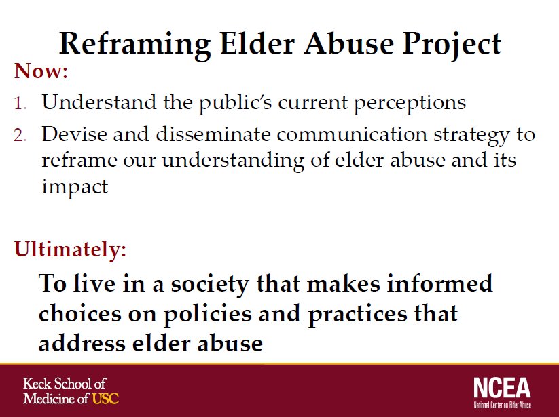

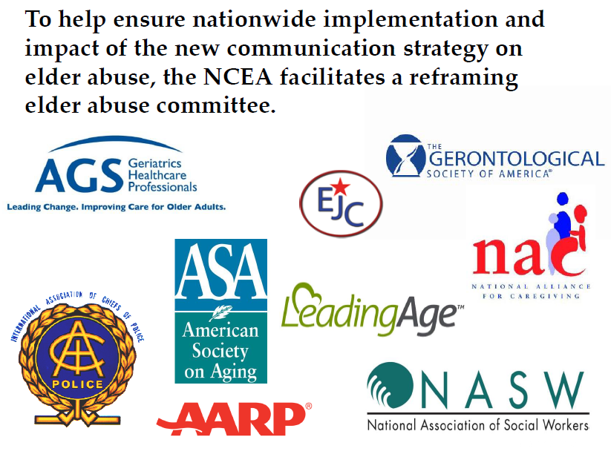
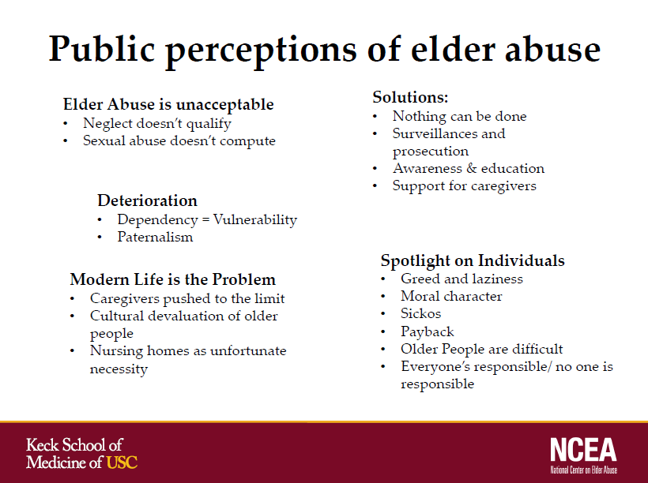

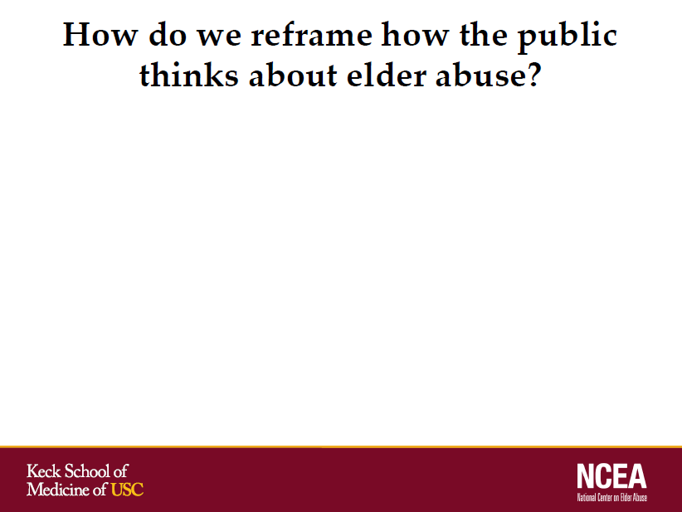

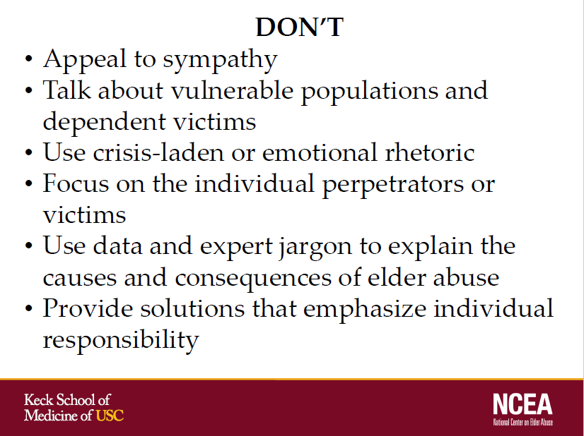

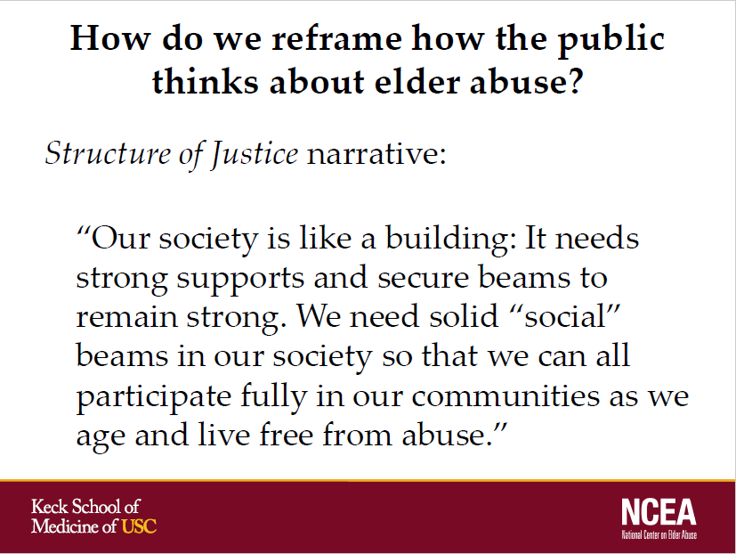

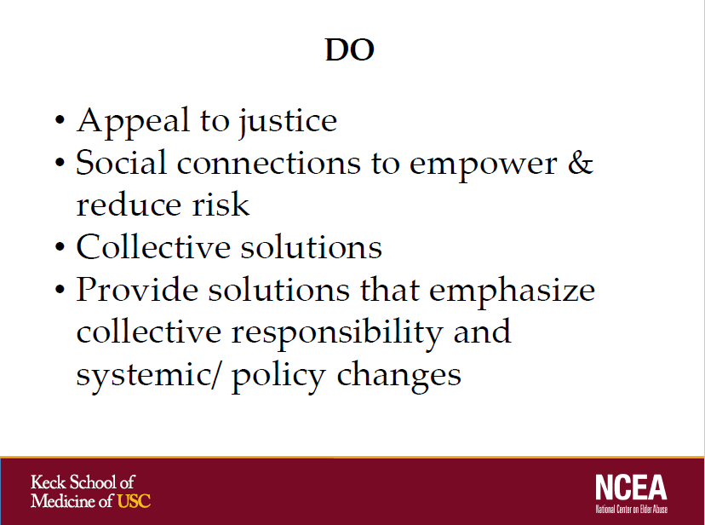

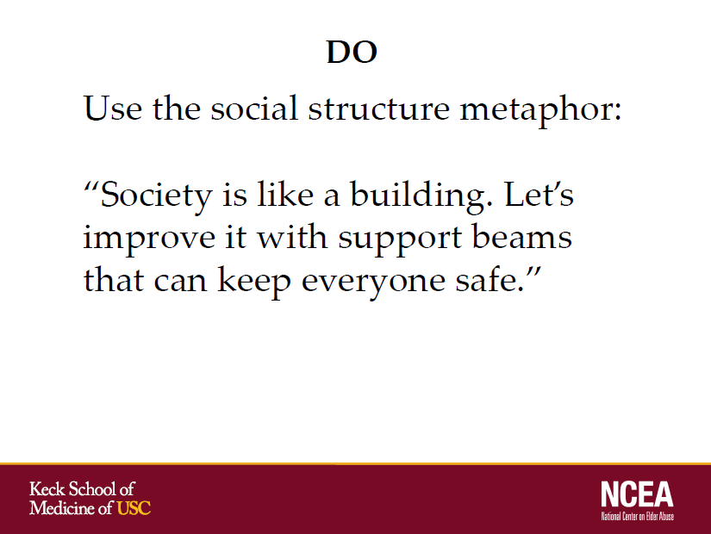

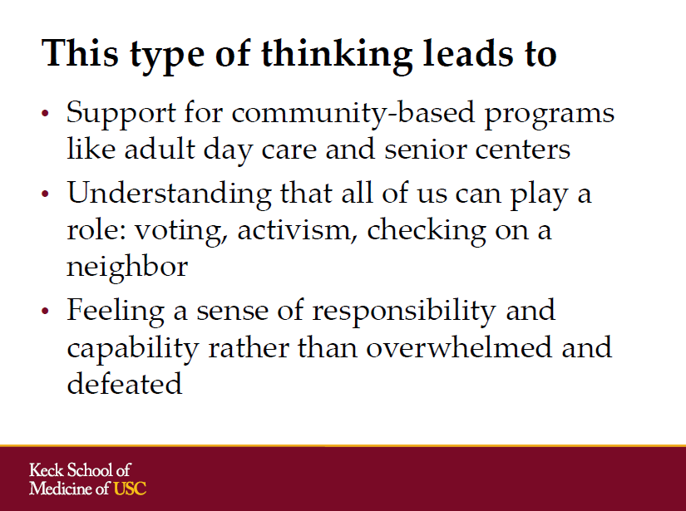

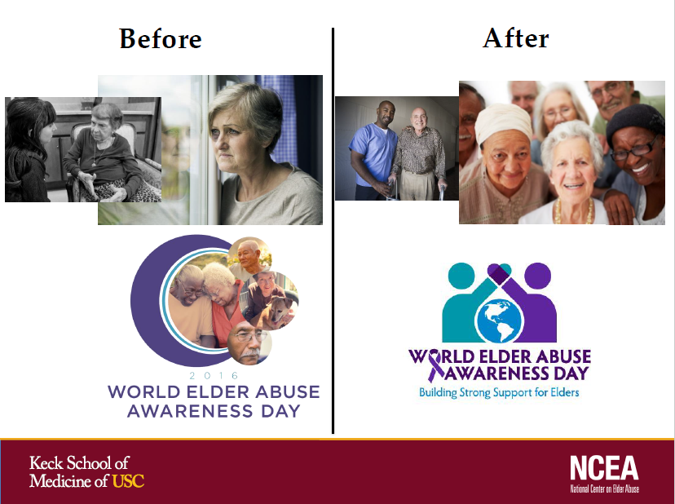

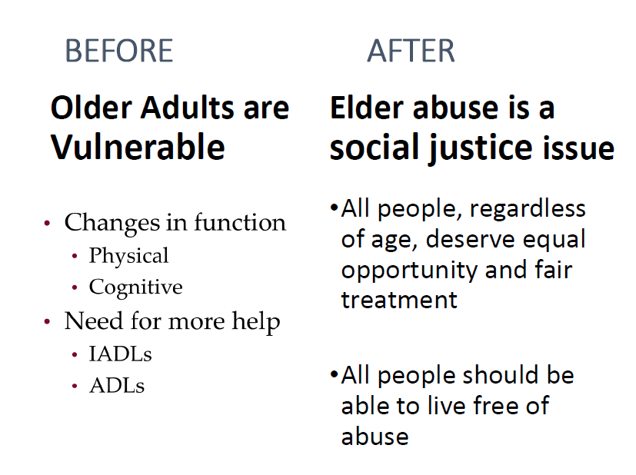

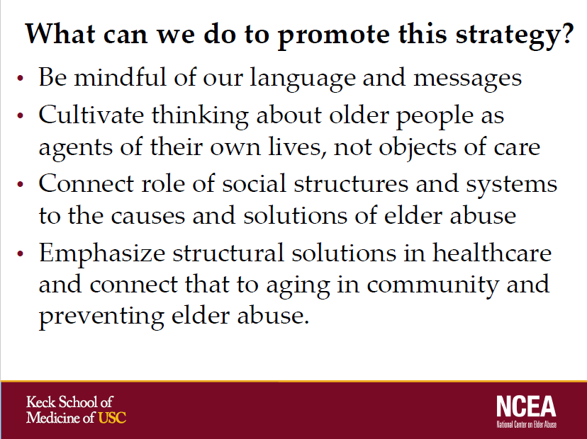

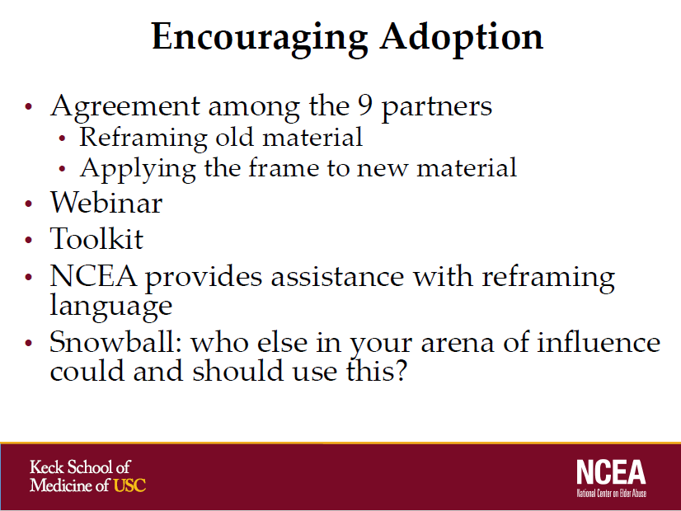

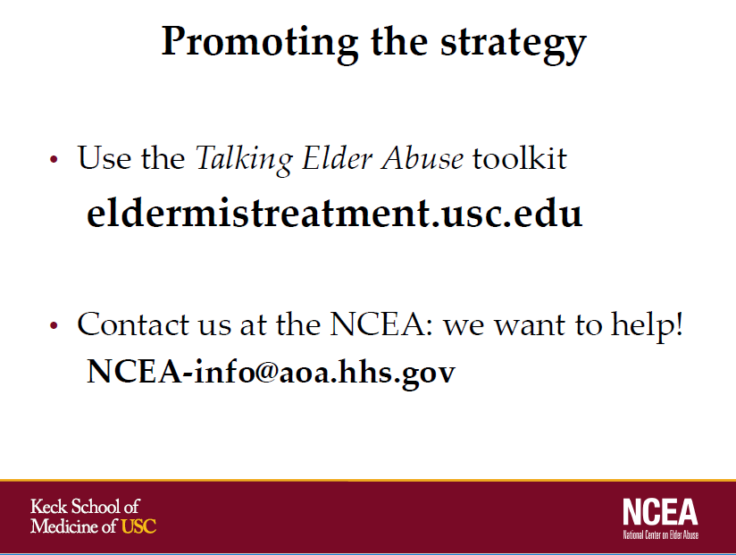

andrew volmert
Director of Research, FrameWorks Institute
Washington, D.C.

Presentation Slides
Elder Justice Coordinating Council
June 12, 2017

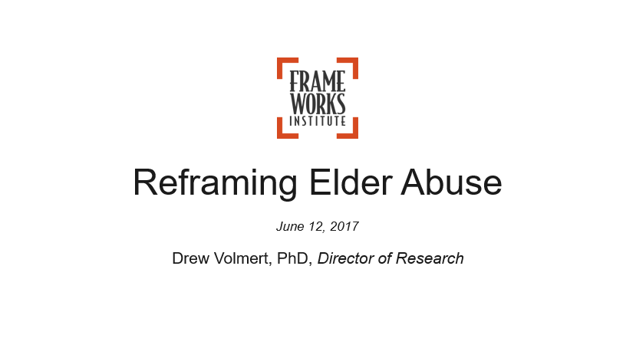

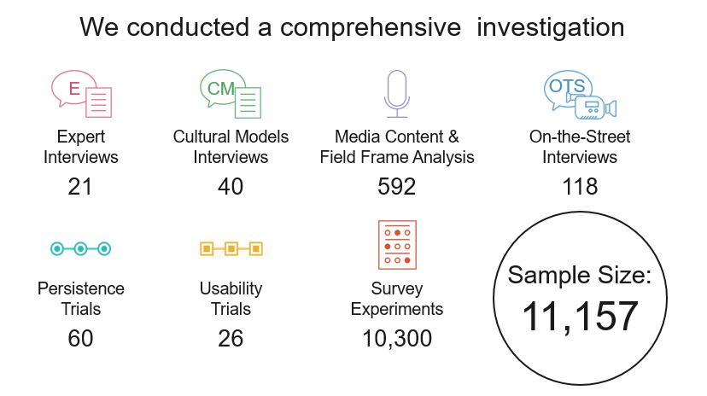
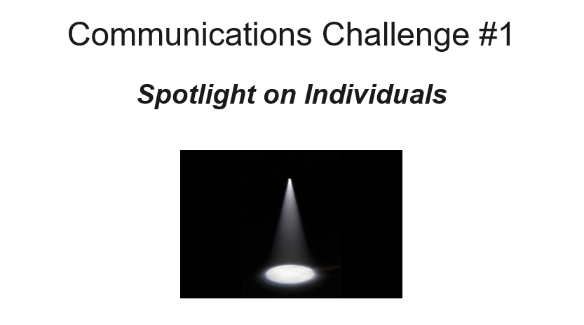

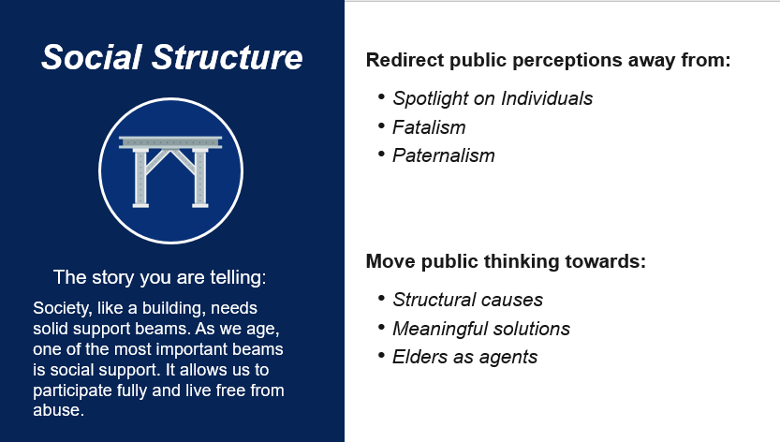

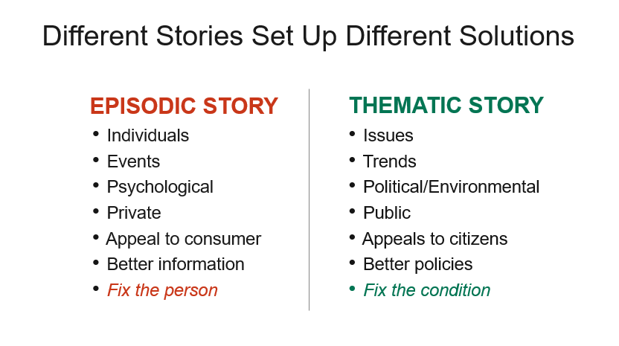

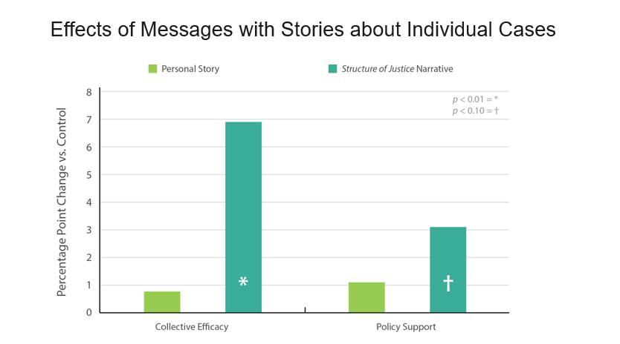

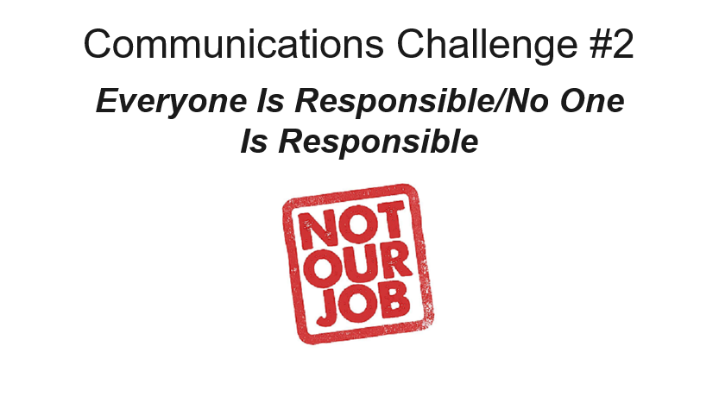

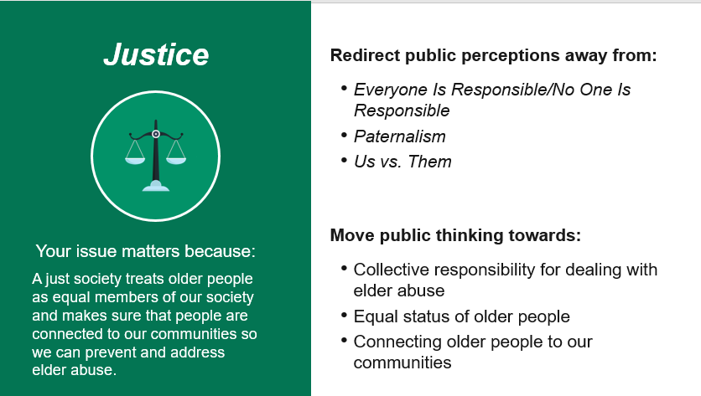

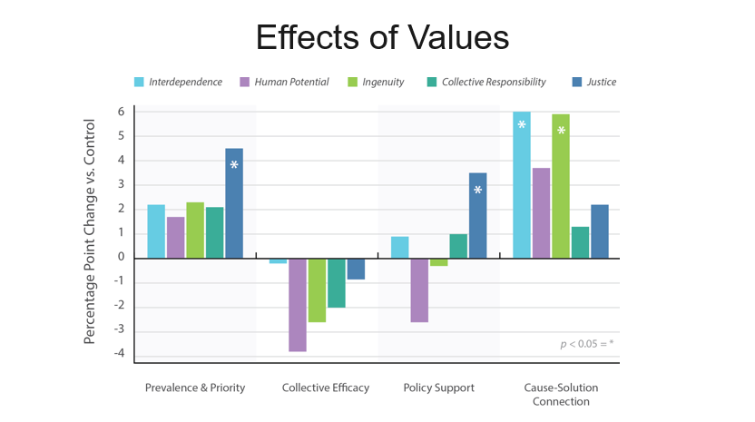

fall 2017 executive session materials
  - Agenda from the EJCC Executive Session – October 30, 2017

The fall 2017 meeting was a closed, Executive Session that occurred on October 30, 2017. The meeting centered on reviewing the collaborative efforts of the EJCC to date, as well as determining a strategic focus for the Council over the next year. The Council dialogued about the ongoing and future elder justice coordination among federal partners consistent with the Eight Recommendations. An agenda for this Executive Session can be found in the Appendix D.
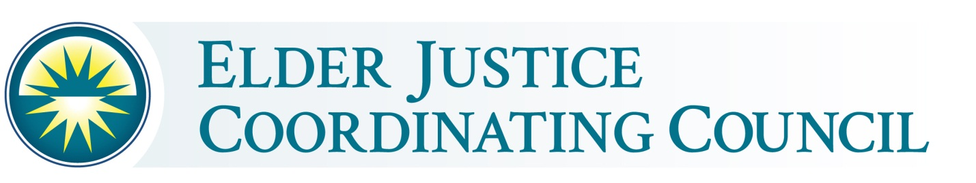
Executive Session
October 30, 2017 ~ 9:30 – 11:30 AM
Holiday Inn - 550 C St SW, Washington, DC 20024

Fall 2017 Meeting Agenda

- Welcome, opening remarks, and discussion on goal setting by Chairman Robertson (20 min)

- EJCC Member Introductions (20 min)

- Discussion – vision, goals, opportunities and plans for intergovernmental coordination and collaboration and public-private partnerships in elder justice (50 minutes)

- Looking Ahead and Closing Remarks – facilitated by Chairman Robertson (20 min)

SPring 2018 public meeting materials
  - Agenda and Written Remarks of Panel of Experts Consulted by the EJCC at Public Meeting held on June 5, 2018
The spring 2018 meeting of the Elder Justice Coordinating Committee took place on June 5, 2018. The meeting included an in-depth discussion on the opioid crisis and elder abuse and featured remarks from federal leaders including DHHS Secretary Alex Azar, Attorney General Jeff Sessions, and Securities and Exchange Commission Chair Jay Clayton. The Elder Justice Working Group, a group of federal employees who support the work of the Elder Justice Coordinating Council, also presented on their proposed activities for research and grant making, data collection and sharing, and information dissemination. Please visit the ACL webpage summarizing the spring 2018 EJCC meeting for more information. Following are the written materials submitted by the panel of experts who were consulted.

June 5, 2018 agenda E-2
dr. laura mosqueda E-3
roberT b. blancato E-6
william f. benson E-10

Spring 2018 EJCC Meeting
June 5, 2018
9:30 – 11:30 AM
Hosted By the Securities and Exchange Commission
100 F Street NE
Washington, DC 20549

Spring 2018 Meeting Agenda
- Opening remarks by
Alex M. Azar II, Secretary of Health and Human Services – Chair, Elder Justice Coordinating Council

- Introductory remarks by EJCC Members

- Effects of the Opioid Crisis
- Laura Mosqueda, MD, Director, National Center on Elder Abuse
  - Impact of opioids on families, based on work as a clinician and National Center on Elder Abuse Director
- Robert B. Blancato, National Coordinator Elder Justice Coalition
  - Comments on progress addressing elder justice and on implementing EJCC Recommendations, and how the opioid epidemic is an elder justice issue
- William F. Benson, National Policy Advisor, National Adult Protective Services Association
  - Impact of the opioid crisis on Adult Protective Services

- Presentation by Elder Justice Working Group Representatives
Opportunities and Plans for Improving Intergovernmental Coordination and Collaboration in Elder Justice:
- Research and Grant Making
- Data Collection and Sharing
- Information Dissemination

- Conclusions and Closing Remarks

laura mosqueda, md
Professor of Family Medicine and Geriatrics, Keck School of Medicine of USC,
Direction, National Center on Elder Abuse
Los Angeles, California

Written Testimony
Elder Justice Coordinating Council
June 5, 2018

The Intersection of the Opioid Crisis and Elder Abuse

As a family physician and geriatrician as well as the Director of the National Center on Elder Abuse, I have dealt with all forms of elder abuse. Many years ago I was administering to a patient who was in the end stages of life, on hospice care. Her pain was excruciating and we were doing all that we could to make her comfortable, however, nothing seemed to be helping. I carefully increased her dose of morphine and still she was in agony. Not understanding how this could be possible, I decided to check her blood levels only to find that she had no morphine in her system. I reported this incident to APS as well as the hospice agency, and we realized that someone else, probably her 26-year-old grandson with a known history of substance abuse was taking the medication. This is so hard to imagine, but it is one of many stories that describes an intersection of the opioid crisis and elder abuse.
The NCEA is a resource center funded by a grant from the Administration on Community Living to the Keck School of Medicine of USC. At NCEA we assist thousands of individuals with their questions concerning all aspects of suspected elder abuse. We field inquiries pertaining to emotional, financial, physical, sexual and neglectful situations via the telephone, emails and social media. Over the past year or so we have noted an increase in the number of inquiries relating to the opioid crisis and a possible correlation to elder abuse. I guess this shouldn’t be a surprise: opioid use disorder has become a nation-wide issue affecting people from all walks of life.
Wanting to learn more about the intersection of elder abuse and opioid use disorder, the NCEA surveyed our 2500 member listserv several months ago. From this informal survey we had many respondents who confirmed connections between opioid use disorder and elder abuse allegations. Particularly noteworthy is the variety of ways in which these two issues not only intersect but interact. In fact, we are in the early stages of trying to understand the full scope of the problem and there is much more to be learned about the economic, emotional and physical toll this is taking on our country. Here is a sample of what we’ve heard from around the country.

- Wisconsin Adult Protective Social worker Cheryl reported that she is investigating reports of care providers, both family and non-family members, using and/or stealing older adult’s prescriptions.
- An attorney at Greater Boston Legal Services reported increased litigation involving intergenerational family theft and ensuing elder abuse with addicted adult children at home. Resulting consequences include evictions, theft, undue influence and grandparents raising grandchildren.
- From the Department of Family Protective Services in Texas, we’ve learned that there has indeed been an uptick in opioid abuse cases involving older adults, in particular cases relating to family members having access to a patient’s opioid medications and the family member stealing and abusing the drugs.
- A faculty member at Emory University in Atlanta GA reported examples of people who use opioids neglecting an older adult for whom they had caregiving responsibilities.
- A person from Thomas More College in Crestview Hills KY reported that financial elder abuse crimes were on the rise in direct responses to adult and family member opioid addiction including a case of heirloom jewelry being sold for drugs.
- Missouri has taken a close look and has actually added a new reporting mechanism on their reporting forms so they can capture new reports that are linked directly or indirectly to opioid use disorder. In only three months they had more than one hundred cases. Some of these cases involved immediate danger, requiring an emergency response to protect the older adult. Some involved Medicaid providers who were then put on an employee disqualification list. In one instance an elderly mother was about to be evicted from her home because of a call related to “domestic disturbance” in the household. It turns out that her two opioid-addicted adult children were living there: the daughter was verbally abusive and the son was alleged to have broken his mother’s jaw.

Across the country from colleges to medical offices to APS divisions, the message is clear. The intersection between elder abuse and the opioid crisis is real and growing. Older adults are sometimes addicted, taking much higher doses than prescribed and going from doctor to doctor seeking more pills and resulting in problems such as falls and delirium, thus making that older adult more susceptible to being victimized by others. Some older adults may actually be selling their opioids in order to have enough funds to avoid eviction or starvation. As highlighted with earlier examples, abusers may steal from or neglect an older adult for whom they have care and custody.
ACL has demonstrated that the opioid crisis is a priority and is committed to finding solutions. In December of 2017 the ACL authored an issue briefing entitled “The Opioid Public Health Emergency and Older Adults”. In this report they explored opioid use among community dwelling older people, evidence-based treatments for the disorder, and federal resources and state and local innovations that address opioid use among older people. They came to the conclusion that the opioid crisis is indeed a big problem for older adults.

Solutions/Impact

No matter how old we are, we all deserve the chance to enjoy a life of dignity, free from abuse and neglect. The opioid epidemic takes away this opportunity for many people. This is an issue that impacts all of us, not just the individuals who are abusing opioids and their immediate friends and families. It creates health care costs, nursing home costs, housing costs and legal costs while reducing the quality of life for all involved.
Both topics, elder abuse and opioid use disorder, are complicated issues so it’s no surprise that solutions must involve a multifactorial approach:
- Increasing the availability of support groups, resources, and senior-only treatment centers,
- Special programs dedicated to assist grandfamilies affected by opioids.
- Provide substantially more support to those who are tasked with protecting and serving our nation’s older adults: those who work in senior centers, Adult Protective Services, our justice systems. They include social workers, prosecutors, officers, health care providers, victim advocates, and, unfortunately, medical examiners.
- Funded research to understand the risk factors that link opioid misuse and elder abuse. This will help us identify more solutions and, importantly, work towards effective strategies for prevention.

Think about what we have learned regarding cigarettes– we know now that it does not just impair the person who smokes, but that there are 2nd and even 3rd hand effects. Similarly, elder abuse affects not only the victim themselves, but also those who love them… and society as a whole. Talking about abuse and neglect, building awareness, funding research and education, putting effecting evidence-based programs in place, holding not only perpetrators accountable but ourselves accountable. Asking: what can we do individually and collectively to solve the opioid epidemic and elder abuse? My answer: there is much we can do. We must have the will to do it, and leadership from the agencies on this panel is critical to the success of our efforts.

The NCEA thanks the EJCC for taking time to discuss this important social issue of elder abuse.

Respectfully submitted,
Laura Mosqueda, MD

Dean
May S. and John H. Hooval Dean’s Chair in Medicine
Professor of Family Medicine and Geriatrics
Director, National Center on Elder Abuse
Keck School of Medicine of the University of Southern California

Robert Blancato
Elder Justice Coalition

Written Testimony
Elder Justice Coordinating Council
June 5, 2018

Good morning, Co-Chairman Robertson and members of the Elder Justice Coordinating Council:

The bipartisan 3000-member Elder Justice Coalition is pleased to be making its third appearance before the EJCC and we appreciate the invitation.

We are grateful that there has been a seamless continuation of the work of the EJCC between Administrations. It is a testament to the importance of the issue, your work, and the fact that the EJCC was created by the bipartisan Elder Justice Act.

We call out for special commendation the following activities undertaken in this Administration by agencies included in the EJCC:

We support the work of the Administration for Community Living in its creation of a home for Adult Protective Services (APS) and the National Adult Maltreatment Reporting System (NAMRS), the first national APS system with centralized and improved data collection on elder abuse, neglect, and exploitation cases. I should also mention the great value of the other programs under the ACL’s Elder Justice Initiative, including its grants for elder abuse forensics, abuse education and prevention in Indian Country, addressing self-neglect, and guardianship quality improvement efforts.

The Department of Justice has recently conducted the largest elder fraud enforcement action in American history. The Elder Fraud Sweep, the work of the Consumer Protection Branch, and the designation of an elder justice coordinator in each of the 94 U.S. Attorneys’ offices is to be highly commended. The Department’s previous funding of the National White Collar Crime Center and now its efforts to create law enforcement partnerships around the country is particularly helpful in prosecuting perpetrators. These efforts are already bearing fruit with the announcement of charges against more than 200 defendants for committing elder fraud schemes. The estimated one million victims and more than $500 million in resources stolen by these defendants is shocking, yet we know it is the tip of the iceberg. The ten DOJ regional Elder Justice Task Forces that bring together federal, state, and local prosecutors, law enforcement, and other key stakeholders are also essential in the battle against a growing exploitation market. Finally, the elder justice website and training videos have been well-received by the field.

Providing new Medicare cards which assign a new Medicare number that is unique to the individual and is not their Social Security number is another important step in preventing fraud against older adults. We know that there are unscrupulous individuals already attempting to use this as an opportunity to defraud older Americans, but efforts to identify such scams and educate the public have been visible and hopefully effective.

We also appreciate the work that has been done to date on the eight existing EJCC recommendations adopted at the May 2014 meeting. The approach of the EJCC to report on the progress on these recommendations is valued. For example, issuance of the Long-Term Care Ombudsman Program regulations, support for training and technical assistance through a national resource center, and coordination with the DOJ on related issues addresses several of the recommendations. Further, release of the Elder Justice Roadmap by DOJ and DHHS has provided the field with a needed tool to assess our priorities and think strategically.

The Consumer Financial Protection Bureau is also playing a critical role in protecting older adults from fraud and financial exploitation. They have done the research and developed tools for financial security, and educational materials, including placemats that can help us avoid common scans, and even information on planning for retirement.

These are some of the things that the federal government is doing to help protect older adults from abuse, neglect, and exploitation. There is of course much more you and we can do together. If there was ever a time for there to be a coordinated and comprehensive federal approach to fighting elder abuse it is now.

As we know, the national menace of elder abuse is continuing. One in ten older adults will experience abuse annually; close to 50% of people with dementia will be abused. And, recent reports from the FBI show that almost 50,000 people over 60 lost $342.5 million in 2017 to internet fraud and scams.

We all recognize on a bipartisan basis that we should use existing federal resources as wisely and effectively as possible in this effort. It can make the case for additional resources that much more persuasive.

On that point, I commend today’s focus on the national opioid crisis and its impact on older adults and its tie to elder abuse. To show how rapidly this issue has evolved, there is not a single reference to opioids in the 2014-2016 EJCC reports to Congress but here we are today having it as a front and center issue.

I think it is absolutely critical that before the billions in new funds are allocated to address the opioid crisis, the EJCC take the lead in ensuring that an adequate amount of these funds can go to help prevent opioid based elder abuse from spreading. It clearly meets the mission of the EJCC.

In preparation for this appearance today we asked our EJC members and others from the aging network to share stories about opioid abuse. Let me first note and submit for the record a survey done by NCEA assessing the mounting impact of opioid addiction on elder abuse, where respondents (28 in nine states) affirmed the correlation between opioid addiction and resultant elder abuse.

These findings are similar to a project our EJC has undertaken with Virginia Tech, led by Dr. Pam Teaster and Dr. Karen Roberto. We also gathered information about the relationship between opioid use and elder abuse. Focus groups have been held in four states (Kentucky, Ohio, Virginia, and West Virginia) with 20 representatives from agencies serving older adults. Multiple APS representatives in these focus groups estimate local double-digit percent increases in elder abuse and exploitation in recent years, solely because of family members, caregivers, and others having opioid-related problems

Other stories from the field include:

In North Carolina, a young grandson who was an opioid addict stole medications from his grandparents. When confronted he pushed his grandfather, fracturing his vertebrae and breaking a rib. The grandson also stole money and it took a protective order from APS to stop this abuse. Also, from North Carolina, a Vance County Commissioner stated that individuals are harming their animals and getting pain medication from veterinarians.

And, in Iowa, a Council Bluffs nurse pleaded guilty to stealing thousands of painkillers from those in her care in an older adult facility. More specifically, she stole 9,727 narcotic hydrocodone pills from 44 different residents. These cases are much more than someone stealing a few pills for his or her own use.

To the EJCC, I say that these are local stories of elder abuse today, but they will become grim national statistics if we don’t begin to address this emerging new crisis in elder abuse.

Let me close with some recommendations directly for EJCC and for your individual agencies.

First, as opioid crisis funds flow into each of your agencies, work to ensure that these includes resources to help those on the ground helping older adults.

Funding is needed at the county/local level, particularly in rural America and particularly directed to Adult Protective Services, to develop protocols and systems to deal with older adults experiencing and abuse, neglect, and exploitation that is related to opioid abuse. Current and future opioid resources going to states could have dedicated funding to address this problem. Resources would be used for bringing together key public and private sector stakeholders for strategy development and information sharing. These meetings would lead to intra-agency agreements on data collection, data sharing, and collaboration on referrals and response protocols.

Also, there is a need for training (including national webinars) of key stakeholders and services and supports staff in recognizing, documenting, and intervening in cases of abuse which are linked to individuals with opioid addiction. Funding should be provided to train Older Americans Act program staff and for training caregivers on these issues.
Next, we need to create data collection and sharing systems between key agencies to support multiple agency coordination on opioid related cases. Part of this effort should include developing materials, public service announcements, a hot line to report cases, senior center programs, and other outreach to older persons to educate about and empower them to respond to the potential threats in the community by providing a safe place to contact if an opioid-related situation arises.

The EJCC needs to work more closely with Crime Victims Act funds to ensure that funds are being used as called for in the recent DOJ rule—in other words, that ten percent of funding is serving previously underserved victims, especially victims of criminal elder abuse. An extra emphasis would be those who are victimized because of someone else’s opioid abuse.

The EJCC should recommend, as called for in the NCEA survey, the support of Statewide Prescription Drug Monitoring databases which identify patients with multiple sources of pain prescriptions accessed by doctors and pharmacists before filling prescriptions.

The EJCC should continue to support the good work of the CFPB and its Office of Older Americans.

The EJCC should work to have all twelve of its agencies provide highlights of their work in your reports to Congress.

Please ensure there are adequate resources in your budget proposals to help in a coordinated federal response to elder abuse. We call on each agency in EJCC to go to OMB with the strongest possible budget requests for the programs directly dealing with elder justice.

Finally, since elder justice and its achievement is locally driven, take the EJCC’s next meeting on the road. Continue your focus on the opioid addiction’s tie to elder abuse and go to a location hard hit by the problem—but one that is addressing it with solutions.

Thank you.

William F. Benson
National Adult Protective Services Association (NAPSA)

Written Testimony
Elder Justice Coordinating Council
June 5, 2018

Thank you for the invitation to speak to you today. My name is Bill Benson and I serve as the National Policy Advisor to the National Adult Protective Services Association (NAPSA). We are grateful to again have this opportunity to provide testimony to the Elder Justice Coordinating Council, as we last did at your fall 2016 meeting. And we are delighted to have the Council meeting today in coordination with NAPSA’s 4th Global Summit commemorating the 13th Anniversary of World Elder Abuse Awareness Day. We would like to thank Assistant Secretary Lance Robertson for his leadership in continuing the Administration for Community Living’s (ACL’s) focus on elder justice and the continued leadership by the Elder Justice Coordinating Council participants in addressing this crisis, as ACL rightfully labeled it in its May 7 release of the first ever data from the National Adult Maltreatment Reporting System (NAMRS).

NAPSA represents the nation’s state and local Adult Protective Services (APS) programs. Adult Protective Services are the nation’s only system of state-based statutorily-authorized programs to investigate vulnerable adult abuse, neglect, and exploitation and to respond to and protect its victims. APS differs from state to state and even county to county including in definitions, services, and data collection, which is the result of states historically establishing their APS programs to address the critical issue of elder and vulnerable adult abuse in the absence of direct federal funding and guidance from the federal level. Programs are also administratively different with about half in state units on aging, about half in state departments of social services, and a few in other arrangements. The majority of states serve all individuals with significant disabilities ages 18 and older; while several serve only older adults with disabilities or older adults regardless of disability. Despite the differences, all APS programs investigate abuse in home and community settings, and almost half also investigate reports of abuse in long-term care facilities.

We are grateful now for the federal leadership and resources related to APS since the 2010 enactment of the Elder Justice Act, including the creation of ACL’s Office of Elder Justice and Adult Protective Services, the Voluntary Consensus Guidelines for State APS Systems and the National Adult Maltreatment Reporting System. However, the continuing variations make it difficult to gather data, describe APS, educate the community, and develop standards or practice and training.

Despite these disparate structures and services, APS is essential to states and communities developing an adequate response system to protect vulnerable adults across the lifespan. Today, we would like to focus on being a voice for APS and its clients in responding to the current opioid abuse and misuse epidemic. In the last year, in addition to the Administration’s declaration of an opioid public health emergency, eight states have issued emergency declarations on the opioid epidemic. Among the population APS serves, the brief issued by ACL earlier this year identifies national data that older adults are more likely to use prescription opioids and for longer periods of time creating a risk of potential misuse by the consumer or others including caregivers and family. Additionally, increased side effects of opioids in older individuals can lead to falls, injury, and fatalities. Comments collected and summarized by the National Institute on Disability, Independent Living, and Rehabilitation Research (NIDILRR) suggest that people with disabilities are at a higher risk of opioid abuse, as well.

Most APS programs and NAMRS collect data on substance abuse present in a case generally, not specific to opioid use, whether prescription or otherwise. However, discussions with states’ APS administrators have shown that reports involving opioid abuse are increasing and complex. These cases often involve neglect, financial exploitation, medication theft, or self-neglect. Looking to the future, the opioid epidemic will not only continue to impact APS, but the impact is likely to be even greater. In rural counties, adults ages 45 and older comprise 43% of opioid related deaths. Soon this new generation of older adults struggling with addiction as well as caregivers will be seen by APS.

To best inform the Council on the impact of the opioid epidemic on APS programs, supervisors, and workers – and the victims they serve – we decided to go straight to the source. We are grateful to the state APS administrators who took the time to identify and provide case examples and their insights. We are also appreciative of the numerous informal discussions with APS folk and during our bimonthly NAPSA regional APS program calls. While not nationally comprehensive, the descriptions they’ve given provide a snapshot of challenges across a variety of program structures.

Allow me to cite excerpts from two cases shared with us by APS programs:

“Client taking opioids for chronic pain but medications were not found in the home. The daughter, who lived with the client, was suspected of taking and selling the medications. The client had been prescribed oxycodone and methadone by the pain clinic but lab tests from the pain clinic showed no presence of opioids in the client’s system.”

“The client was reported to be misusing pain medication and overmedicating on prescriptions given for pain and preparation for surgery. Home health aides reported witnessing overmedication though the older adult says this is not true. APS opened a case and was able to refer the older adult for treatment services.”

It is important to note that these examples show that opioid-related cases, whether involving prescription opioids or illicit opioids, are a microcosm of the larger APS caseloads. Analysis of contributed case snapshots largely reflect the nature of APS reports as a whole. The most frequent reports discussed in opioid-related cases are self-neglect, exploitation, and caregiver neglect. These allegations do not stand by themselves. As one APS administrator notes, “APS usually finds additional allegations that need to be investigated in addition to the missing narcotics.” Alleged perpetrators were most often family members followed by non-family caregivers stealing prescriptions for their own use. Cases also underscore the impact beyond APS with the need to coordinate with partners such as EMS, law enforcement, home and community-based services, nursing services, mental health crisis units, and hospitals.

The most profound impact of opioid-related cases on APS is their increased complexity. Case workers may face additional assessments and challenges including behavioral assessments, coordination with medical providers, navigating family dynamics and addictions, and impacts of overmedication of both consumers and alleged perpetrators. Criminal elements in a case may add further complexity in working with law enforcement. Workers note that overmedication can exacerbate underlying conditions and affect the client’s Activities of Daily Living (ADLs) such as basic toileting. Opioids can also create a safety risk for the consumer, the APS worker, and the neighborhood. One worker reported that clients may cause fires when smoking while over medicated. Cases were also reported to involve criminal elements in the house.

These challenges require time, expertise and resources. One worker gave a sample timeline for a case involving opioids and self-neglect.

“A timeline of events for APS when completing an involuntary hold affidavit on a client who is a harm to themselves or others due to over medicating/abusing narcotic prescriptions. It takes approximately 4-5 hours to initiate and complete an affidavit. That includes face to face interviews, home visit, assessing behaviors, investigating allegations, contacting law enforcement, contacting the mental health crisis mobile unit (if accessible), filling out the forms with law enforcement, EMS, transportation to the local hospital, travel to the hospital, notarizing affidavit, communicating with the hospital SW [social worker] and hospitalist, and requesting that a behavioral team assess the client. Then follow up the next day including referrals, family involvement, resources, etc. This takes 3-4 hours. Then type up APS contacts and services provided with evidence attached for another 3 hours.”

This account totals 12 hours over two days for one case. One case among an APS worker’s potential caseload of 25. Whether it is the client who self-neglects or an elder being abused by others, cases involving opioids require more time particularly in making referrals to appropriate services and potential coordination with law enforcement.

A challenge identified by APS programs that plagues APS generally is the lack of resources in the community and in the program. They face a lack of services to assist clients and family. Just as in domestic violence cases involving older adults in which shelters are often not available, communities often lack treatment options and support appropriate for older adults dealing with opioid-related issues. This is especially the case in rural communities. One APS worker noted, “The main issue I’ve noticed is it becomes a cycle and due to lack of resources/knowledge there is no one to intervene.” This repeat cycle is compounded by the ease of access to prescriptions whether through a doctor’s over-reliance on opioid treatments, “doctor shopping” both in and out of state, and limited tracking of prescriptions. As a result, an already under-resourced system is at risk of being overwhelmed with more complex and demanding cases. APS workers also noted that staff may not have enough training in identifying misuse or abuse or in advanced skills for complex cases.

The challenges brought by the opioid epidemic highlight the need to fully support and fund APS and the resources it relies upon. We applaud the modest increased funding for the Elder Justice Act in the recent Congressional omnibus package but must note that it still does not provide any form of a funding stream for APS services. The development of NAMRS and the grants for enhancing state programs remain crucial. More needs to be done to build on these accomplishments. Some APS programs are now receiving Victims of Crime Act grants from their states, mostly possible because of the increased Crime Victims Fund distribution cap which has made more funding of innovative projects possible.

However, it remains that the majority of states’ APS programs continue to rely on the Social Services Block Grant (SSBG) as the only source of federal funding for program operations – for paying the salaries and associated costs of investigators and case workers. SSBG is crucial to addressing the opioid epidemic across the lifespan as evidenced by the SSBG Coalition brief that we have provided. Despite the importance of SSBG to APS and other services, SSBG remains under continuing threat. Elimination of SSBG would be devastating to APS’ ability to address the opioid epidemic, as well as the many other reports of abuse and exploitation they receive. APS administrators tell us that there is almost no likelihood state legislatures would be able to off-set the revenue that would be lost without SSBG.

While there are many challenges and difficulties facing us in this current opioid epidemic, APS is a crucial support for vulnerable adults. States’ APS programs are describing cases with positive outcomes including consumers receiving much needed addiction and mental health treatment, voluntary movement out of unsafe environments, and change from a rep payee situation to independent financial management. How we address the opioid epidemic and prevent vulnerable adults from falling through the cracks will help guide and provide lessons for future public health challenges. Supporting our frontline APS workers and the vulnerable adults they serve supports the entire community.

The full text of the EJCC Recommendations can be found in Appendix A herein.
Beach SR, Schulz R, Castle NG, Rosen J. Financial Exploitation and Psychological Mistreatment Among Older Adults: Differences Between African Americans and Non-African Americans in a Population-Based Survey. Gerontologist 2010. Acierno R, Hernandez MA, Amstadter AB, Resnick HS, Steve K, Muzzy W et al. Prevalence and Correlates of Emotional, Physical, Sexual, and Financial Abuse and Potential Neglect in the United States: The National Elder Mistreatment Study. American Journal of Public Health 2010; 100(2):292-297.
Teaster PB, Dugar T, Mendiondo M, Abner EL, Cecil KA, Otto JM. The 2004 Survey of Adult Protective Services: Abuse of Adults 60 Years of Age and Older. National Center on Elder Abuse: Washington, DC. Retrieved August 8, 2011 from: http://www.ncea.aoa.gov/Main_Site/pdf/2-14-06%20FINAL%2060+REPORT.pdf.
National Research Council. Elder Mistreatment: Abuse, neglect and exploitation in an Aging America. Washington, D.C.: The National Academies Press, 2003.
Lachs, Mark, et al. (2011) Under the Radar: New York State Elder Abuse Prevalence Study Final Report. Lifespan of Greater Rochester, Inc.: Weill Cornell Medical Center of Cornell University and New York City Department for the Aging.
National Research Council. Elder Mistreatment: Abuse, neglect and exploitation in an Aging America. Washington, D.C.: The National Academies Press, 2003.
National Research Council. (2003). Elder Mistreatment: Abuse, Neglect, and Exploitation in an Aging America. Panel to Review Risk and Prevalence of Elder Abuse and Neglect. Richard J. Bonnie and Robert B. Wallace, Editors. Committee on National Statistics and Committee on Law and Justice, Division of Behavioral and Social Sciences and Education. Washington, DC: The National Academies Press.
Elder Justice Act of 2009, Title XX of the Social Security Act, §2011 (42 U.S.C. 1397j).
Lachs, M.S., Williams, C.S., O'Brien, S., Pillemer, K.A., & Charlson, M.E. (1998). “The Mortality of Elder Mistreatment.” JAMA. 280: 428-432.
Bitondo Dyer C., Pavlik V. N., Murphy K. P., and Hyman D. J. (2000). “The high prevalence of depression and dementia in elder abuse or neglect.” Journal of the American Geriatrics Society. 48:205-208. Burt, M. and Katz, B. “Rape, Robbery, and Burglary: Responses to Actual and Feared Criminal Victimization, with Special Focus on Women and the Elderly,” Victimology: An International Journal 10 (1985): 325-358. Mouton C. P., Espino D. V. (1999). “Problem-orientated diagnosis: Health screening in older women.” American Family Physician. 59: 1835. Fisher, B.S., and Regan, S.L. (2006). “The Extent and Frequency of Abuse in the Lives of Older Women and Their Relationship With Health Outcomes.” The Gerontologist, 46: 200-209. Coker, A., Davis, K., Arias, I. et al. (November 2002). “Physical and Mental Health Effects of Intimate Partner Violence for Men and Women.” American Journal of Preventive Medicine. Vol. 23 No. 4: 260-268. Stein, M. & Barrett-Connor, E. (2000). “Sexual Assault and Physical Health: Findings from a Population-Based Study of Older Adults.” Psychosomatic Medicine. Vol. 62: 838-843.
See full article discussing the negative behavioral health consequences at: http://www.ncea.aoa.gov/NCEAroot/Main_Site/Library/Statistics_Research/Research_Reviews/emotional_distress.aspx. Comijs, H.C., Penninx, B.W.J.H., Knipscheer, K.P.M., & van Tilburg, W. (1999). Psychological distress in victims of elder mistreatment: The effects of social support and coping. Journal of Gerontology, 54B (4), P240-P245.
Stein, M. & Barrett-Connor, E. (2000). “Sexual Assault and Physical Health: Findings From a Population-Based Study of Older Adults.” Psychosomatic Medicine. Vol. 62; p 838-p843.
See: National Research Council. (2003). Elder Mistreatment: Abuse, Neglect, and Exploitation in an Aging America. Panel to Review Risk and Prevalence of Elder Abuse and Neglect. Richard J. Bonnie and Robert B. Wallace, Editors. Committee on National Statistics and Committee on Law and Justice, Division of Behavioral and Social Sciences and Education. Washington, DC: The National Academies Press. The National Academies Committee on National Statistics. (2010). Meeting on Research Issues in Elder Mistreatment and Abuse and Financial Fraud. Washington, D.C. Retrieved from: https://www.nia.nih.gov/sites/default/files/d7/meeting-on-research-issues-in-elder-mistreatment-and-abuse-and-financial-fraud.pdf. IOM (Institute of Medicine) and NRC (National Research Council). (2014). Elder Abuse And Its Prevention: Workshop Summary. Washington, DC: The National Academies Press. U.S. Government Accountability Office. (2011). Stronger Federal Leadership Could Enhance National Response to Elder Abuse (GAO Publication No. 11-208). Washington, D.C.: U.S. Government Printing Office. U.S. Government Accountability Office. (2013). More Federal Coordination and Public Awareness Needed (GAO Publication No. 13-498). Washington, D.C.: U.S. Government Printing Office. Pillemer, K.A.; Mueller-Johnson, K.U.; Mock, S.E.; Suitor, J.J.; & Lachs, M.S. (2007). Interventions to Prevent Elder Mistreatment. In Doll, L.; Bonzo, S.; Sleet, D.; Mercy, J.; Haas, E.N. (Eds.), Handbook of Injury and Violence Prevention. New York: Springer for the U.S. Centers for Disease Control and Prevention.
https://ncea.acl.gov/
https://apstarc.acl.gov/
https://acl.gov/programs/elder-justice/state-grants-enhance-adult-protective-services
https://www.nationalacademies.org/our-work/forum-on-global-violence-prevention
https://ltcombudsman.org/
https://theconsumervoice.org/events/sexual-abuse-webinar/archived
https://www.cms.gov/Regulations-and-Guidance/Guidance/Manuals/Internet-Only-Manuals-IOMs-Items/CMS1201984
https://www.cms.gov/Outreach-and-Education/American-Indian-Alaska-Native/AIAN/LTSS-TA-Center/LTSS-Webinars
https://www.cms.gov/Outreach-and-Education/American-Indian-Alaska-Native/AIAN/LTSS-TA-Center/ltss-focus-areas/elder-abuse-prevention
Hall, JE, Karch, DL, Crosby, AE. Elder Abuse Surveillance: Uniform Definitions and Recommended Core Data Element, Version 1.0. Atlanta (GA): National Center for Injury Prevention and Control, Centers for Disease Control and Prevention, 2016. Available at: https://www.cdc.gov/violenceprevention/pdf/EA_Book_Revised_2016.pdf
https://www.cdc.gov/features/cdc-connecting-dots/
https://grants.nih.gov/grants/guide/rfa-files/RFA-AG-18-010.html
https://grants.nih.gov/grants/guide/pa-files/PAR-18-544.html and https://grants.nih.gov/grants/guide/pa-files/PAR-18-538.html
Burnes D, Henderson CR Jr, Sheppard C, Zhao R, Pillemer K, Lachs MS. Am J Public Health. 2017 Aug;107(8):e13-e21. doi: 10.2105/AJPH.2017.303821.
Evans CS, Hunold KM, Rosen T, Platts-Mills TF. Diagnosis of Elder Abuse in US Emergency Departments. Journal of the American Geriatrics Society. 2017;65(1):91-97. doi:10.1111/jgs.14480.
Breckman R, Burnes D, Ross S, Marshall PC, Suitor JJ, Lachs MS, Pillemer K. Gerontologist. 2018 Jul 13;58(4):719-723. doi: 10.1093/geront/gnw257.
https://www.nia.nih.gov/sites/default/files/d7/nih_workshop_on_multiple_approaches_to_understanding_and_preventing_elder_abuse_-final.pdf
Journal of Elder Abuse & Neglect Volume 28, 2016 - Issue 4-5: Multiple Approaches to Understanding and Preventing Elder Abuse: Proceedings of the Cross-Disciplinary National Institutes of Health Workshop.
https://www.nia.nih.gov/sites/default/files/2018-07/fy2020-milestones-chart.pdf
https://www.nia.nih.gov/health/caregiving/long-distance-caregiving
https://oig.DHHS.gov/oas/reports/region1/11600509.asp and https://oig.DHHS.gov/oas/reports/region1/11700513.asp
https://www.justice.gov/elderjustice/webinars and https://www.fincen.gov/sites/default/files/2017-08/8-25-2017_FINAL_CFPB%2BTreasury%2BFinCEN%20Joint%20Memo.pdf
https://www.justice.gov/elderjustice/task-forces
https://www.justice.gov/civil/consumer-protection-branch/elder-fraud
https://www.justice.gov/elderjustice
https://www.consumerfinance.gov/data-research/research-reports/report-and-recommendations-fighting-elder-financial-exploitation-through-community-networks/
https://www.consumerfinance.gov/consumer-tools/managing-someone-elses-money/
https://www.consumerfinance.gov/practitioner-resources/resources-for-older-adults/protecting-against-fraud/
https://www.consumerfinance.gov/practitioner-resources/resources-for-older-adults/financial-education-placemats/
https://files.consumerfinance.gov/f/201603_cfpb_advisory-for-financial-institutions-on-preventing-and-responding-to-elder-financial-exploitation.pdf and https://files.consumerfinance.gov/f/201603_cfpb_recommendations-and-report-for-financial-institutions-on-preventing-and-responding-to-elder-financial-exploitation.pdf
https://www.consumerfinance.gov/policy-compliance/guidance/supervisory-guidance/memorandum-financial-institution-and-law-enforcement-efforts-combat-elder-financial-exploitation
https://www.nationalservice.gov
https://www.ftc.gov/reports/protecting-older-consumers-2017-2018-report-congress-federal-trade-commission
https://www.donotcall.gov/
https://identitytheft.gov/
https://www.ftc.gov/stay-connected
https://www.consumer.gov/content/common-ground-conferences-and-roundtables-calendar
https://www.ftc.gov/news-events/events-calendar/2016/12/changing-consumer-demographics
https://www.ftc.gov/news-events/press-releases/2018/02/ftc-challenges-schemes-target-or-affect-senior-citizens
https://www.justice.gov/opa/pr/justice-department-coordinates-largest-ever-nationwide-elder-fraud-sweep-0
https://blog.ssa.gov/hiring-our-heroes-is-an-honor/
https://www.ssa.gov/payee/rp_training2.html
https://www.ssa.gov/payee/documents/WINGS%2017-8PP-2.pptx
https://www.nimss.org/projects/view/mrp/outline/14656 And https://www.nimss.org/projects/view/mrp/outline/18384
www.ncran.org
https://www.fincen.gov/sites/default/files/2017-08/8-25-2017_FINAL_CFPB%2BTreasury%2BFinCEN%20Joint%20Memo.pdf
https://www.sec.gov/litigation/litreleases/2018/lr24287.htm
https://www.sec.gov/news/press-release/2017-124
https://www.sec.gov/files/elder-financial-exploitation.pdf
https://www.iosco.org/library/pubdocs/pdf/IOSCOPD595.pdf
DISCLAIMER: The Written Remarks provided by speakers at the EJCC public meetings reflect the opinions and thoughts of the authors as submitted to the Elder Justice Coordinating Council. They do not represent the interests or positions of the Elder Justice Coordinating Council nor any of the federal agencies that are members of the Council. The Council has reviewed the remarks and has taken their contents under advisement, but does not endorse nor adopt these papers wholly or in part as representing the policies or positions of the federal government.
National Adult Protective Services Resource Center and National Council on Crime and Delinquency. Evidence-Based Practices in Adult Protective Services: Survey Results. 2012.
Acierno, R., Hernandez, M. A., Amstadter, A. B., Resnick, H. S., Steve, K., Muzzy, W., & Kilpatrick, D. G. (2010). Prevalence and correlates of emotional, physical, sexual, neglectful, and financial abuse in the Congressional Record Feb. 10, 2003. http://thomas.loc.gov/cgi-bin/query/R?r108:FLD001:S02121United States: The National Elder Mistreatment Study. American Journal of Public Health, 100, 292-297. Sedlak, A.J., Mettenburg, J., Basena, M., Petta, I., McPherson, K., Greene, A., and Li, S. (2010). Fourth National Incidence Study of Child Abuse and Neglect (NIS–4): Report to Congress. Washington, DC: U.S. Department of Health and Human Services, Administration for Children and Families. Retrieved from: http://www.acf.DHHS.gov/programs/opre/abuse_neglect/natl_incid/index.html. ONE DEPARTMENT: OVERVIEW of ACTIVITIES ON VIOLENCE AGAINST WOMEN 2008-2009. DHHS Office of Women’s Health. Retrieved from: http://www.womenshealth.gov/owh/pub/violence-against-women.cfm.
Dugan, L, Nagin, D & Rosenfeld, R. Do Domestic Violence Services Save Lives? NIJ Journal. ISSUE NO. 250 / NOVEMBER 2003
Schillerstrom, et al. Informing Evidence Based Practice: A Review of Research Analyzing Adult Protective Service (APS) Data. Submitted for publication, 2012.
National Adult Protective Services Resource Center and National Council on Crime and Delinquency. Evidence-Based Practices in Adult Protective Services: Survey Results. 2012.
ACL press release, August 16, 2016.
https://www.justice.gov/elderjustice/webinars
https://www.judiciary.senate.gov/imo/media/doc/S. 3270 Substitute Amendment - ALB16846.pdf
The US Constitution prohibits states from entering into agreements without prior Congressional approval. Virtually every social service and criminal justice system (child protective services, corrections, etc.) has such compacts in place.
While this paper focuses primarily on SSA representative payees and VA fiduciaries, other federal agencies – such as the Office of Personnel Management and Railroad Retirement – have similar payee program, as do some state and even private entities.
In this paper, the generic term “guardianship” refers to guardians of property, frequently called “conservators” including guardians of both person and property, unless otherwise indicated.
Kania, J. & Kramer, M., “Collective Impact,” Stanford Social Innovation Review, pp. 36 - 41 (Winter 2011).
Black’s Law Dictionary, 2nd Ed., http://thelawdisctionary.org/fiduciary.
Wood, E., “The Paradox of Adult Guardianship: A Solution To – and A Source For – Elder Abuse,” Generations, American Society on Aging, Vol. 36, No. 3, pp. 79 – 82 (Fall 2012).
National Research Council, Improving the Social Security Representative Payee Program: Serving Beneficiaries and Minimizing Misuse, Executive Summary, p. 9 (2007).
National Guardianship Association, Position Statement on Guardianship, Surrogate Decision-Making and Supported Decision-Making (2015) http://www.guardianship.org/documents/NGA_Policy_Statement_052016.pdf. Also see National Resource Center for Supported Decision-Making, http://www.supporteddecisionmaking.org.
Social Security Administration, A Guide for Representative Payees, SSA Publication No. 05-10076 (July 2015), Retrieved from https://www.ssa.gov/pubs/EN-05-10076.pdf
Social Security Administration, When People Need Help Managing Their Money (2015) https://www.ssa.gov/payee.
U.S. Department of Veterans Affairs, A Guide for VA Fiduciaries (2013), http://benefits.va.gov/fiduciary. Wynn, S., Justice in Aging, Issue Brief: How SSA Can Improve the Representative Payee Program to Protect Vulnerable Seniors (June 2016). Also see Wynn, S., Justice in Aging, Fact Sheet: SSA’s Representative Payee.
American Bar Association Commission on Law and Aging, “Guardianship Law and Practice,” – List of State Guardianship Handbooks, List of State Guardianship Videos, http://www.americanbar.org/groups/law_aging/resources/guardianship_law_practice.html .
Consumer Financial Protection Bureau, “CFPB Releases Guides for Managing Someone Else’s Money” (October 23, 2013), http://www.consumerfinance.gov/about-us/newsroom/cfpb-releases-guides-for-managing-someoneelses-money.
American Bar Association policy approved by the Association’s House of Delegates in August 2013 states: “Resolved, that the American Bar Association urges courts with jurisdiction over adult guardianship and governmental agencies that administer representative payment programs for benefits to collaborate with respect to information sharing, training and education in order to protect vulnerable individuals with fiduciaries who make financial decisions on their behalf.”
U.S. Government Accountability Office, Guardianships: Collaboration Needed to Protect Incapacitated Elderly People (2004)
U.S. Government Accountability Office, Incapacitated Adults: Oversight of Federal Fiduciaries and Court-Appointed Guardians Needs Improvement (2011).
Administrative Conference of the United States, SSA Representative Payee: Survey of State Guardianship Laws and Court Practices (2014): https://www.acus.gov/sites/default/files/documents/SSA%2520Rep%2520Payee_State%2520Laws%2520and%2520Court%2520Practices_FINAL.pdf
Pub.L. 93–579, 88 Stat. 1896, enacted December 31, 1974, 5 U.S.C. § 552a.
U.S. Government Accountability Office, Guardianships: Collaboration Needed to Protect Incapacitated Elderly People (2004).
Elder Justice Interagency Working Group, “Participating Federal Departments and Agencies Mission Statements and Agency Activities Relevant to Elder Justice” (May 2013).
The WINGS effort has been coordinated by the National Guardianship Network and the American Bar Association Commission on Law and Aging: http://www.nationalguardianshipnetwork.org/NGN/WINGS/Court-Community_Reform_Through_WINGS/NGN/WINGS/Court-Community_Reform.aspx?hkey=7d32011f-2ac5-461a-9b4a-5636722c4914
Administration for Community Living, Elder Justice Innovation Grants, http://www.grants.gov/web/grants/view-opportunity.html?oppId=283115.
Email message from VA Fiduciary Program, June 27, 2015, in file with author.
Truhe, J., “Social Security Seeks Pro Bono Lawyers to Meet Need for Representative Payees,” Bifocal, American Bar Association Commission on Law and Aging, Vol., 36, Issue 4 (April 2015). SSA has also initiated a volunteer pilot in Chicago, Illinois.
Email message from SSA Office of Income Security Programs, September 16, 2016, on file with author.
Wynn, S., “Ways to Meet the Growing Need for Representative Payees,” Policy Issue Brief, Justice in Aging (2016), Retrieved from http://www.justiceinaging.org/our-work/economic-security/rep-payee-program.
Concerning the Office of Personnel Management payee program, note that in 2015, S. 1576 would have “close[d] a loophole that currently exists in statute whereby the embezzlement or conversion of federal Social Security and Veterans benefits by representative payees is a federal felony but the same embezzlement or conversion of benefits provided to federal retirees through the federal retirement system is not.” Representative Payee Fraud Prevention Act of 2015 (S. 1576) Senate Report 114-95 (July 2015).
Email message from SSA Office of Income Security Programs, September 16, 2016, on file with author.
Karp, N. & Wood, E., Guarding the Guardians: Promising Practices for Court Monitoring, AARP Public Policy Institute (2007). Also see National Association for Court Management, Adult Guardianship Guide (2014), https://nacmnet.org/sites/default/files/publications/AdultGuardianshipGuide_withCover.pdf. Also see Administrative Conference of the United States, SSA Representative Payee: Survey of State Guardianship Laws and Court Practices (December 2014).
Office of the Inspector General, Social Security Administration, “The Social Security Administration’s Oversight of Employer Representative Payees, Congressional Response Report, A-13-10-20125 (2010), Retrieved from http://oig.ssa.gov/sites/default/files/audit/full/html/A-13-10-20125_7.html
National Disability Rights Network, Representative Payee Reviews (March – June 2016).
American Bar Association Commission on Law and Aging, Volunteer Guardianship Monitoring and Assistance: Serving the Court and the Community (2011), http://ambar.org/VolunteerGrdMonitor .
In addition to the SJI and DoJ initiatives described, note that in previous sessions, a U.S. Senate bill entitled the Court-Appointed Guardian Accountability and Senior Protection Act would have bolstered state efforts to develop accountability tools such as guardian background checks and court guardianship databases. Elements of the bill are incorporated into S. 3270, the Elder Abuse Prevention and Prosecution Act.
The National Center for State Courts is partnering with the Virginia Tech Center for Gerontology and the American Bar Association Commission on Law and Aging in the conservator fraud project.
https://acl.gov/programs/elder-justice/spring-2017-ejcc-meeting
DISCLAIMER: The Written Remarks provided by speakers at the EJCC public meetings reflect the opinions and thoughts of the authors as submitted to the Elder Justice Coordinating Council. They do not represent the interests or positions of the Elder Justice Coordinating Council nor any of the federal agencies that are members of the Council. The Council has reviewed the remarks and has taken their contents under advisement, but does not endorse nor adopt these papers wholly or in part as representing the policies or positions of the federal government.
DISCLAIMER: The Written Remarks provided by speakers at the EJCC public meetings reflect the opinions and thoughts of the authors as submitted to the Elder Justice Coordinating Council. They do not represent the interests or positions of the Elder Justice Coordinating Council nor any of the federal agencies that are members of the Council. The Council has reviewed the remarks and has taken their contents under advisement, but does not endorse nor adopt these papers wholly or in part as representing the policies or positions of the federal government.
http://theconsumervoice.org/uploads/files/general/ACL_Issue_Brief_-_Opioid_Abuse_and_Older_Adults_-_Dec2017.pdf
1 Tilly, J., Skowronski, S., & Ruiz, S. (2017, December). The opioid public health emergency and older adults. Retrieved from https://www.acl.gov/
NIDILRR. (2018, May). Summary of responses from a request for information: People with disabilities and opioid use disorder. Retrieved from https://acl.gov/.
Aldrich, N. & Benson, B. (2017, August). Raising awareness and seeking solutions to the opioid epidemic’s impact on rural older adults. Retrieved from: https://www.giaging.org/documents/170818_Benson-Aldrich_paper_for_GIA_web_FINAL.pdf.

